Press Release Contacts: For Immediate Release Vinitaly International
International Media Dept.
+39 045 8101447
media@vinitalytour.com
www.vinitalyinternational.com
Twitter: @VinitalyTour
Join Italian Wine Community on LinkedIn

Three Vinitaly International tastings celebrate international women’s achievements in the wine business

Three Vinitaly International tastings during Vinitaly will illuminate international women producers and professionals, celebrating their achievements along with their outstanding wines coming from countries such as the United States, France, Spain, Australia, China and others. These three tastings, organized by Vinitaly International in collaboration with the Vinitaly International Academy (VIA), will take place at wine2digital in Veronafiere’s Palaexpo on Monday April 16th and Wednesday April 18th.

Although the number of women in the wine industry is growing and their responsibilities and skills are increasingly recognized, according to wine writer Karen MacNeil (author of The Wine Bible) women in top positions in the wine industry are still few, with the gender wage gap still far from being levelled off. MacNeil also highlights that women professionals are also 15% less likely to be promoted, hence “about a century” will be necessary “to achieve gender parity among executives.” (Source: Karen MacNeil, “Women and the Wine Industry,” WineSpeed, 29 Dec. 2017, http://bit.do/eddKW). In addition to showcasing a wide array of wines, these three Vinitaly International tastings will also offer unique perspectives on women working in the wine industry from various international locations and in various capacities, with the intent to fuel a wider debate and encourage a constructive exchange of ideas on the influence of women in the business.
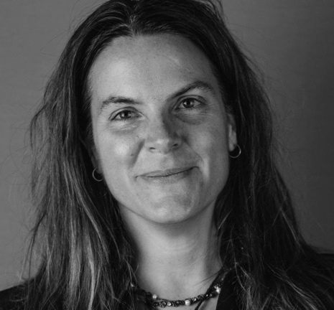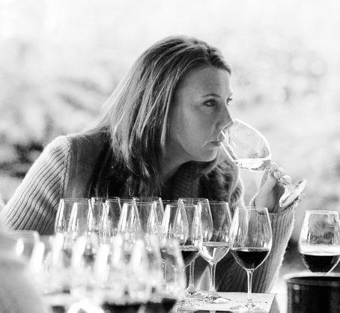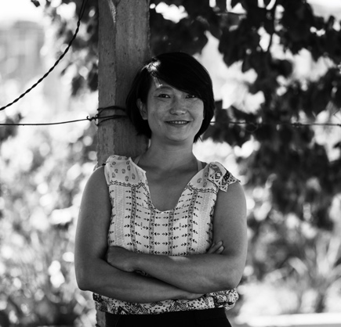
Photographs: (Left to right) Cathy Huyghe, Gina Gallo, and Emma Gao.
On Monday April 16th at 11am, Cathy Huyghe, CEO of Enolytics and author of Hungry for Wine: Seeing the World through the Lens of a Wine Glass (Provisons Press, 2015) will kick off this international women in wine celebration with a tasting entiled “W3: Wine Women of the World,” Huyghe will lead a seminar that will showcase wine produced exclusively by women winemakers, growers and winery owners from Spain, Austria, Australia, Germany, France, California, and Oregon. In her tasting, glasses will be raised to acknowledge the work of Lynn Penner-Ash, the very first woman hired a winemaker in Oregon, or Xandra Falcó’s work at the legendary Spanish estate Dominio de Valdepusa in Castilla-La Mancha, Spain. Huyghe will also unearth stories from winemakers specializing in low-intervention wines, from the collective WOW (Woman-owned Wineries) Sonoma Initiative in Califorinia, and many others. On her preparation for such a wide-ranging seminar Huyghe states: “Preparing for this event has been one of the most illuminating experiences of my wine career. I thought I had a good understanding of women’s roles in the wine world but, through conversations and suggestions leading up to this tasting, I’ve learned so much more, both about the initiatives that are newly happening in response to the current global political climate, as well as the organizations and producers who have been women-led for generations. I am both humbled and excited by what’s to come.” For a detailed Huyghe preview of this tasting see also Huyghe’s three-part feature for Forbes (part 1, part 2, part 3).

On the same day at 1pm, Gina Gallo, Senior Director of Winemaking at E. & J. Gallo Winery in California (the largest family-owned winery in the United States) will lead a tasting showcasing three wines from three different terroirs in California. Gina Gallo, one of the most important personalities of the wine business globally, studied winemaking at the University of California in Davis and learned her trade at the family winery with her grandfather Julio. The wines at the tasting are all part of Gallo’s own Signature Series, the finest expression of her wine making philososphy. They include: Russian River Chardonnay 2015; Santa Lucia Highlands Pinot Noir 2014, Gallo Signature Series; and Napa Valley Cabernet Sauvignon 2014. Gallo comments on the wine selection: “I have the extraordinary honor of representing my family’s namesake wines. Our Gallo Signature Series wines express the terroir of our remarkable vineyards in three of California’s most important wine regions, the Napa Valley, the Russian River Valley and the Santa Lucia Highlands. We made these wines to represent three things: the journey of our family, where we are today and our legacy of aspiring to do more. This tasting provides an opportunity to share our family’s heritage and my interpretation of the terroir of our vineyards.”

From California to China, on Wednesday April 18th at 10:30 am, wines from the Chinese winery Silver Heights will be in the spotlight, as well as another exceptional woman winemaker, Emma Gao. Located in the Ningxia region, Silver Heights has been owned and run by the Gao family for three generations and is considered the first boutique winery due to its focus on quality over quantity. Emma Gao’s wine making philosophy has been inspired by western techniques she learned in the famous French wine-making region of Saint-Estèphe (Bordeaux), while studying oenology and working at the Grand Cru Château Calon-Ségur. Of her training in France, she recalls: “When I first arrived in France, a friend opened a bottle of 1985 Faiveley Charmes-Chambertin Grand Cru, one of Chateau Faiveley's most complex, subtle, layered, and long-finishing wines. I was blown away! Until that moment I hadn't understood the full potential of wine or tasted a wine that was the very pinnacle of wine-making and terroir. It definitely inspired me to pursue my oenology studies more rigorously.” Since the year of her first acclaimed vintage in 2007, Gao’s contribution to wine making shifted China’s mostly bulk-oriented wine production, with Silver Heights becoming the epitome of a refined and terroir-driven approach to wine making in the Ningxia region.

See below for additional information on the seminars:

1. “W3: Wine Women of the World”
Convenor: Cathy Huyge, CEO of Enolytics
Time: Monday April 16th, 2018, 11.00 - 12.30
Location: wine2digital
Link: http://bit.do/eddgX

2. “3 terroir, 3 wines, 3 stories by Gina Gallo from E. & J. Gallo Winery”

Convenor: Gina Gallo (E. & J, Gallo Winery)

Time: Monday April 16th, 2018, 13.00 - 14.30

Location: wine2digital

Link: http://bit.do/eddho
3. “Iconic Chinese wine tasting: Silver Heights from Ningxia”

Convenor: Emma Gao (General Manager & Winemaker at Silver Heights)

Time: Wednesday April 18th, 2018, 10.30 - 13.00

Location: wine2digital

Link: http://bit.do/eddAf

About:
Veronafiere is the leading organizer of trade shows in Italy including Vinitaly (www.vinitaly.com), the largest wine and spirits fair in the world. During its 51st edition Vinitaly counted more than 4,270 exhibitors on a 100,000+ square meter area and 128,000 visitors from 142 different countries with more than 30,000 top international buyers (up by 8%). The next edition of the fair will take place on 15 - 18 April 2018. The premier event to Vinitaly, OperaWine (www.operawine.it) “Finest Italian Wines: 100 Great Producers,” will unite international wine professionals on April 14th in the heart of Verona, offering them the unique opportunity to discover and taste the wines of the 100 Best Italian Producers, as selected by Wine Spectator. Since 1998 Vinitaly International travels to several countries such as Russia, China, USA and Hong Kong thanks to its strategic arm abroad, Vinitaly International. In February 2014 Vinitaly International launched an educational project, the Vinitaly International Academy (VIA) with the aim of divulging and broadcasting the excellence and diversity of Italian wine around the globe. VIA this year launched the fourth edition of its Certification Course and today counts 139 Italian Wine Ambassadors and 9 Italian Wine Experts.

