Press Release Contacts: For Immediate Release Vinitaly International
International Media Dept.

+39 045 8101447
media@vinitalytour.com
www.vinitalyinternational.com
Twitter: @VinitalyTour
Join Italian Wine Community on LinkedIn

April 11th, 2018

23 Italian Wine Ambassadors and 2 Italian Wine Experts certified at the Vinitaly International Academy Verona edition

For the fourth time since its launch, the Vinitaly International Academy (VIA) held its Certification Course in Verona, Italy, and welcomed 23 new Italian Wine Ambassadors (IWA ) and 2 Italian Wine Experts (IWE). Based on the average score of the class with 2 students scoring 91 and 92 for the first time, this VIA Certification Course was characterized by the highest calibre of students so far.
After touring also 2 American cities (New York City, San Francisco) and 3 Chinese cities (Beijing, Shanghai and Chengdu), the Vinitaly International Academy Certification Course came back to where it all started in 2015, Verona. This time from April 6th to 10th, VIA welcomed 58 wine professionals at wine2digital, Vinitaly International’s headquarters located in Veronafiere’s PalaExpo. Coming from more than 20 different countries, from the Czech Republic to Mexico, students were all brought together by the same passion for Italian wine.
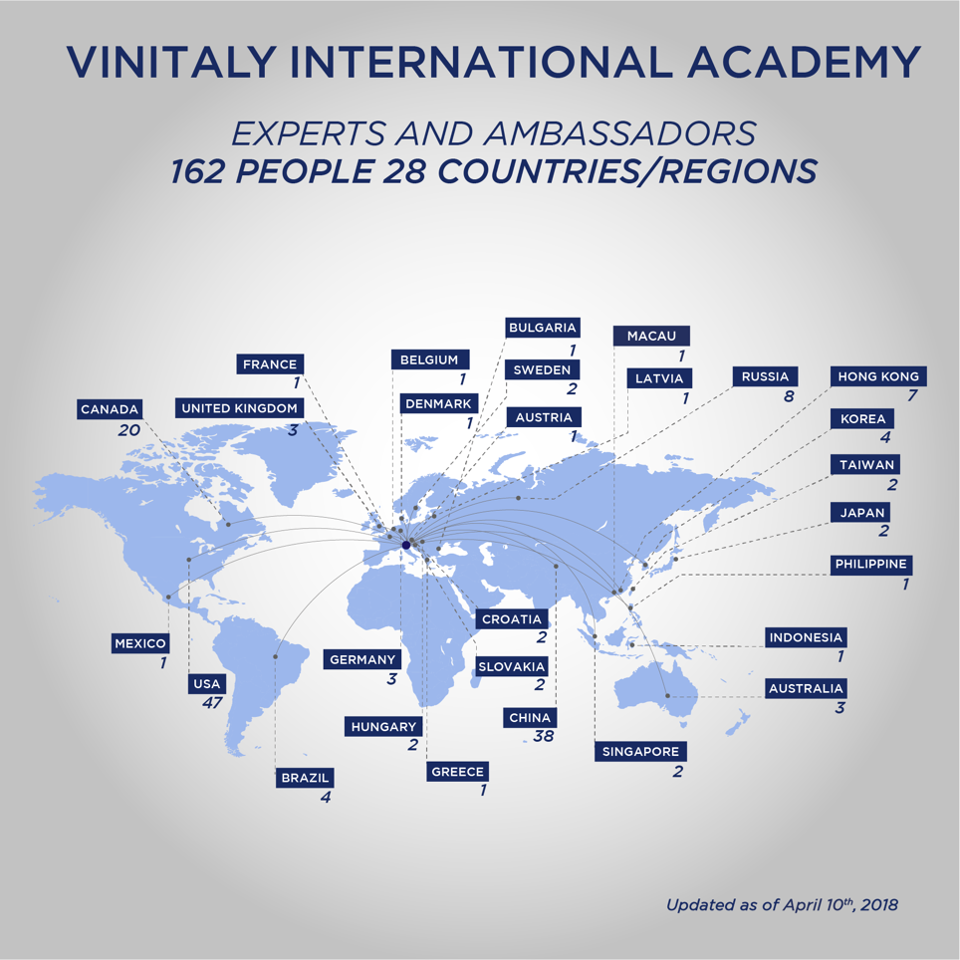
Photograph: Vinitaly International Academy world map of certifies Ambassadors and Experts
The 2018 Verona edition saw 23 new Italian Wine Ambassadors and 2 new Italian Wine Experts entering the Vinitaly International Academy family. Based on the average score of the class, with 2 students scoring 91 and 92 (over 100) for the first time, the outcomes of this last VIA Certification Course were the best so far. This Verona edition represented the perfect opportunity to gain extensive knowledge on the Italian wine world, directly from Italy; scheduled in the lead-up to Vinitaly, the Verona edition gives candidates the chance to fully immerse themselves in Italian wine and the business around it. With the level of the candidates getting higher and higher edition after edition, VIA can now count on the support of 11 Italian Wine Experts and 151 Italian Wine Ambassadors. Sue Tolson, Managing Editor at WineSofa and one of the two newly-proclaimed IWEs commented, “Really great experience! You come here thinking you know quite a lot about Italian wine and Italian grapes and then you realise you know actually nothing. Ian really open your eyes on all the fascinating varieties of the country and gives you really interesting anecdotes to help you remember, so it’s really good fun. I would really recommend it to anybody who would like to know more about Italian wine but I also have to say that…you really need to study for it!”
With 590 wine grape varieties officially recognised (one quarter of the world’s total) and over 500 wine regions, the Italian wine world is, without any doubt, difficult to explore. Even for the Masters of Wine or the Masters Sommelier, the Italian wine scenario can remain some kind of a riddle. Created to fulfil the ever-growing demand for specific knowledge and training on Italian wines, VIA Certification Courses function as the perfect answer for wine professionals interested in learning how to speak of Italian wine in a unified, organised, and thorough manner. Jenna Briscoe, general manager at Café Medina, Vancouver, and one of the 23 new IWAs certified on April 10th, stated that the course just proves how the journey into learning about Italian wine is unending: “You have to be systematic if you intend to just deal with the pure volume of information, with respect to studying, one should start breaking down grape by grape and then drawing the parallels between DOC and regions in Italy.”
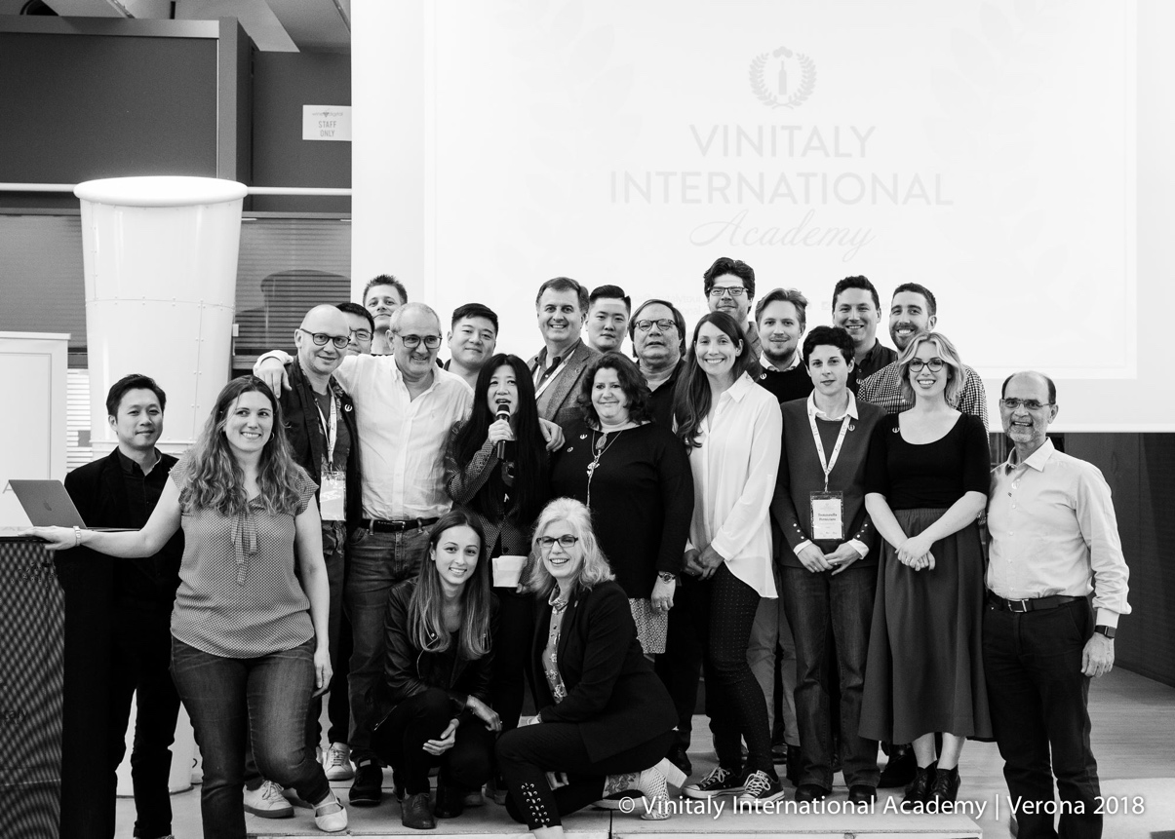
Photograph: Italian Wine Ambassadors and Italian Wine Experts at the 2018 VIA Verona
Under the leadership of its Managing Director Stevie Kim, VIA is an educational initiative aimed at simplifying the vast diversity of Italian grape varietals by explaining, divulging and broadcasting the characteristics of Italian wine around the world. Conducted by Dr. Ian D’Agata (Scientific Director), the VIA Certification Course is a 5-day journey through the vast subject of Italian grape varieties and wines. In the first 4 days, students focus on theory and tastings. On the fifth and last day, they take a challenging written exam to become “Italian Wine Ambassadors”. In order to become “Italian Wine Experts” (the higher certification) participants who score at least 90/100 in the written test also have to take an oral exam consisting of a blind tasting. Held in English, what VIA offers is a touring course with editions in the US, China, Italy and Hong Kong.
The next edition of the Certification Course will be held in Hong Kong, in November 2018. Registrations are open and additional information can be requested at via@vinitalytour.com.

Full list of the 23 newly-certified IWAs and 2 IWEs from the 2018 Verona Edition

Italian Wine Expert:
Marcia J. Hamm, DipWSET, Store Manager at Hicks Fine Wines
Sue Tolson, Wine writer, translator and educator. Managing Editor at WineSofa

Italian Wine Ambassadors:
Stephanie Gut, Sommelier at The French Café
Srdan Lisac, Wine Educator at Biotechnicon
Andrea Eby, Educator/Buyer/Assistant Manager at Banville & Jones Wine Co.
Xiaolei Duan, General Manager at The Wine Story Co Dalian
Julie Garton, Wine Writer
Tommasella Perniciaro, Self-employed at The Good Wine Habit
Matthew Landry, General Manager/Sommelier at Stable House Bistro
Jenna Briscoe, General Manager at Café Medina
Christopher Poon, Senior Consultant, Information Risk Management at Manulife
Erik Klein, Export Manager at Freelancer
Yanhua Yang (Jack), Wine Educator at COFCO W&W International LTD CO
Faye MacLachlan, Regional Sales MGR Grape Brands/Sommelier at Langdon Hall
Fangqian Tang, Export Manager at S.A.R.L Pont Vin
Guido Walter, Owner/CEO at Walter & Soon - Weinhandlungen, Fritz Müller
Pedro Balesteros Torres MW, Master of Wine
Niklas Bergqvist, Wine Educator, Sommelier and Wine Writer at Restaurangakademien, Vinkällaren Grappe
David Furka, Wine Journalist at Vinoport Online Wine Magazine
Samuel Melanson, Wine Educator at The Sommelier Factory
George Caflish, Wine Educator and Attorney at Texas Wine School
Blagoy Kuzmanski, Sommelier at 67 Pall Mall
Bruno Vianna, President at Brazilian Association of Sommeliers - Campinas
Jay Hutchinson, Wine Advisor at Soutirage
Bin Zhang, Commercial Manager at Accenture

About
The grand Vinitaly 2018 will be held from April 15th to the 18th. Every year, Vinitaly counts more than 4,000 exhibitors on a 100,000+ square meter area and 130,000 visitors from over 140 different countries with more than 30,000 top international buyers. The premier event to Vinitaly, OperaWine (https://www.vinitalyinternational.com/?page_id=646) “Finest Italian Wines: 100 Great Producers,” which will be held on the 14th of April, one day prior to Vinitaly will unite international wine professionals in the heart of Verona, offering them the unique opportunity to discover and taste the wines of the 100 Best Italian Producers, as selected by Wine Spectator. Since 1998 Vinitaly International travels to several countries such as Russia, China, USA and Hong Kong thanks to its strategic arm abroad, Vinitaly International. In February 2014 Vinitaly International launched an educational project, the Vinitaly International Academy (VIA) with the aim of divulging and broadcasting the excellence and diversity of Italian wine around the globe. VIA this year launched the third edition of its Certification Course and today counts 151 Italian Wine Ambassadors and 11 Italian Wine Experts.

