Press Release Contacts: For Immediate Release Vinitaly International
International Media Dept.

+39 045 8101447
media@vinitalytour.com
www.vinitalyinternational.com
Twitter: @VinitalyTour
Join Italian Wine Community on LinkedIn

Sweet dreams come true: the “Austrian Sweet Wines” tasting at Vinitaly 2018

On April 15th, Vinitaly International Academy in collaboration with Austrian Wines will host a tasting on Austrian sweet wines. Lead by CEO of the Austrian Wine Marketing Board Willi Klinger, the seminar will be a unique opportunity to explore many renowned Austrian oenological gems.

Austrian sweet wines iare crafted in different styles and with different production techniques. Spätlese and Auslese wines are very fruity and aromatic. They demonstrate finesse with velvety residual sugar and a dynamic balance of fruit and acidity. Beerenauslese, Ausbruch, and Trockenbeerenauslese are all affected by the concentration of botrytised grapes, and showing lightly smoky honey-notes and dried fruit aromas. The noble Ausbruch in particular has a centuries-old tradition and is considered one of the most sophisticated wines in the world. Strohweine and Schilfweine are vinified with grapes that have been dried on straw or reed for months. Eiswein is produced with grapes harvested and pressed while they are still frozen, turning them into wines with expressive, velvety-fruit aromas and flavours.

These and other Austrian sweet treasures will be the protagonists of “Austrian Sweet Wines”. This tasting, together with a number of other tastings of international flair, is organised by the Vinitaly International Academy (VIA), the institution which promotes Italian wine education through its certification courses and various seminars. In the attempt to broaden its scope and to offer Italian wine students a comparative framework from international winemaking traditions, VIA joined forces with Austrian Wines for this unique seminar.

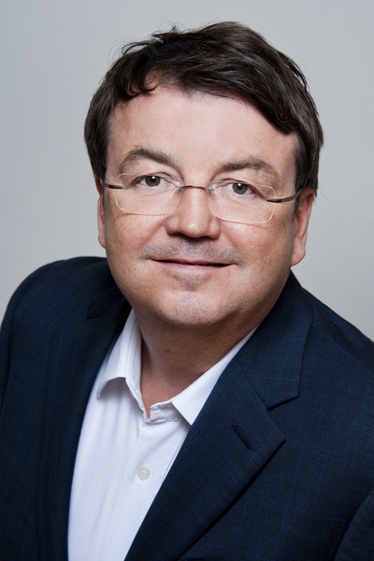
During the tasting, Willi Klinger, CEO of the Austrian Wine Marketing Board (AWMB), will unveil a memorable series of precious samples representing Austria’s best. After having started as Head of Marketing at the renowned wine distributor A. V. Stangl in Salzburg, Klinger played a significant role in the development of the Austrian wine distributor chain Wine & Co. He demonstrated pioneering achievements for Austrian wine at an international level as executive manager of Freie Weingärtner Wachau and later became responsible for more than 50 export markets when working for the Italian cult vintner Angelo Gaja. On the Vinitaly tasting he comments "Austria’s noble sweet wines regularly get the highest ratings in international wine media and are in demand in the Italian gastronomy and an exciting accompaniment for meals. The wines I will present are all oenological treasures often referred to as ‘Austria’s Liquid Gold’.”

Austria is probably not the first country that comes up to mind when thinking about wine, since the western part of the country is covered by mountains. Yet, Austria produces 1% of the global wine production with the wine growing region to be found on the eastern side of “the Alpine Republic”. Best known for its white wine varieties like Gruener Veltliner and the fruity Rieslings, Austria only started producing dry reds and whites in the past two decades. On the other hand, Austrian noble sweet wines have long belonged to the elite of the wine world. With this tasting, Vinitaly International and Veronafiere will shed light on the “sweet bottles” that granted Austria the access among the great wine producers. “Austrian Sweet Wines” is a trip through the wine-growing regions of the country, a fruit-scented journey for dessert lovers and beyond.

Please see additional information below:

https://www.vinitaly.com/it/eventi2018/calendario/wine2digital---palaexpo-ingresso-a2-1-piano/via-IViniDolcidellAustria/

“Austrian Sweet Wines”
Convenor: Willi Klinger (CEO Austrian Wine Marketing Board)
Time: Sunday April 15th, 2018, 14.30 - 16.00
Location: wine2digital
Link: http://bit.do/edi5T

About
The grand Vinitaly 2018 will be held from April 15th to the 18th. Every year, Vinitaly counts more than 4,000 exhibitors on a 100,000+ square meter area and 130,000 visitors from over 140 different countries with more than 30,000 top international buyers. The premier event to Vinitaly, OperaWine (https://www.vinitalyinternational.com/?page_id=646) “Finest Italian Wines: 100 Great Producers,” which will be held on the 14th of April, one day prior to Vinitaly will unite international wine professionals in the heart of Verona, offering them the unique opportunity to discover and taste the wines of the 100 Best Italian Producers, as selected by Wine Spectator. Since 1998 Vinitaly International travels to several countries such as Russia, China, USA and Hong Kong thanks to its strategic arm abroad, Vinitaly International. In February 2014 Vinitaly International launched an educational project, the Vinitaly International Academy (VIA) with the aim of divulging and broadcasting the excellence and diversity of Italian wine around the globe. VIA this year launched the third edition of its Certification Course and today counts 122 Italian Wine Ambassadors and 9 Italian Wine Experts.

