5StarWines proclaimed over 600 international treasures

In the run-up to Vinitaly 2018, over 2700 wines from all over the world participated at the third edition of 5StarWines, Vinitaly International’s annual wine selection. Held April 11th to April 13th in Verona, over 600 wines achieved a score over 90 out of a 100, making it onto the 5StarWines-The Book.

On April 13th, the third edition of 5StarWines came to a close at wine2digital, Verona. Organised by Vinitaly, 5StarWines is a three-day tasting aiming at shedding light on wineries investing in the improvement of their products. During the event, a highly qualified panel of wine professionals tastes and gives score on a 100-point scale to more than 2.700 wines.

Under the guidance of Vinitaly International Managing Director Stevie Kim and Vinitaly International Academy Scientific Director Ian D’Agata, the international team of judges is led by 3 General Chairmen: Bernard Burtschy, president of the French Wine Press; Robert Joseph, Editor at Large for Meininger's Wine Business International; and Spanish Master of Wine Pedro Ballesteros Torres. Main task of the Chairmen is to re-taste wines with an initial score of 90, that is the score a wine needs to be published on 5StarWines-The Book. On the selection he chaired for two years in a row, Joseph commented “There are new producers, new regions, and new grapes every year. I just love being here, discovering all these flavours, and then go on to Vinitaly to meet the actual people that produced them and understand why and how they are making these wines.” Ballesteros Torres, who finds 5StarWines enriching from a personal point of view, added “I think it is a great opportunity for the Italian wines participating. 5StarWines is a major tool for Italian producers because they will have the chance to have a feedback from top level experts from all over the world. Another quality of the event is that while tasting, judges get the chance talk with each other, creating an environment of exchange and growth.”

5StarWines-The Book is a wine-guide including all the wines selected at 5StarWines that aims at giving visibility to worthy wineries. A special feature of the guide (and of the event) is Wine Without Walls, a section solely dedicated to wines either without added sulphites or wines with total quantity of sulphites (naturally produced and added ones) not higher than 50mg/l. Chaired by biodynamic wine expert Monty Waldin, Wine Without Walls gives recognition to the growing importance and relevance of natural wines. In the case of Wine Without Walls, the tasting’s assessment criteria are not numerical but rather descriptive like liveliness, individuality, sense of place, etc. Regine Lee, Head of Customer Business Support at Liberty Wines and one of the judges of the Wine Without Walls section observed “WWW is a really interesting opportunity for us to valuate a lot of natural wines through quantitative and qualitative assessments that really look at whether the wine is of quality or not. US judges are able to look across wide diversity styles, mostly Italians, and I think it’s a really nice way to understand what makes natural wines particularly good and whether they can be judged in themselves or across wines as a whole.”
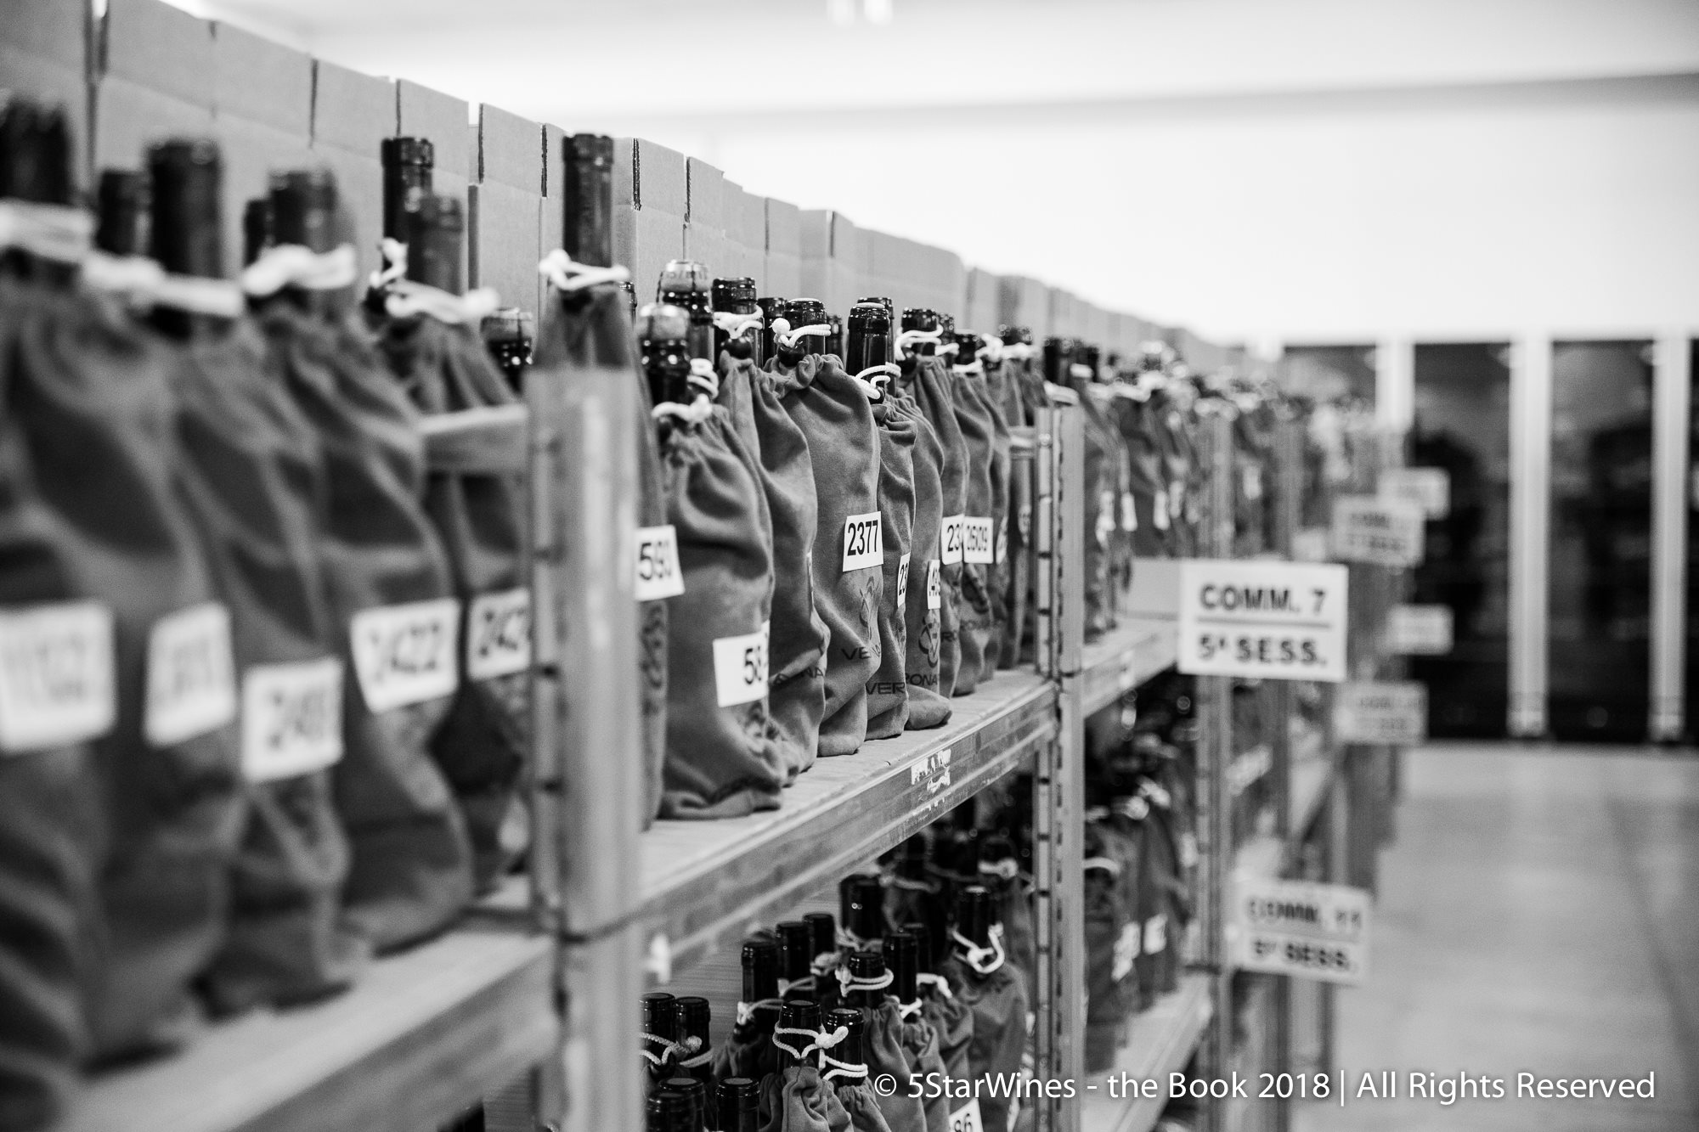

Coming from all over Italy, California, Argentina and other countries, the wines participating at this edition of 5StarWines were around 2700, 500 more than last year’s. Out of these 2700, more than 600 scored more than 90 out of 100 and therefore will make it on The Book.
For the second year in a row Italy stood out as one of the best producers at the selection, with Cantine del Notaio Soc.Agr. A R.L. taking home the “Best Winery of the Year - Gran Vinitaly 2018”. Worth a mention is the fact that this year, the selected 5 star wines will also be indicated as 5StarWines on Wine-Searcher’s online listings, one of the most famous web search engines for wine. Moreover, The 5StarWines label will also feature on the Vinitaly App during and after Vinitaly ,for all buyers and trade.
You can see the complete list of wines on http://www.5starwines.it/

About
The grand Vinitaly 2018 will be held from April 15th to the 18th. Every year, Vinitaly counts more than 4,000 exhibitors on a 100,000+ square meter area and 130,000 visitors from over 140 different countries with more than 30,000 top international buyers. The premier event to Vinitaly, OperaWine (https://www.vinitalyinternational.com/?page_id=646) “Finest Italian Wines: 100 Great Producers,” which will be held on the 14th of April, one day prior to Vinitaly will unite international wine professionals in the heart of Verona, offering them the unique opportunity to discover and taste the wines of the 100 Best Italian Producers, as selected by Wine Spectator. Since 1998 Vinitaly International travels to several countries such as Russia, China, USA and Hong Kong thanks to its strategic arm abroad, Vinitaly International. In February 2014 Vinitaly International launched an educational project, the Vinitaly International Academy (VIA) with the aim of divulging and broadcasting the excellence and diversity of Italian wine around the globe. VIA this year launched the third edition of its Certification Course and today counts 122 Italian Wine Ambassadors and 9 Italian Wine Experts.

