Press Release Contacts: For Immediate Release Vinitaly International
International Media Dept.

+39 045 8101447
media@vinitalytour.com
www.vinitalyinternational.com
Twitter: @VinitalyTour
Join Italian Wine Community on LinkedIn

Verona, 19 April 2018
Wine Spectator's Iconic Copertine: Italy 1978-2018

On Saturday April 14th, 2018, 107 Italian wine producers gathered in Verona for “OperaWine, Finest Italian Wines: 100 Great Producers” to celebrate the quality and diversity of Italian wine along with its enduring bond with the United States, the largest market for Italian wines. Organised by Veronafiere and Vinitaly International in partnership with Wine Spectator, since 2012 OperaWine has been the opening act of Vinitaly as well as a showcase of the finest Italian wineries selected by the prestigious American publication.
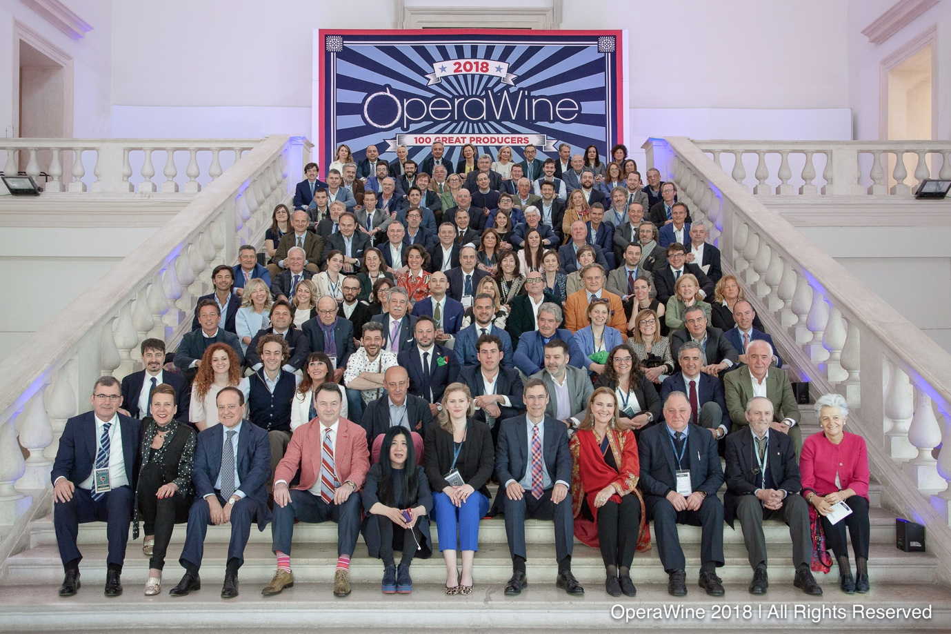
During the press conference preceding the Grand Tasting, Wine Spectator’s Senior Editors Bruce Sanderson and Alison Napjus introduced a retrospective of the magazine’s coverage on Italian wine through its iconic covers. The covers spanned four decades, from 1978 to 2018. In 1978, the magazine paid homage to Italy with a cover story on the Chianti region. Fast-forward forty years, Wine Spectator’s cover for its latest issue (dated April 30th) features a photograph of Sassicaia producers Nicolò Incisa della Rocchetta and his daughter Priscilla. As Napjus comments, “We’ve seen a lot of changes in our Italian coverage since 1978; no doubt we’ll continue to see changes to Italy’s wines over time. One thing we do know for certain: Italian wine producers are talented, dedicated, and passionate. They respect tradition show concern for the environment, adopt innovations and never cease their efforts to improve their wine. We are very excited to be a witness to this ongoing evolution.”
Founded in 1976 in San Diego, Wine Spectator is the most read wine magazine in the world. With wine always at the center of attention, the publication has also grown to become a lifestyle guide for wine lovers. At the heart of the magazine are its critical reviews. Today, Wine Spectator reviews nearly 20,000 wines each year, all in blind tastings. Through these blind ratings the magazine selects the wineries that participate to OperaWine. The selection process has two goals: first, to testify to the extraordinary quality of Italian wines; second, to showcase the breadth of Italy’s wine regions, grapes, and styles. The editors’ main criteria are wine quality, regional leadership, and historical significance.
This year, OperaWine welcomed more than 2,000 guests from all over the world that enjoyed an afternoon of tasting in Verona’s historic Palazzo Gran Guardia. The tasting included producers representing all 20 Italian regions, bringing more than 60 Italian native grape varieties together in one single room. Along with several regulars, 13 new wineries made it through the selection for the first time. As Senior Editor Bruce Sanderson explained, “since the first edition of OperaWine in 2012, 170 different producers and wines have been selected.” The changing selection of producers demonstrates Wine Spectator’s commitment to keep the event fresh and reflects the vitality of the Italian wine industry.
On making it into the list for the first time, Fausto Maculan, owner of Maculan in Veneto, commented on his long-lasting acquaintance with Wine Spectator’s editor and publisher Marvin Schenken and on the winery’s participation to the magazine’s famous wine events in New York: “Having known Marvin Schenken for at least 25 years, and having participated to many New York Wine Experience events, I know the magazine very well and I can only be immensely and truly honoured to be here. The wine we presented at OperaWine is Acininobili, a sweet wine we produce with the Vespaiola grapes. To make it, we select only the grapes that have been affected by the Botrytis cinerea fungus. The result is this extraordinary, rich, elegant, exquisite, and unique wine!” On being one of the new entries too, Michele Faro, owner of the Pietradolce winery in Sicily, added: “For us it is a great responsibility to represent the Etna area. Our region is in fashion right now and is getting a lot of attention from the global market and also for the American market. At OperaWine 2018 we presented Vigna Barbagalli Etna Rosso, the cru we produce from our 100-year-old vines. This is a vineyard with a very low yield (only 1/1.5 kg for each plant) that, I must say, we cultivate more because of passion, than because of money. The US plays a major role in our exports and is always very keen to discover more about how wine is made around the world.”
An exclusive event dedicated to foreign press and professionals, OperaWine’s 2018 theme celebrated Italian wine’s strongest ally on the international markets, the United States. In addition to OperaWine’s American partner Wine Spectator, one of the special guests to the event was the Senior Director of Winemaking at E. & J. Gallo Winery, Gina Gallo, who spoke during the Press Conference and whose wines were served during OperaWine’s light lunch.

For the OperaWine 2018 catalogue see: https://www.vinitalyinternational.com/?page_id=1356&lang=it

Photographs from the press conference are available at the following link:
http://www.operawine.it/

About
The grand Vinitaly 2019 will be held from April 7th to the 10th. Every year, Vinitaly counts more than 4,000 exhibitors on a 100,000+ square meter area and 130,000 visitors from over 140 different countries with more than 30,000 top international buyers. The premier event to Vinitaly, OperaWine (https://www.vinitalyinternational.com/?page_id=646) “Finest Italian Wines: 100 Great Producers,” which will be held on the 6th of April, one day prior to Vinitaly will unite international wine professionals in the heart of Verona, offering them the unique opportunity to discover and taste the wines of the 100 Best Italian Producers, as selected by Wine Spectator. Since 1998 Vinitaly International travels to several countries such as Russia, China, USA and Hong Kong thanks to its strategic arm abroad, Vinitaly International. In February 2014 Vinitaly International launched an educational project, the Vinitaly International Academy (VIA) with the aim of divulging and broadcasting the excellence and diversity of Italian wine around the globe. VIA this year launched the seventh edition of its Certification Course and today counts 151 Italian Wine Ambassadors and 11 Italian Wine Experts.

