A Foodie’s Exploration of Chile
4 D / 3 N

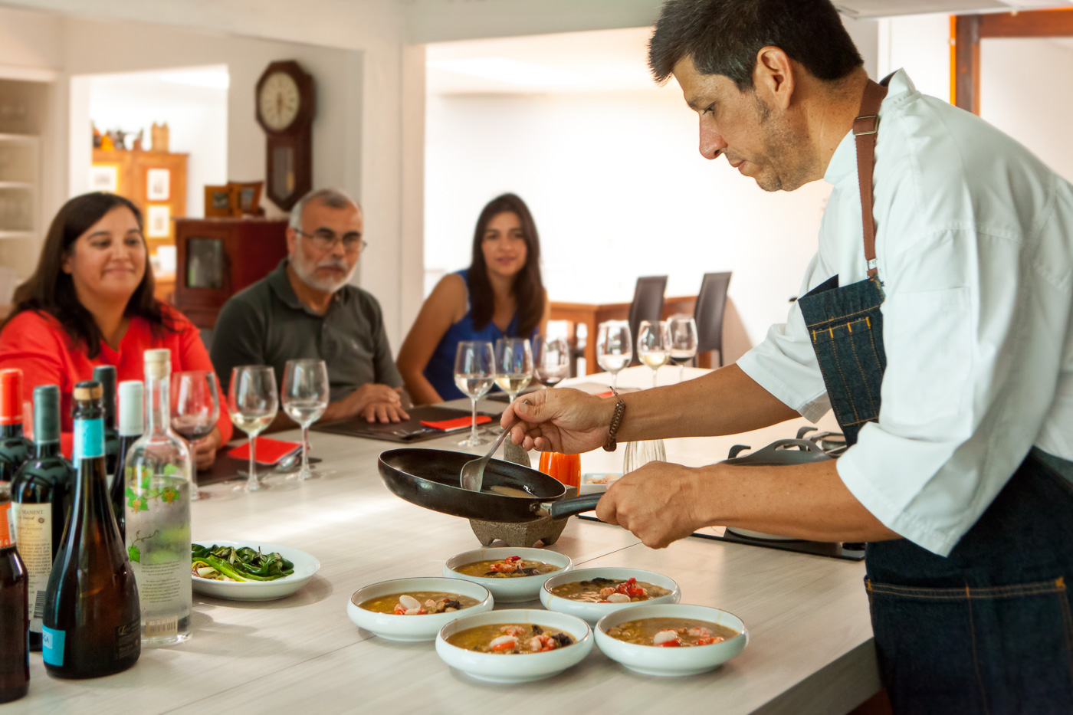

WHEN
TO GO

Year-round
OVERNIGHT

Luciano K
WHERE

Santiago
Casablanca Valley

START / END

Santiago / Santiago

DAY-BY-DAY HIGHLIGHTS
Day 1 | Transfer-in / Discover Santiago + Vinomio wine bar / Motemei Dinner
Day 2 | Half Day Santiago Markets experience / MOVI Wine Pairing Dinner
Day 3 | Full Day Casablanca Valley winery visits / Dinner at Boragó Restaurant
Day 4 | Transfer-out to Santiago airport

TRIP DESCRIPTION
DAY 1
Upon arrival to the Santiago (SCL) airport you will be transferred to your hotel (approx. 30-minute drive). After checking in, your bilingual guide will lead you on a tour highlighting Santiago’s most important historical sites, including the downtown area surrounding the Plaza de Armas and the La Moneda Presidential Palace.

You will visit some of the lesser-known barrios of Santiago including República and Concha y Toro, which were historically privileged neighborhoods and home to Santiago's high society. There will be time to walk around and take photos of the varied styles of architecture dating back to the 19th and early 20th century. Continuing through the cobblestoned Lastarria neighborhood, you will walk through the Parque Forestal and pass by the Bellas Artes Museum. For a panoramic vista of the city, you will visit the top of Cerro San Cristobal Hill, 984 feet above the city.

During the tour, you will have the option to visit one of Santiago’s most famous museums, La Chascona, former home to beloved poet and Nobel Laureate Pablo Neruda. The whimsical residence provides a snapshot into the life and mind of Neruda, filled with art, eccentric collections, and even his Nobel Prize.

You will finish up the tour with a wine tasting at Vinomio. This store, new for 2016, is dedicated to introducing the consumer to small-batch, independent and other hard-to-find Chilean wines. It’s situated in the heart of Santiago, in Barrio Bellavista. Tasting options focus on different geographic regions such as coast to mountain, with a wine each from the coastal, midland and pre-Andean zones. The selected wines are paired with local, small-production cheeses and charcuterie, in the pleasant back patio of the store.

The day does not end here. Step into the food studio of Chilean Chef Patricio Cáceres, Motemei, where he will host you for an unforgettable dining experience. The name, Motemei, is a double reference to the word “mote de maíz,” or “corn of wheat,” which is a sweet drink prepared with corn, peach nectar and dried and cooked peaches, and is also name for a renowned former restaurant in Santa Cruz, Chile. At Motemei, conversation is as integral a part of the experience as the food and wine.

The seven-course tasting menu prepared from scratch in front of you draws on old Chilean recipes and emblematic ingredients but plays with modern flavors and techniques and benefits from the added touch of Cáceres’ own creative presentation.

Sit back and relax as the meal unfolds before you, narrated by the chef himself, one multilayered morsel at a time.

Meals: Late afternoon wine tasting, dinner
Accommodation: Luciano K

DAY 2
Departing from the hotel, you will drive to the downtown center and the iconic Plaza de Armas. Here, you will learn a bit of the history of the founding of the Republic of Chile as well as discuss how the Spanish colonial past continues to influence Chilean cuisine today.

Continuing through the Plaza, you will walk the short distance to La Vega Market, Santiago’s largest and most vibrant produce market. A combination of four markets, La Vega Central has been the largest market in the center of Santiago for over 200 years. Local families shop for their meals alongside buyers from Santiago’s top restaurants. Your guide will take you by a food cart for a simple but tasty sopaipilla and then on to an eatery that dishes out fresh home-cooked meals daily for a sampling of different Chilean classics rarely found at brick-and-mortar restaurants.

Following your sampling, what better time to try one of Chile’s most typical drinks! You’ll taste a homemade “cola de mono” (monkey’s tail), a creamy drink usually served around the holidays, or a “terremoto” (earthquake), made with pineapple ice cream and an artisan white wine called pipeño.

You’ll head out of the market on foot and cross the Mapocho River to enter the Mercado Central, Santiago’s famous seafood market, where you will witness the bounty of the Chilean seas. Mercado Central was ranked the fifth best market in the world by National Geographic in 2012. Of course, the experience will not be complete until you sample a fresh seafood empanada (alternatives available upon request) paired with a crisp Sauvignon Blanc from Chile’s San Antonio Valley.

And let’s not forget the most important course in the Chilean meal, “el postre.” Chileans are experts when it comes to dessert, and the sheer quantity of diverse cakes and tarts makes it impossible to try them all. You will sample either some artisanal ice cream or another dessert spread accompanied by coffee, tea, or herbal water.

After the market tour, you will be driven back to your hotel to have time to freshen up for a one-of-a-kind tasting and pairing evening guided by a representative of MOVI, (Movimiento de Viñedos Independientes). MOVI, which groups together some of the best independent winemakers in the country, was originally founded to carve out a space for themselves in the Chilean wine economy, where buying batches of less than 10,000 of anything (corks, bottles, etc) used to be impossible. What they founded was a fellowship of disparate, but like-minded projects, with the goal of creating meaningful vintages on a personal scale. MOVI has as an unofficial rule that it’s the winemakers themselves that represent their wines, not brand managers or marketing people.

The meal with wine pairing we have planned for you is guided by one of the winemakers, Toronto-born Derek Mossman. He is one of the spokesmen and original twelve members of MOVI, and makes his own label, Garage Wine Co. The group has now grown to 28 members, each of them contributing diversity and unique personality, as well as anywhere from one to a dozen high-quality wines to the MOVI offer. Those include new wines made from old stock of former table-wine grapes, like Uva País, and wines made in a traditional Chilean style, but on a more human scale. “How much can you personally manage?” he says, is one good question for winemakers to ask before seeking out MOVI membership.

What Derek most wants you to know about the Upscape meal and wine paring with MOVI, is that it isn’t. “We go with a quiver of possibilities and we open things, based upon tastes,” he says. What he means by that is that he will carefully select a set of wines that he thinks goes well with the meal at hand, but he will never dictate to you which wine goes with which dish. You can repeat wines, go back to wines sipped earlier in the meal. Some of the dishes themselves may have unconventional combinations, which Derek sees as a plus, because you have no preconceived notions about what pairs and what doesn’t. This night, he says, “is a blank canvas.” As such, each guest has his or her own opinion or opinions about which wines combine with which foods. Expect to have a selection of stemware at your place setting as you participate in building your own personal pairing, with Derek’s skillful guidance.

Meals: breakfast, tastings at local markets and shops, dinner
Accommodation: Luciano K

DAY 3
Chile’s move toward cool-climate viticulture began 25 years ago when innovative winemakers dared to suggest planting in this pre-coastal region. Chardonnay continues to reign, but Sauvignon Blanc and Pinot Noir – two of Chile’s most attention-grabbing varietals – are on the rise. Now with time and experience under their belts, growers have better identified the ideal locations for each variety in this valley that is anything but homogenous.

This morning, your guide will meet you at your hotel to head for the renowned Casablanca Valley. Your first visit will be to La Recova, a small, boutique vineyard tucked away in a remote part of the Casablanca Valley sitting just 11 meters from the coast with extremely cold nights; hence, Casablanca Valley’s cool-climate viticulture. La Recova specializes in making wine from a single varietal: Sauvignon Blanc, and their vines are planted on the slopes of the surrounding hills. This, combined with valley’s poor, granitic soil, produces a citrusy-white fruit wine with strong mineral notes and has a nice balance of acidity, minerality and volume – truly showcasing Casablanca’s unique terroir. Enjoy a tour and tasting here.

Afterwards, we will head to Villard Wines, one of the Casablanca Valley’s premium boutique wineries for a tour, tasting and lunch. The winery was founded in 1989 by Thierry Villard, and is still run by this French-Chilean family, which prides itself on making traditional, elegant wines.

Return to your hotel in Santiago in time to freshen up for this evening’s dinner at Boragó. Boragó nurtures an innovative culinary concept combining 100% local ingredients, European cooking techniques, and a dedicated philosophy focused on provoking and awakening the senses. Chef Rodolfo Guzman prepares a nine-course menu of food and wine pairings which feature native ingredients and traditions of cooking on hot stones and smoking with native woods. In 2015, 2016 and 2017, Boragó was rated one of the World’s 50 Best Restaurants and was rated Number Four out of Latin America’s 50 Best Restaurants in 2016. An experience at Boragó is absolutely unique and sure to be unforgettable.

Meals: breakfast, lunch, dinner
Accommodation: Luciano K

DAY 4
After breakfast, you will be transferred from your hotel to the Santiago (SCL) airport in time for your flight home.

Meals: breakfast
ACCOMMODATIONS

Luciano K – 3 nights
Luciano K is a small, boutique hotel located in the heart of the eclectic Lastarria neighborhood, known for its gastronomic scene and cultural activities and events. The hotel was originally designed by the architect Luciano Kulczewski in the 1920’s and was not only the tallest building in Chile at that time, but was also the first building complete with an elevator and central heating. The glamour and elegance of the 1920’s really shines through in Luciano’s architecture and design. Additionally, the hotel has a bar, restaurant, heated swimming pool on top of a roof top terrace covering 300 meters; providing incredible views of the city.

What’s included in our pricing:
- All ground transportation
- Professional, bilingual guide
- All overnight accommodations
- Meals as listed in trip description
- All experiences listed in trip description

What’s additional:
- International and domestic flights
- Travel insurance
- Tips for drivers and guides

Of note:
- Please notify us in advance of any dietary preferences or restrictions!
- The Culinary market tour includes a mix of walking and driving. Please be sure to wear comfortable shoes and be prepared to walk the equivalent of walking 8-9 city blocks.
- The Culinary market tour is a great way to experience firsthand an interesting part of Chilean culture. However, please keep in mind that the markets are quite crowded and, at times, hectic with lots of activity happening simultaneously. For this reason, it is very important that you remain vigilant and avoid bringing items of value (expensive cameras, watches, jewelry, etc.) which could make you a target for petty theft.

