Rompower: The latest technologies in power conversion reduces the size of the 65 W laptop adapter to the size of an AC power plug

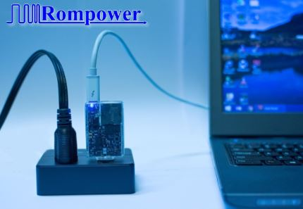

April 24, 2018 10:00 AM Eastern Daylight Time
Tucson, AZ. The ac/dc adapter technology has evolved over the last years and presently the technologies developed by Rompower Energy Systems Inc., increase the efficiency from 88% to 94%, the highest in its class. This increase in efficiency decreases the power dissipation by more than 50% making the adapter to run much cooler. Lower heat dissipation allowed Rompower engineers to reduce the size of a 65W laptop adapter to a tiny volume of 2.3 inc³ (38.5cm³) comparable with the AC power plug, while eliminating the bulky AC cable.
“We always push ourselves to be at the forefront of power conversion technology “says Ionel “Dan” Jitaru the founder and CEO of Rompower Energy Systems Inc.
This outstanding achievement was made possible by the use of intelligent power processing facilitated by Infineon XDP™ digital power controller together with Rompower innovation in topology and magnetics.
The technologies implemented in this adapter are based on Rompower latest intellectual properties and the “know how” going back for 25 years when Rompower was founded. For application such as power adapters the simplicity and low cost is essential. Rompower design utilizes low cost silicon devices and a reduced number of components, also enabled due to the high level of integration offered by Infineon’ XDP™ digital power controller.
In Rompower’ proprietary technologies the energy from the parasitic elements is harvested and not dissipated as is currently done in conventional technologies.
“Rompower`s adapter is an excellent combination of digital control, superjunction switches, topology and magnetics leading to unprecedented efficiency levels. It also meets cost points for high volume consumer applications“ says Dr. Christian Burrer, Head of Product Segment AC/DC and Lighting ICs at Infineon Technologies. Infineon XDP™ digital power controllers were introduced in 2015. With more than 60 million units shipped so far, this technology is today widely established in consumer and lighting applications.
Rompower Energy Systems Inc. is an internationally recognized research and development company in the field of power conversion. The primary goal of this engineering firm is to develop new technologies designed to meet the needs of the power conversion industry.
Infineon Technologies AG is a world leader in semiconductor solutions that make life easier, safer and greener. Microelectronics from Infineon is the key to a better future. In the 2017 fiscal year (ending September 30), the company reported sales of about 7.1 billion euros with some 37,500 employees worldwide. Infineon is listed on the Frankfurt Stock Exchange (ticker symbol: IFX) and in the USA on the over-the-counter market OTCQX International Premier (ticker symbol: IFNNY).
Contacts
Rompower Energy Systems
Daniel Murariu
Product Manager
+40721224735
daniel.murariu@rompower.com

