Press Release
For Immediate Release
Vinitaly International
International Media Dept.

+39 045 8101447
media@vinitalytour.com
www.vinitalyinternational.com
Twitter: @VinitalyTour
Join Italian Wine Community on LinkedIn

Verona, 23 April 2018
Canada bound: for the first time six Canadian trade monopolies met Italian producers at Vinitaly

Canada is the sixth biggest wine importer in the world and 14% of its wine imports come from Italy. During Vinitaly 2018, the seminar “Destination Canada: Opportunities for Italian Wine. A meet-up with the Canadian trade monopolies” illustrated current trends and the interests of the Canadian market in Italian wine.
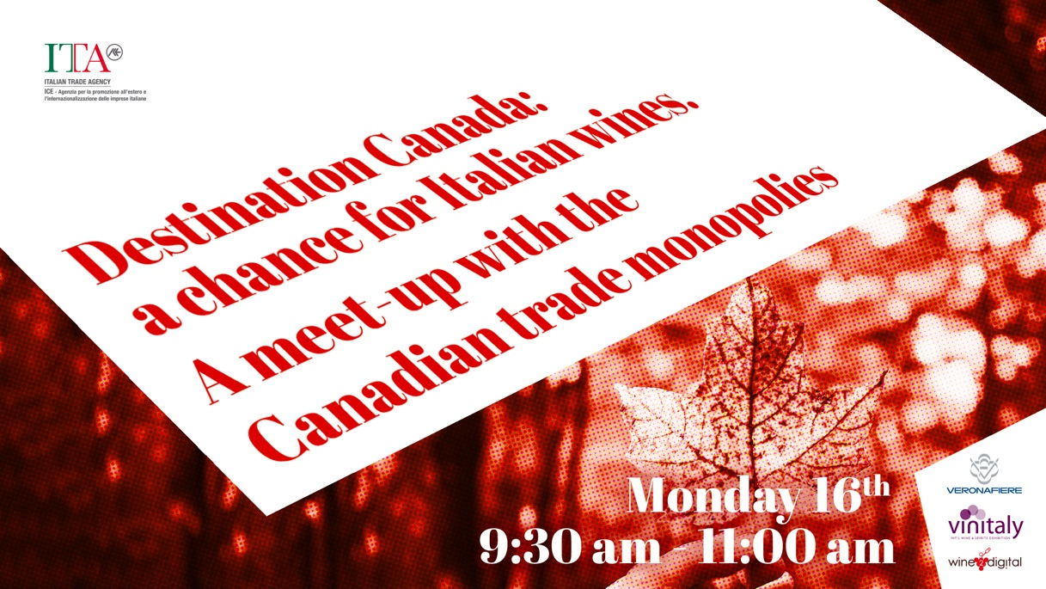

Canada extends more than 7,821 km, from the Atlantic Ocean to the Pacific Ocean. Despite its harsh winters, Canada has made a name for itself in the wine industry. In Canada numerous microclimates produced by mountain ranges and bodies of water provided some of the world’s best areas for growing grapes. The most recognised areas for producing wines in Canada are the Niagara Peninsula in Southern Ontario and the Okanagan Valley of British Columbia. Canadians love their wines, yet they mostly prefer foreign brands. In 2017, Canadians drank 467 millions litres of wine, marking a 1.2% growth from the previous year. Of these 467 millions, 30% was locally produced, 14% was imported from Italy and 13% from the US.
Canada is one of the major consumers of imported wines. Research conducted by Euromonitor International stated that, in the next 5 years, wine sales in Canada will register a 2.9% growth in volume and a 3.8% growth in value. While sparkling wines will register the higher growth, white wines sales will continue to grow faster than red wines’. Even if in the last few years Canadians started to approach producers from other markets such as Chile and New Zealand, Italy and France are still the Canada’s favorite. In 2017, Italy exported 80 millions litres of wine to Canada (+9% from the previous year). Italy is the first supplier for volume and second only to France for value.
The relationship between Canada and Italy was the focus of the seminar “Destination Canada: Opportunities for Italian Wine. A meet-up with the Canadian trade monopolies” organized by Vinitaly International and the Italian Trade Agency (ICE). Managing Director of Vinitaly International Stevie Kim and ITA-ICE representatives Anna Flavia Pascarelli and Matteo Picariello welcomed delegates from 6 Canadian Liquor Boards on their very first trip to Vinitaly in Verona on on Monday April 16th. The Canadian delegation visited the exhibition and met Italian producers. Moreover, during the meeting at wine2digital, speakers introduced new programs for the promotion and purchase of Italian wines that are part of the new ITA-ICE support campaign for the wine sector.
In Canada the sale of alcoholic beverages is controlled by the Liquor Control Boards. These provincial boards manage every aspect related to import, distribution, and retail. These alcohol monopolies are completely independent, with their procedures varying from one province to the other. Each of the Canadian provinces has its own liquor board. Anna Flavia Pascarelli, Manager for the Food Department at ITA-ICE, explained the usefulness of the seminar: “It was the perfect occasion for representatives of the Liquor Boards to present current market trends as well as the interest that Canadian provinces have in made-in-Italy products.”

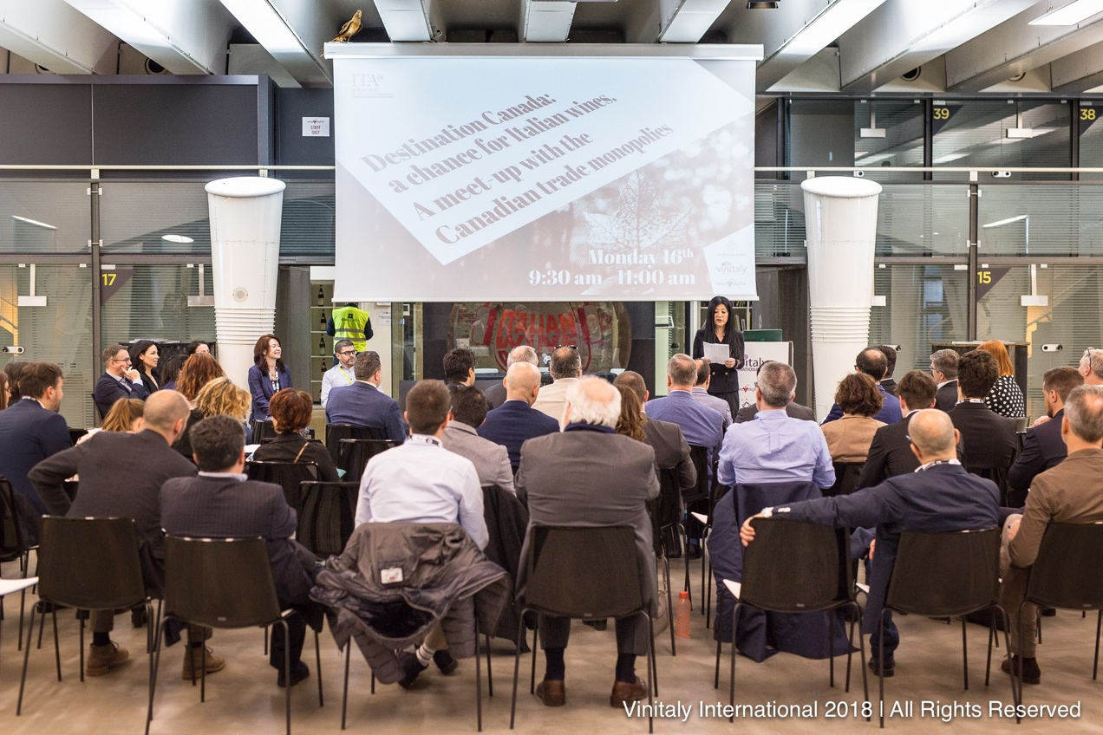

On the opportunities for Italian wines in Canada, George Soleas from the Liquor Control Board of Ontario (LCBO) commented: “Italian wines in Ontario are doing great, the market is surely opening up. We are now issuing 450 licenses to stores that will be able to sell more Italian wines. Overall, Italian wines and Italian suppliers are doing very well in Ontario and we are very happy to have them as part of the selection of wines that we have at the LCBO. At LCBO we import wines and spirits from 84 different countries and Italy is right at the top.” Moreover, on the trends of Italian wine in Canada, Barbara Philip (MW) from the British Columbia Liquor Distribution Branch (BCLDB), added “I think there are many trends but at the fore front are classic wines and indigenous white grape varieties. On top of knowing the trends, to export to Canada it is important for a producers to have an agent importer who really understands the market. Sometimes that means having 2 or 3 agents within Canada.”
On the importance of this first-time gathering Stevie Kim also comments: “This seminar would have been a dream session for wine2wine, the wine business forum which gathers professionals at the end of the year when producers have more time on their hands. During Vinitaly producers are busier selling their wines and rightly so. However, we did not want them to miss out on this exceptional opportunity, since it was the very first time that the delegation travelled to Vinitaly. So we live-streamed the event and made their slides available online. I would like to thank the Canadian delegates for allowing us to share their helpful presentations.” “Destination Canada: Opportunities for Italian Wine” was a unique opportunity for Italy, one of the major wine producers, and Canada, one of the major wine consumers, to meet, discuss, and improve their commercial relationship.

List of spokespersons and links to presentation slides:

Anna Flavia Pascarelli, Manager, Food Department, Italian Trade Agency (ICE)
Matteo Picariello, Trade Commissioner, Italian Trade Agnecy (ICE) – Canada

Liquor Control Board of Ontario (LCBO):
Julie-Ann McNeilly, George Soleas, Bobby Panchu,
Slides: https://www.slideshare.net/VinitalyInternational/lcbo-vinitaly-2018

Manitoba Liquor & Lotteries (MBLL):
Brad Fulham
Slides: https://www.slideshare.net/VinitalyInternational/manitoba-liquor-lotteries-presentation-vinitaly-2018

Société des alcools du Québec (SAQ):
Stéphane Le Coënt
Slides: https://www.slideshare.net/VinitalyInternational/saq-market-and-category-perspectives-vinitaly-2018

British Columbia Liquor Distribution Branch (BCLDB):
Barbara Philip
Slides: https://www.slideshare.net/VinitalyInternational/barbara-philips-mw-british-columbia-wine-market-vinitaly-2018

Nova Scotia Liquor Corporation (NSLC)
Glenda Williams, Sue Oland.
Slides: https://www.slideshare.net/VinitalyInternational/the-nova-scotia-liquor-commission-presentation-vinitaly-2018

New Brunswick Liquor Corporation (ANBL):
Leah Anderson, Angela Pyne, Paul Henderson.
Slides: https://www.slideshare.net/VinitalyInternational/anbl-vinitaly-2018

Link to the Facebook live-streaming: https://www.facebook.com/vinitalyinternational/videos/1669025599848516/

About
The grand Vinitaly 2019 will be held from April 7th to the 10th. Every year, Vinitaly counts more than 4,000 exhibitors on a 100,000+ square meter area and 130,000 visitors from over 140 different countries with more than 30,000 top international buyers. The premier event to Vinitaly, OperaWine (https://www.vinitalyinternational.com/?page_id=646) “Finest Italian Wines: 100 Great Producers,” which will be held on the 6th of April, one day prior to Vinitaly will unite international wine professionals in the heart of Verona, offering them the unique opportunity to discover and taste the wines of the 100 Best Italian Producers, as selected by Wine Spectator. Since 1998 Vinitaly International travels to several countries such as Russia, China, USA and Hong Kong thanks to its strategic arm abroad, Vinitaly International. In February 2014 Vinitaly International launched an educational project, the Vinitaly International Academy (VIA) with the aim of divulging and broadcasting the excellence and diversity of Italian wine around the globe. VIA this year launched the seventh edition of its Certification Course and today counts 151 Italian Wine Ambassadors and 11 Italian Wine Experts.

