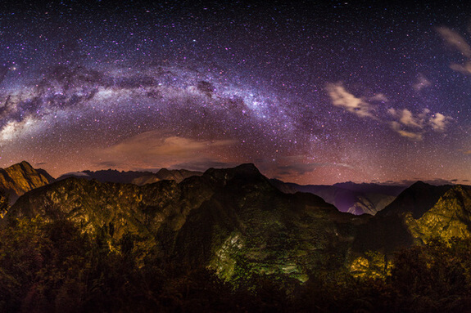

FOR IMMEDIATE RELEASE
Alpaca Expeditions
CONTACT: Nancy Harrison
TEL: 307.421.4473
EMAIL: nharrison@adventuremedianews.com
WEB: www.alpacaexpeditions.com

Machu Picchu and the Southern Skies
Navigate the skies with Alpaca Expeditions
Cusco, Peru - Hiking the Inca Trail to Machu Picchu is on the life list for many people. This 45km/26-mile trail that leads to Machu Picchu is on the list of the 7 Wonders of the World and is one of the most popular hikes in the world. For those who book with Alpaca Expeditions on one of their Alternative Treks, Alpaca has now added Telescopes to campsites. See how the Peruvian skies differ from the sky at home. Learn about the constellations and why the Incas relied on them so much for weather and farming conditions.
For those coming from the northern hemisphere, this will be especially interesting. With the South Pole facing the galactic center of the Milky Way, the southern skies provide a much brighter white stripe of the Milky Way – and the majestic Large and Small Magellanic Clouds (the Milky Way’s satellite galaxies). A northern observer will see things topsy-turvy when looking at the southern skies – familiar constellations seem upside down – but getting a glimpse of Crux, the Southern Cross, which is the smallest and the most famous constellation in the southern hemisphere is a thrill that reminds you how dependent travelers were on the stars to navigate their way across the world.
For the Incas, “Mayu,” (the Milky Way) was a life-giving river in the heavens with its earthly counterpart – the Urubamba River in the Sacred Valley, high up in the Andes Mountains. The Incas grouped constellations into two different types – luminous and dark. The reason the Incas revered the skies and celestial events was two-fold. First, their observations of stars, of constellations (dark and stellar), and of the movements of the sun and moon, provided them with units of time, and a calendar system which helped them plan agricultural and herding activities.
Second, although the Incas worshipped dark constellations, they thought of themselves as descendants of the sun god – Inti. The Festival of the Sun “Inti Raymi “is still celebrated in indigenous cultures throughout the Andes. “Inti Raymi” was celebrated by the Incas on the shortest day of the year during the winter solstice and was the most important event in their lives.
Alpaca Expeditions is a leader in all tours in Peru and treks to Machu Picchu. They are 100% Peruvian, all growing up in villages around the city with tales of the greatness of the Incas. While they focus on the care and quality of their tours, their commitment to their own community is unparalleled. They are also dedicated to the planet and leave no footprint on tours and provide extra support to help clean the trails on every trek. They are excited to show guests their homeland and know guests will fall in love with it too!
Alpaca Expeditions is the highest rated operator in Peru offering treks to Machu Picchu. Their services to guests include everything from applying for permits, guiding groups on all trails, providing for all needs along the way.

About Alpaca Expeditions
Alpaca Expeditions, 100 % Peruvian company, is a pioneer adventure operator diligently working to provide the best services in available. Although they offer daily departures, it’s important to check with a member of their sales team to plan a trek. Please email them at info@alpacaexpeditions.com,. They stand ready to help answer questions and help prepare for this amazing journey.

