PRESS RELEASE – For immediate release

Press contact:
Margaux Maertens, Communications Specialist
207-351-2713 or mmaertens@stonewallkitchen.com

Stonewall Kitchen Voluntarily Recalls a Limited Amount of Basil Pesto Aioli due to Mislabeling and Undeclared Presence of the Dairy Allergen, Egg

York, Maine April 30, 2018: Stonewall Kitchen is voluntarily recalling a limited amount of 10.25oz Basil Pesto Aioli with an Enjoy By date of 28 Sep 2019 which may contain the undeclared allergen egg, as we may have inadvertently placed the label for our Basil Pesto on a small portion of our most recent production run. Basil Pesto Aioli contains the dairy allergen egg, whereas Basil Pesto does not. People who have an allergy or severe sensitivity to egg run the risk of serious or life-threatening allergic reaction if they consume these products. The case pack is correctly labeled as Basil Pesto Aioli, it is the individual units which may have the incorrect label (Basil Pesto) on the jar. Photos of the correct and incorrect items are included in this release.

We began shipping this product on Monday April 23rd, and we have determined that this error was limited to no more than 732 units which were shipped to 38 different wholesale retailers, all of whom have been contacted.

Affected product includes the following details:

Case Markings
- Stonewall Kitchen Basil Pesto Aioli, 10.25 oz., 12 pack
- Enjoy By Date: 28SEP2019
- UPC: 7 11381 31752 5

Unit Markings
- Label: Stonewall Kitchen Basil Pesto, 8 oz.
- Enjoy By Date: 28SEP2019
- UPC: 7 11381 03060 8
- Packaged in a 10.25oz. glass jar
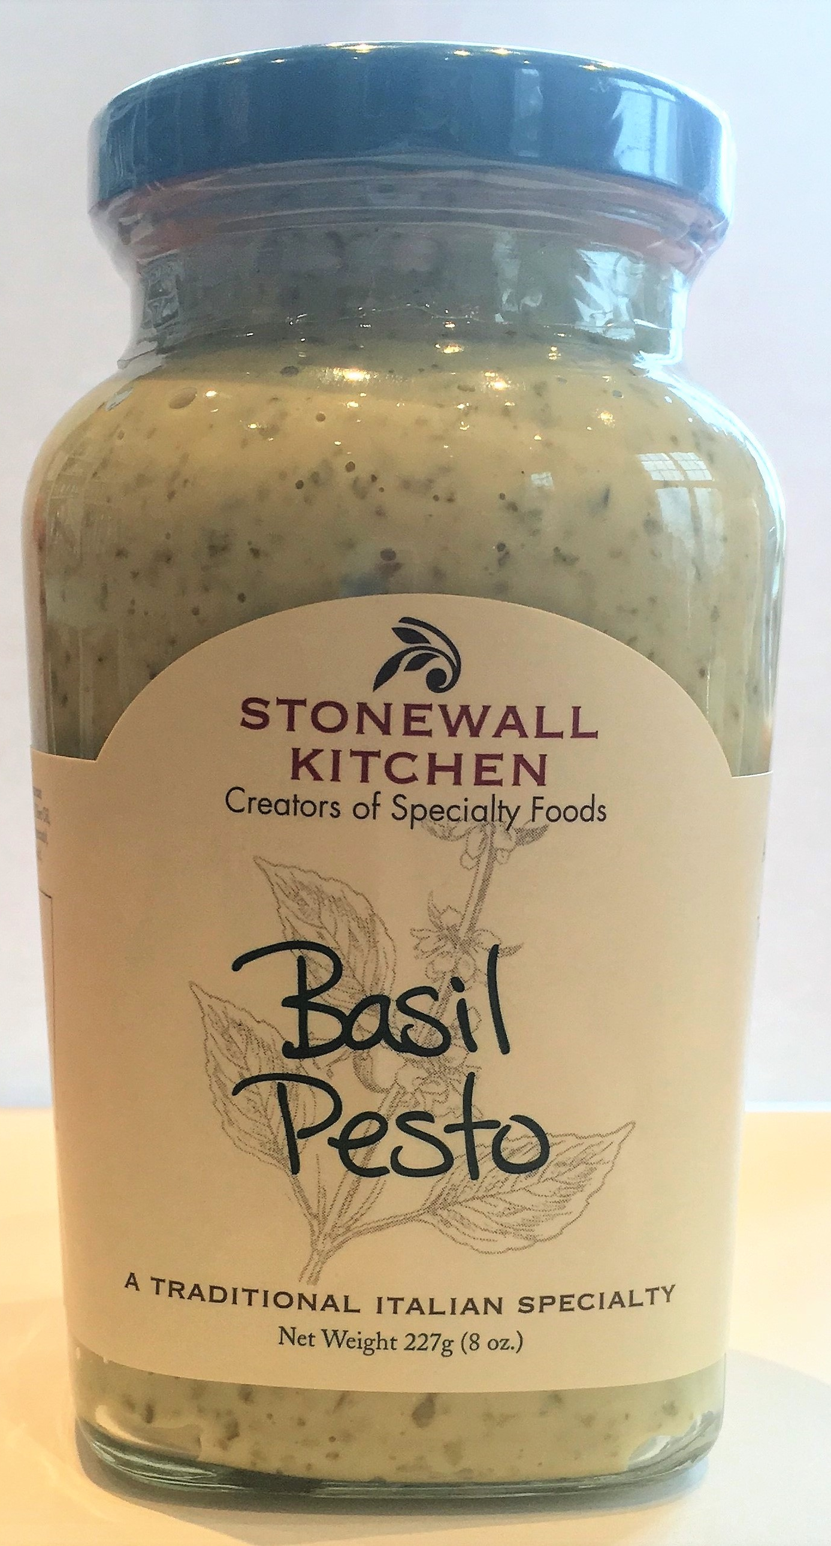
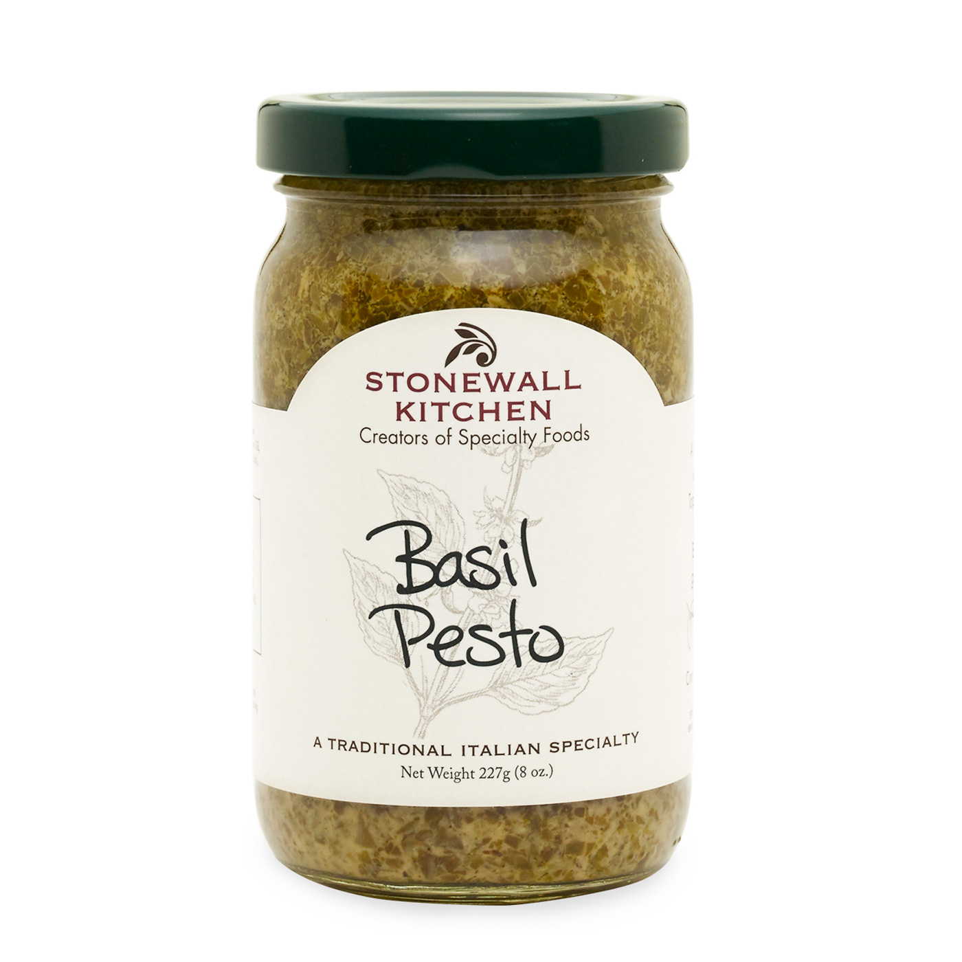
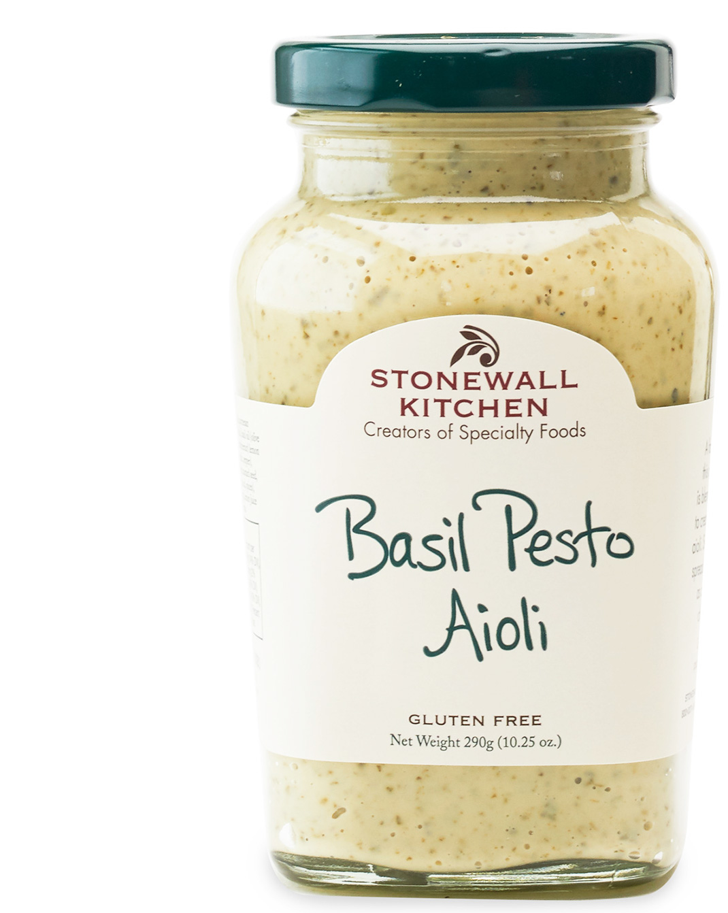
Correct Basil Pesto Aioli Correct Basil Pesto Incorrect Product

To date, Stonewall Kitchen has not experienced any problems or complaints about these products. No injuries or illnesses have been reported. This voluntary recall is being conducted with the knowledge of the US Food and Drug Administration.

If consumers have any of the above product, they must discontinue use and discard product immediately.

Consumers should contact Stonewall Kitchen Premier Guest Services by email at
guestservices@stonewallkitchen.com or by phone at 800-826-1735 for refund instructions and any further information.

Enclosed: Photo of Basil Pesto Aioli, Basil Pesto, and Incorrectly Labelled Product.

For more information about Stonewall Kitchen, please visit www.stonewallkitchen.com

####

