**FOR IMMEDIATE RELEASE AND DISTRIBUTION**

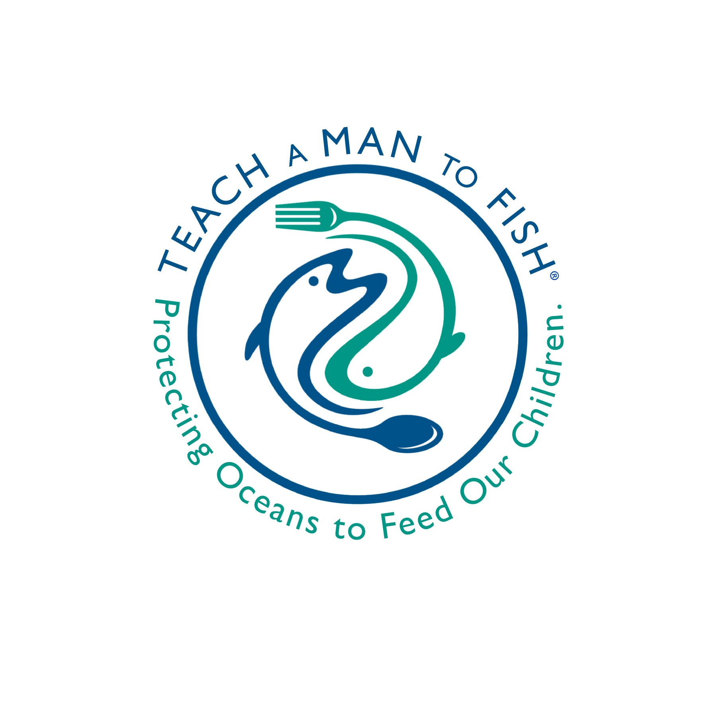

**LAUNCH OF TEACH A MAN TO FISH, INC.**

May 3, 2018 — Lansing, Michigan

Teach A Man To Fish, Inc. President Mark Campbell today announced the launch of TAMTF as a charitable organization to help restore marine ecosystems and to work with local fishermen in developing countries to adopt safe and sustainable harvesting techniques.

The heart of the TAMTF’s business model involves the merger of marine restoration and aquaculture. The first phase integrates a lobster farm operation within a matrix of artificial reefs, both of which are legally protected by the partner organization operating the farm. The artificial reefs become a natural incubator for all reef-dwelling marine life and the integrated lobster aquaculture operation helps local fishermen transition away from wild catch in an area with seriously depleted fisheries. The development of a lobster hatchery, which will be used to annually seed the ocean farm with 8-month old lobster juveniles, ensures long-term sustainability.

This initiative has two unique features that ensure success. First, with the help of scientific experts on lobster aquaculture, TAMTF will be creating the first-ever open-water lobster hatchery to produce lobster juveniles. Secondly, TAMTF’s Nicaraguan partners have received the first-ever government concession for the ocean floor off the Pacific coast of Nicaragua that will give them the legal authority to protect the matrix of artificial reefs as well as the integrated lobster aquaculture.

A key sustainability component of the TAMTF business model is TAMTF’s retention of ownership of the lobster hatcheries. Control over the hatchery helps ensure our goals are met: protection of the matrix of artificial reefs and sustainable operation of the lobster farm.

**Media Contact:**  Mark Campbell at (517) 802-8586 or [mc@tamtf.net](mailto:mc@tamtf.net)  
   
**Website: www.tamtf.net** **Facebook:** facebook.com/tamtf.net

®/™ Trademarks of Teach A Man To Fish, Inc.