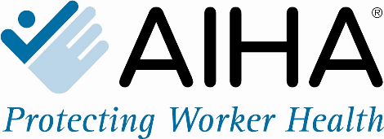

MEDIA CONTACT:

Susan Marchese
smarchese@aiha.org
(202) 256-8986

First Responders to Appear with Worker Safety Watchdogs to Address On-the-Job Opioid Exposure Crisis
The American Industrial Hygiene Association (AIHA) Warns: America’s First Responders Are at Risk

FALLS CHURCH, Va. (May 15, 2018) - The American Industrial Hygiene Association (AIHA) will host a press conference at the AIHce EXP 2018 conference on May 22, 2018, at the Pennsylvania Convention Center, to discuss the opioid exposure crisis threatening the safety of the nation’s first responders. Speakers will include first responders, occupational safety experts, and a White House drug control official. Participants will discuss the risks of opioid exposure and the critical steps necessary to adequately train and protect first responders on the job. AIHA warns that every day a wide range of first responders are in danger of potentially fatal opioid exposures, including firefighters, EMTs, nurses, doctors, law enforcement, and crime lab technicians.

What: First Responders Opioid Exposure Crisis Press Conference
Where: AIHce EXP 2018, Pennsylvania Convention Center (PCC), 1101 Arch Street, Philadelphia, PA (Ballroom AB)
When: 9:15 am – 9:45 am, Tuesday, May 22nd, 2018

Who: Lawrence D. Sloan, CAE, CEO, American Industrial Hygiene Association
Donna S. Heidel, CIH, FAIHA, Member of AIHA Board
John Howard, MD, MPH, JD, LLM, MBA, Director of the National Institute for Occupational Safety and Health
Adam K. Thiel, Philadelphia Fire Commissioner
Crystal Yates, Assistant Deputy Commissioner for EMS, Philadelphia Fire Department
Kemp Chester, Associate Director of the White House’s Office of National Drug Control Policy

The press conference is a credentialed event taking place outside the PCC Ballroom AB in a private area that is closed to the public and will immediately follow an 8:00 am panel discussion entitled “Mitigating Opioid Exposure Risks to First Responders: What’s Been Done, What’s Left to Do & How You Can Help.” The panel discussion is also open to the press. Media wishing to attend the panel discussion and/or the press conference must register for an AIHA Press Credential by contacting Susan Marchese at smarchese@aiha.org or (202) 256-8986. A press feed will be available.

About AIHA®
Founded in 1939, the American Industrial Hygiene Association (AIHA) is the premier association of occupational and environmental health and safety professionals. AIHA’s 8,500 members play a crucial role on the front line of worker health and safety every day. Members represent a cross-section of industry, private business, labor, government and academia. Learn more at www.aiha.org.

