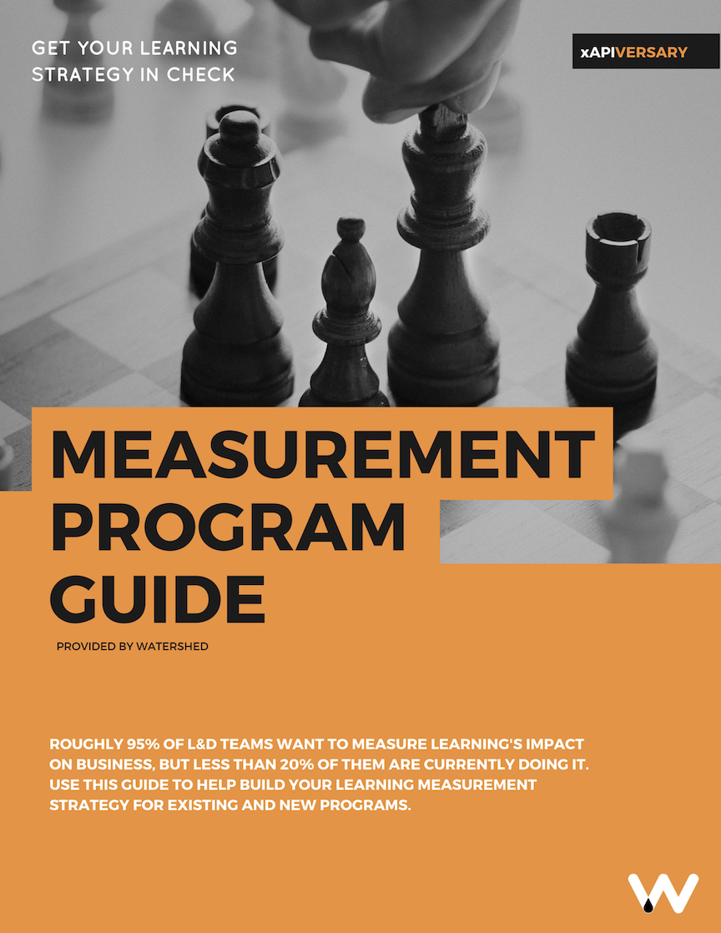
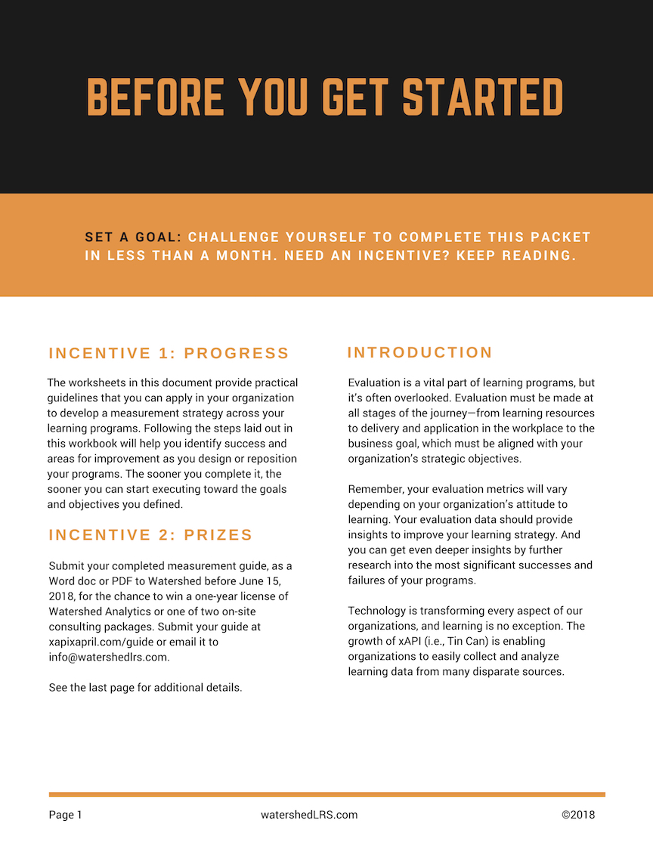

Step 1: Learning Evaluation, Align

Identify program goals and evaluate alignment with strategic priorities.
If your program has multiple goals, repeat this sheet for each goal.

What's the goal of the program? (prior to considering alignment)

Which organizational priority/priorities does this goal support?

On a scale of 1 to 10, how well aligned is the program goal to the priority/priorities you listed? Check one.

Vague or no link |  |  | Some overlap |  |  | Mostly overlapping |  |  | Fully aligned
0 | 1 | 2 | 3 | 4 | 5 | 6 | 7 | 8 | 9 | 10

How can you adjust your program goal to create greater alignment? Write the new program goal below. Using a different color/symbol, update your alignment rating on the chart above.

Given the level of alignment to strategic priorities, should the program go ahead? Select one.
No
Yes

If you chose “Yes,” but didn’t rate alignment as 9 or 10, justify the reasons for proceeding with the program. Otherwise, explain the reasons for your final alignment rating.

Example Step 1: Learning Evaluation, Align
Identify program goals and evaluate alignment with strategic priorities.
If your program has multiple goals, repeat this sheet for each goal.

What’s your program’s goal? (prior to considering alignment)
All salespeople to be rated as “good" or “excellent” with regard to product knowledge of the new UltraWidget line

Which organizational priority/priorities does that goal support?
Successful launch of UltraWidget with $4 million worth of product sold, delivered, and invoiced by the end of Q2 2016

On a scale of 1 to 10, how well aligned is the program goal to the priority/priorities you listed? Select one.
Vague or no link |  |  | Some overlap |  |  | Mostly overlapping |  |  | Fully aligned
0 | 1 | 2 | 3 | 4 | 5 | 6 | 7 | 8 | 9 | 10
 |  |  |  |  |  | ✓ |  |  | ✓

How can you adjust your program goal to create greater alignment?
Write the new program goal below. Using a different color, put a new tick on the chart above.
Salespeople achieve $4,000,000 worth of UltraWidget sales in the first quarter of 2016, supported by their strong product knowledge and sales skills

Given the level of alignment to strategic priorities, should the program go ahead? Select one.
No
Yes

If you chose “Yes,” but didn’t rate alignment as 9 or 10, justify the reasons for proceeding with the program. Otherwise, explain the reasons for your final alignment rating.
The final alignment was rated 9 because the program will focus on improving sales and not production, delivery, and invoicing. Past product launches (e.g., the SuperWidget) suggest that sales training is the most important area of focus.

Step 2: Learning Evaluation, Define
Identify success metrics most appropriate to the organization. Complete one of these sheets for each relative metric.
Reference the level and category key below the chart. Don’t worry about feasibility yet; you will prioritize and reduce this list in Step 4.

Metric
Metric Level
Metric Category
Metric Title
Data Source
Stakeholders
(and their associated metrics)

Metric Levels | Metric Categories
• Overall achievement of project goals  • Improvements in job performance  • Improvements in knowledge & competency  • Delivery & discoverability of learning experiences  • Usage & quality of content | Category 1: Learning Experiences (understand more about specific learning activities)  Category 2: Learner (understand more about a person or group engaged in activities where learning is an output)  Category 3: Learning Program (understand how an overall learning program is performing)

Step 3: Learning Evaluation, Discover (optional)
Identify what learning is already happening in your organization that supports the program’s goals.
To help direct research during the discovery step, answer these questions about the learning activities that relate to your program's goals—including both learning that might support or undermine the program's goal.

What learning activities do you already know about within your organization?

Ask learners about the learning they've completed in areas that you may not have known about.

Which teams, departments, and/or individuals are successful in areas relating to program goals?

What are the reasons for that success?

Can any of these positive learning experiences be replicated? Can that expertise be shared?
Example Step 3: Learning Evaluation, Discover
Identify what learning is already happening in your organization that supports the program’s goals.
To help direct research during the discovery step, answer these questions about the learning activities that relate to your program's goals—including both learning that might support or undermine the program's goal.

What learning activities do you already know about within your organization?
Salespeople have sales skills from e-learning courses via the LMS. About 76% of salespeople have completed this training during the last two years.

Ask learners about the learning they've completed in areas that you may not have known about.
Salespeople also receive technical briefings and product fact sheets (PDF) from the production team each time a new product is launched.
Which teams, departments, and/or individuals are successful in areas relating to program goals?
The North territory sales team consistently achieves higher sales and customer feedback scores for new products within the first six months of those products being launched.
What are the reasons for that success?
The area manager for the North sales team manager for the North sales team believes that one reason for his team’s success is an informal 5-minute product quiz at the end of each weekly sales meeting. They also have a team member, Dave Smithson, who used to work on the product team and is particularly good at understanding and explaining the product fact sheets issued by the production team.
Can any of these positive learning experiences be replicated? Can that expertise be shared?
- Encourage all territories to include product quizzes during their sales meetings. Consider tracking completion and scores.
- Include Dave Smithson as an SME in production of the training materials.

Step 4: Learning Evaluation, Design
Design how evaluation metrics will be captured, aggregated, and displayed.
Complete a copy of this worksheet for each metric identified in Step 2, Define.

Use this worksheet to prioritize and ensure a good spread of metrics.
Metric Name/Topic:

At what level or area does the metric operate? Select all that apply.

Project goals | Job performance | Knowledge | Delivery | Quality

During what stage of the program will the metric be captured? Select all that apply.
Pre-training | Training | Post-training | Application | Post-application

Technical question: How will data be captured? Outline all possible options and choose one.
If you're unsure how to answer, ask your Watershed contact for help. Use the next page if you need more space.

How important is this metric compared to others you’ve identified? Select one.

♥ | ♥♥ | ♥♥♥ | ♥♥♥♥ | ♥♥♥♥♥

How much time is required to capture this metric compared to others you’ve identified? Select one.

How much cost is required to capture this metric compared to others you’ve identified? Select one.
$ | $$ | $$$ | $$$$ | $$$$$

Use this extra space to list options for data capture.

Step 5: Learning Evaluation, Monitor

Continually monitor success and progress toward the program goal.

Use this sheet as a reminder to monitor your evaluation metrics throughout your project and take appropriate action. Decide how often you will check metrics (e.g., daily, twice a week, or once a week). Record any action(s) required to improve metrics and then mark the actions as complete.

Date | Which metrics have cause for concern? |  | Actions Required | Done
 | Metric | Value

Want to take your learning evaluation program even further? Visit our website for two additional learning evaluation steps! Keep in mind, Steps 6 and 7 are not required when submitting your plan.

