Press Release:

GROWING AI-ASSISTED CONVERSATIONAL DISCOVERY…
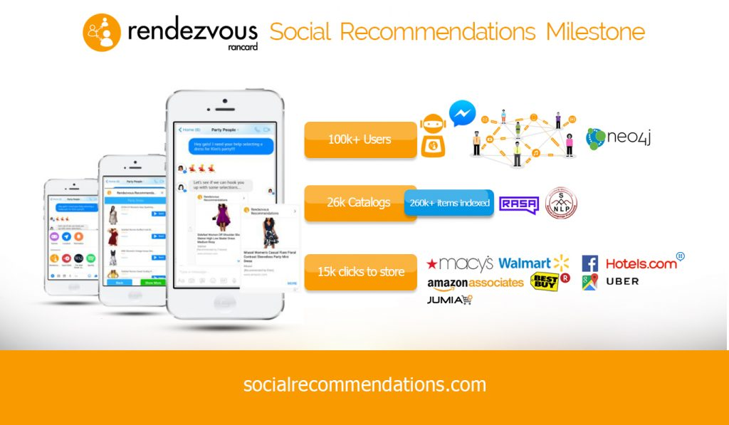
- Over 100k real people engaged in 6 continents!
- Getting personalized recommendations from trusted sources

SAN FRANCISCO,CALIFORNIA, May 16, 2018 – Rancard Inc. today announced a major Rendezvous social recommendations milestone: achieving an engagement milestone of over a hundred thousand real users in 6 continents! These users are predominantly from the US, Egypt, Canada, Philippines, Australia among others.

The users who are subscribers of Facebook Messenger have found a new way to get their friends opinions on literally anything – retail, places and services.
Rendezvous is unusual but most natural as a recommendation engine because it’s all about getting you results based on whose opinion you trust in a specific genre- See www.socialrecommendations.com
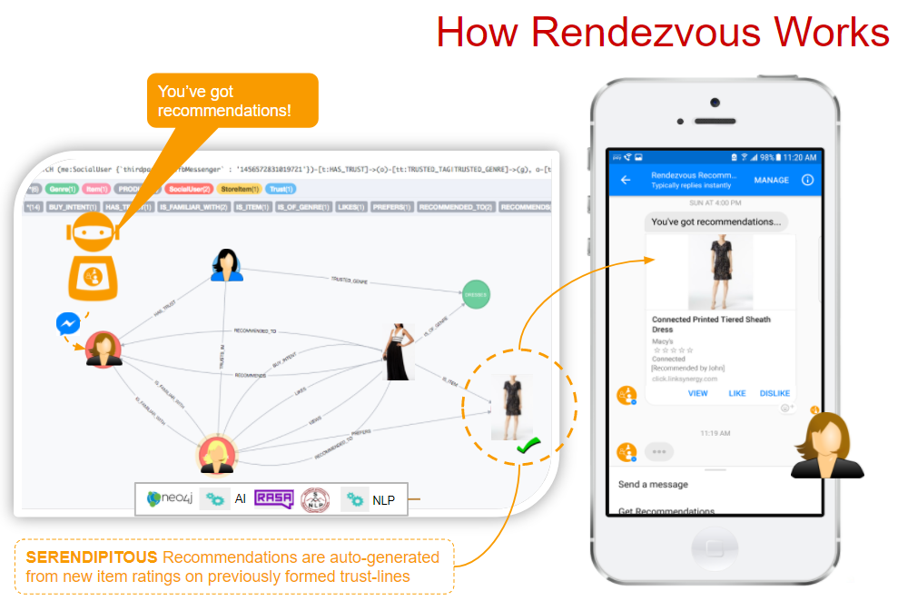
Users can share catalogs to get their friends opinions in Messenger and eventually across other channels including WhatsApp, iMessage, WeChat, etc.
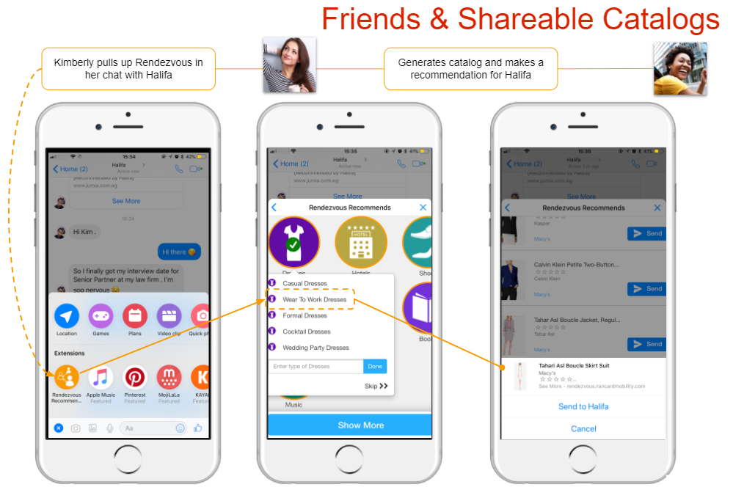
Ultimately, Rendezvous users get serendipitous recommendations as their trust graph grows…The Rendezvous zeitgeist shows the most requested categories are music, fashion apparel, electronics…
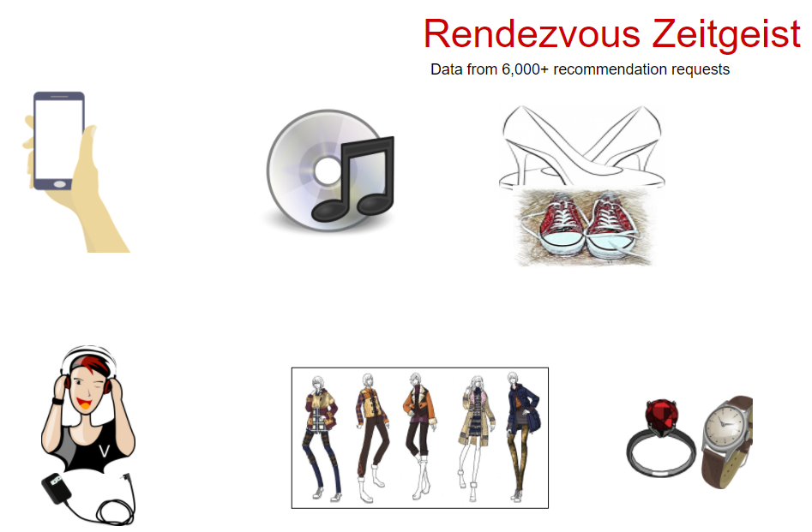

Ends-
-Amazon and the Amazon logo are trademarks of Amazon.com, Inc. or its affiliates.
-Rancard does not claim rights to any of the logos or trademarks used in this article and its images except Rancard’s own trademarks.

About Rancard
Rancard delivers social recommendations technology for online retail and places via Rendezvous, a social graph with AI-enabled interfaces. Featured by Facebook at F8 2017 and 2018, Rendezvous enables users engage through a Messenger bot and chat extension to share and receive trusted recommendations from selected friends on actual items in retail, places destinations and services. The engagement method is conversational:
users dialog with the Rendezvous bot to obtain recommendations from their friends in a requested genre, and/or share a curated item catalog to friends for opinions/validation. They can also invoke the Rendezvous Messenger Chat Extension to introduce actual shoppable items into their peer conversations.
Messenger bot at https://m.me/rndzvu (best onmobile) and more information at www.socialrecommendations.com.

