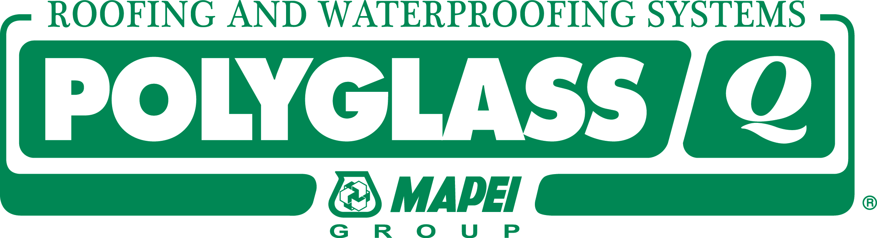 NEWS

RELEASE

FOR IMMEDIATE RELEASE

Polyglass Develops New Roof Sloping Compound
Polyglass extends its line of roofing and waterproofing solutions with the launch of POLYSLOPE™.
DEERFIELD BEACH, Fla. May 24, 2018—Polyglass U.S.A., Inc. announced today the launch of POLYSLOPE, a reinforced cementitious, water repellent compound designed as a sloping material for many roofing substrates and situations.
POLYSLOPE can be used to create positive drainage on roofs that have low spots and divert standing water. The product is ready to use after adding water and mixing. It is easy to screed and paintable after 48 hours.
“We are proud to bring this product to market and enable contractors to quickly resolve roof challenges,” said Ariel Lender, director of product management and codes and compliance. “Our mission is to deliver quality and innovative solutions to the roofing industry that are sustainable and help prolong the life of the roof.”
About Polyglass:
Polyglass U.S.A., Inc. is a leading manufacturer of roofing and waterproofing systems for low-and steep-slope applications. Known for its self-adhered modified bitumen roofing systems based on the company’s patented ADESO® Technology and CURE Technology®, Polyglass also produces a full line of premium roof coatings and roof maintenance systems. As an ISO 9001:2015 certified company, Polyglass provides quality products and adds value worldwide. For more information about the premium products and services offered by Polyglass, call 800.222.9782 or visit polyglass.us.

###

