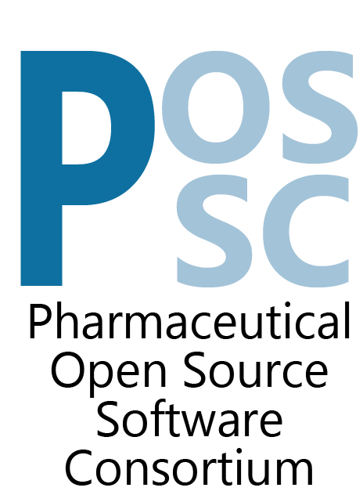

++++++++++++++++++++++++++++++++++++++++++++++++++++++++++++++++++++++++
REQUEST FOR INFORMATION
NCA Software
May 29, 2018

Pharmaceutical Open Source Software Consortium
Request for Information
Table of Contents

1 Introduction 4
1.1 About Pharmaceutical Open Source Software Consortium (POSSC) 4
1.2 Request for Information 5
1.3 Disclaimer 5
1.4 POSSC Contact Information 6
1.5 Anticipated Time Frames for Evaluation and Selection Process 6
2 Project Information 6
2.1 Possible Project Sponsors 6
2.2 Project Description 7
2.2.1 Problem statements 7
2.2.1 Project Aims 8
2.3 RFI Deliverables 10
2.4 Project Requirements 11
3 Criteria for Evaluation 12
4 Respondent Profile (to be completed by RFI respondent) 12
4.1 Company/Organization Information 12
4.2 Primary Contact Person 12
4.3 Company/Organization Overview 13
4.4 Parent Corporation and/or Subsidiaries 13
4.5 Summary of Expertise 13
4.5.1 Experience in Non-Compartmental Analysis (NCA) and Pharmacokinetic (PK) Domains 13
4.5.2 Experience with Open Source Models of Development and Ownership 13
4.5.3 Experience with Desktop Application Development 14
4.5.4 Experience with Web-based development & Web technologies 14
4.5.5 Experience with Electron Apps/Node.js/Javascript 14
4.5.6 Experience with R and Shiny Application Development 14
4.5.7 Experience with initiating development with existing open source or other prior products or development efforts 14
4.6 Standards Certifications 15
4.7 Goals and Strategic Vision 15
5 Company/Organization Response to RFI (to be completed by RFI respondent) 16
5.1 Functional Requirements & Specifications 16
5.2 Proposal 16
5.3 Development Method 16
5.4 Development Best Practices 16
5.5 Development Environment 17
5.6 Availability of Interim Software Versions 17
5.7 Use of Subcontractors 17
5.8 Estimated Timeline 17
5.9 Estimated Project Cost 18
5.10 Software Acceptance Period 18
5.11 Software Warranty Period 18
5.12 Software Support Model and Cost Estimate 19
5.13 Miscellaneous 19
6 Details of Project Aims 19

Introduction

About Pharmaceutical Open Source Software Consortium (POSSC)
Established in 2018, the Pharmaceutical Open Source Software Consortium (POSSC - https://www.possc.org/) is focused on the development of innovative open-source solutions (open source based software) for pharmacokinetic or pharmacometric applications to serve the Clinical Pharmacology and Pharmacometric Community, standardize common elements, strengthen the discipline, and ultimately bring new medicines to patients.

Membership within POSSC is currently open to any company engaged in the development of new chemical entities or new molecular entities for the prevention, diagnosis, or treatment of disease with at least one active clinical trial application. As of the date of issue, POSSC is comprised of the following Pharmaceutical and Biotechnology companies:
- Amgen
- AstraZeneca
- Biogen
- Boehringer Ingelheim
- Bristol-Myers Squibb
- Eli Lilly
- Genentech
- GlaxoSmithKline
- Johnson & Johnson
- Pfizer
- Takeda Pharmaceuticals
Any companies interested in membership in POSSC are invited to contact the POSSC Secretariat, Drinker Biddle & Reath LLP (secretariat@possc.org).

The first project that will be undertaken by POSSC is the development of next-generation, open source software for non-compartmental analysis (NCA) including options appropriate to incorporate into diverse environments and workflows associated with well controlled and compliant processing, analysis, maintenance and reporting of data and results specifically for NCA.

The POSSC effort has been divided into two phases:
- Feasibility Phase - consists of the formation of the consortium, definition of NCA software requirements, and public solicitation for interest and information to deliver the NCA solution. All of the information learned during the Feasibility Phase will support the business case used by POSSC members to make the decision to enter the next project phase. The Feasibility phase currently in progress and is scheduled to be completed in October 2018.
- Development Phase - comprised of selecting a vendor to deliver the NCA software, finalization of requirements, and kick-off of development. The Development Phase will commence once a decision to proceed has been reached by the POSSC members and will continue until the NCA software is delivered.

Request for Information
The publication of this Request for Information (RFI) will be used to solicit interest in collaborating together on a Next Generation NCA Platform. The information collected during the RFI process along with subsequent interviews and follow-up interactions will be used for evaluation purposes, to provide information to support the creation of the business case to enter the Development Phase, and selection of respondent(s) who may be invited to respond to a future Request for Proposals (RFP).

Disclaimer
The contents and information provided in this RFI are meant to provide general information to parties interested in developing the Next Generation NCA Platform. Prior to initiation of a project with POSSC, the vendor ultimately selected by POSSC will be required to execute an Agreement that will govern the terms of the project. When responding to this RFI, please note the following:
- This RFI is not an offer or a contract;
- Proposals submitted in response to this RFI become property of POSSC;
- Respondents will not be compensated or reimbursed for any costs incurred as part of the RFI process;
- Any questions received and responses thereto will be anonymized and made available to all respondents via our website and/or email;
- All proposals received in response to this RFI will remain confidential within POSSC and not shared with other respondents;
- POSSC will not execute a Non-disclosure or Confidentiality Agreement (NDA or CDA) as part of the RFI process;
- Responses to RFIs should contain only high level discussions of product development efforts and should not contain trade secrets or confidential information;
- POSSC is not obligated to contract for any of the products and services described in this RFI; and
- POSSC reserves the right to:
  - Accept or reject any or all proposals
  - Waive any anomalies in proposals
  - Negotiate with any or all bidders
  - Modify or cancel this RFI at any time

POSSC Contact Information
All questions and inquiries regarding this RFI should be directed to:
Ms. Catherine Graveline
Project Coordinator
POSSC Secretariat
c/o Drinker Biddle & Reath, LLP
1500 K St NW
Washington DC, 20005-1209
(202) 230-5661
secretariat@possc.org or Catherine.Graveline@dbr.com

Anticipated Time Frames for Evaluation and Selection Process
Issue RFI May 29, 2018
Informational Webinars
Webinar 1 (12:30 – 2:00 PM EDT) June 22, 2018
Webinar 2 ( 1:00 – 2:30 PM EDT) July 17, 2018
Responses to RFI due July 30, 2018
Evaluation of Responses July 30 – August 10
Notification of Status and Request for Interview Sent August 10, 2018
Web-based or In-person Interviews End of August 2018

Please submit your response electronically to the above address. Responses received after July 30, 2018 will not benefit from full consideration and may be excluded from the selection process.

Project Information

Possible Project Sponsors
- Amgen
- AstraZeneca
- Biogen
- Boehringer Ingelheim
- Bristol-Myers Squibb
- Eli Lilly
- Genentech
- GlaxoSmithKline
- Johnson & Johnson
- Pfizer
- Takeda Pharmaceuticals

Project Description

Problem statements

The Need for Qualified, reliable industry Standard NCA software
Non-Compartmental Analysis (NCA) is a key activity in non-clinical and clinical pharmacokinetic evaluation, and represents the standard method of analysis and reporting of concentration-time data. Results of NCA analyses are used to inform critical decision-making processes during drug development and are required to support drug registration/approvals, and labeling recommendations (e.g., dosing considerations). Pressures within the industry and from regulatory bodies to advance the efficiency of non-clinical and clinical studies require robust, modern, and adaptable analysis tools, and standardized common elements. Currently available commercial and non-commercial NCA software offers limited options and flexibility to address a wide range of analyses or potential for incorporation into wider pharmacometric workflows. Much of the pharmaceutical industry is currently reliant on commercial off-the-shelf software or a limited variety of ’home-grown” proprietary NCA software, a situation that carries with it the risks inherent in limited sourcing. It is also recognized that there is some variety of choice presented by academic and open source alternatives also currently available. Current open source options are not fully qualified nor documented with full data models, requirements, solutions and test documentation in support of software delivery life cycle standards for software development.
The expectation is that a collaborative approach to develop open-source NCA software will deliver a modern, robust, well-qualified, audit-ready and flexible solution through incorporating expertise from a diverse range of pharmaceutical industry stakeholders and produce standards and a basis for standardized reference test cases and performance. Further, the POSSC seeks to develop options that are based on community and open source tools and development languages that permit rapid extensibility within the community. For example, the statistical programming language R provides a widely adopted standard data management, pharmacokinetic and pharmacometrics modeling tool enabling a wide range of analyses, summarization (e.g. tables, listing and figures) and other reporting options for Clinical Pharmacometrics, Clinical Pharmacology and Clinical Pharmacokinetics practitioners.

Project Aims

Development of an open source application and functional services that can be shared broadly with discipline practitioners without encumbrance to drive collaborative innovation for Clinical PK, Clinical Pharmacology and Pharmacometrics.
Deliverables for the project include the following objectives. Note that additional details are presented in Section Details of Project Aims and detailed requirements are provided with this RFI separately. The following diagram presents a conceptual overview of the elements of the system.
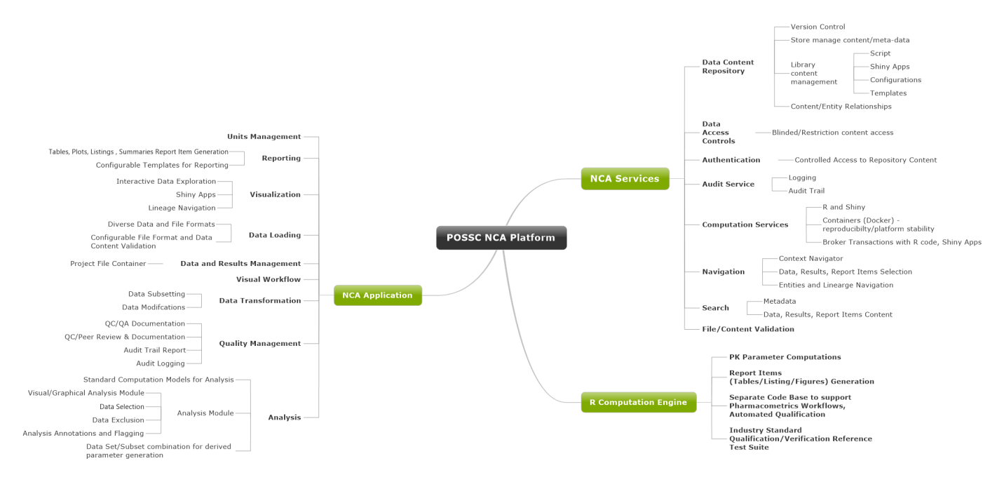
- NCA Computation Engine
The NCA Computation engine will be developed as an open-source R package incorporating functionality to generate the NCA PK Parameters based upon the data and PK analyst selections for these data. The computation engine R code will include capabilities for tables, listings and figures creation to support diverse reporting, visualization and data summary needs. The computation engine will also incorporate any required Shiny applications developed in R necessary to support requirements for data transformation, subsetting, unit management, reporting, visualization, etc. The anticipation is that a Compute Service will be part of the system to broker transactions between the Standalone Desktop Application and the R based computation engine and Shiny apps.
- A Standalone NCA Desktop Application with the following capabilities
POSSC intends to develop a system comprised of a standalone desktop application that can optionally connected to a collection of services to provide a set of configurable components that individual member companies, and ultimately other consumers of the end product, may customize to local processes. Standalone capabilities require that the application could operate with local data sources without access to online data repository.
The standalone desktop application will provide some basic capabilities including
  - flexible visual traceable workflow identifying the discrete entities representing datasets as imported or acquired datasets as Dataloads, Data Transformations, Analyses, Report items (tables, listing, figures), etc.
  - Data import, export and file/data validation capabilities from/to a variety of data file formats and source types
  - Analysis capabilities to permit an analyst to choose the required data, select the settings for analysis, select data appropriate for the computation of pharmacokinetic parameters
  - Data Transformation or preparation capabilities to permit multiple datasets to be merged, to add transformed variables, to manage units, to subset data to focus analysis and reporting, etc.
  - Visualization, review and reporting of data and results
  - Data lineage navigation and versioning of results permitting identification and relationships between Dataloads, Data Transformation and Analysis results.
  - Audit trail, logging and reporting of the lineage of datasets, transformations and generation of results.
  - QC and/or peer review status capture and tracking capabilities

- Modular (configurable/optional) web services
The overall solution will provide capabilities to configure services for a complete closed compliant solution but not require all of the services if a specific use case doesn’t require them. For example, the Standalone NCA Application should be operational without any of these services if a particular installation or use case requires that.
Services that are considered important to a complete solution include:
  - Data content/repository/database/library Service to store and manage both loaded concentration and other input data required for analysis and reporting, output result datasets, reporting items (Tables/Listings/Figures) as well as provide management of metadata that may be applied to the content to facilitate categorization and searching, script, templates and configuration items. Data content may be stored as a parsed data model to permit searching of individual data/result elements.
  - Compute service – manages interaction with R based computation engine code/package for parameter calculations, data transformations, reporting, etc. controlling job submission processes and creation of resulting content
  - Data Access Controls service to permit controlled access to restricted content such as blinded data emanating prior to a clinical study blind break.
  - Authentication Service to permit controlled access to the repository content
  - Audit and Logging Services to provide traceability and reporting for all actions taken by users within the system. This capability must be available within the Standalone Application as well.
  - File validation service to validate data content and format based upon format specification templates
  - Search Services to provide capabilities to search for data, content and meta-data for project and data, entities and results.

RFI Deliverables
Respondents must provide responses to all the requirements detailed below, by providing a comprehensive view on how services will be provided to meet the POSSC requirements.

Respondents are encouraged to provide non-confidential information relevant to the requirements captured within this document that may represent a differentiation from other respondents. Capabilities and services not specifically requested but that may enhance or improve the service as described should be included and called out specifically.

Respondents should provide a detailed approach on how they will provide services POSSC including the estimated cost and timeline. During the Development Phase, once the provider is selected, POSSC will host an in-person workshop, under a non-disclosure agreement, with the leading respondent chosen by the team to fully scope the project in order for the respondent to provide a detailed Statement of Work (SOW) with accurate costs and timelines to complete the project.

It is anticipated that all content produced by this project will be owned by POSSC and will in the future be released into the open source. As such, it is important that the respondent’s strategy to deliver the NCA software takes into account any licensing issues for an open source project.

Project Requirements
POSSC is requesting that the response to this RFI provide a cost, timeline, resourcing and support/maintenance estimates.

Project requirements are provided and attached with this RFI or available for download as a Microsoft Excel workbook of requirements organized by system categories.

Note that as part of the overall scoping process considered by POSSC, there will be an opportunity for RFI responders to evaluate and consider use of a series of software/system contributions being developed by one of the POSSC member partner organizations to serve as the foundation for further software development efforts.

The open source contribution is intended to be an implementation of some of the requirements identified and included through this RFI.

The POSSC requests through the RFI potential consideration be made concerning how the incorporation of existing open source software to jump start development efforts may be managed and may alter the project processes, timelines and costs estimates.

Criteria for Evaluation
POSSC will evaluate the responses to this RFI based on the vendor’s ability to:
- Provide response with desire to participate in collaboration.
- Meet the requirements described in this RFI as evidenced by the RFI response and presentations made to POSSC.
- Provide a cost-effective solution that is compatible with the goals of the project.
- Demonstrate domain expertise and an ability to work collaboratively with POSSC in development of the Next Generation NCA Software.
- Discuss potential partnerships and current development efforts that show similarities to this RFI.
- Provide any additional capabilities that may differentiate them from other potential collaborators.

POSSC will not be able to provide individual feedback to RFI respondents.

Respondent Profile (to be completed by RFI respondent)
Please provide information to the following:

Company/Organization Information
Company/Organization Name
Address
City
State
Country
Zip Code
Website

Primary Contact Person
Name
Title
Email address
Phone Number

Company/Organization Overview
Provide a brief overview of your company/organization including number of years in business, number of employees, nature of business, description of clients, and related products developed and commercialized to date.

Parent Corporation and/or Subsidiaries
Identify any parent corporation and or subsidiaries, if appropriate.

Summary of Expertise
Give a brief description of your company/organization’s expertise in the area/field related to this RFI. Include any experience working on projects with Consortia/Associations.

Experience in Non-Compartmental Analysis (NCA) and Pharmacokinetic (PK) Domains

Experience with Open Source Models of Development and Ownership

Experience with Desktop Application Development

Experience with Web-based development & Web technologies

Experience with Electron Apps/Node.js/Javascript

Experience with R and Shiny Application Development

Experience with initiating development with existing open source or other prior products or development efforts

Standards Certifications
List any certifications currently held, including date received, duration, and renewal date.

Goals and Strategic Vision
Provide a summary of your company/organization’s short term and long-term goals and strategic vision.

Company/Organization Response to RFI (to be completed by RFI respondent)
Please enter your response to each question below. If additional documentation or schematics are required to respond to a particular question, please answer the question as succinctly and accurately as possible and reference supplemental attachments.

Functional Requirements & Specifications
In the provided “NCA Requirements and Specifications” Workbook please complete Column H to indicate your thoughts in accommodating each feature in your proposed approach to deliver a solution and include this workbook in your RFI response.

Proposal
Please provide details on your proposed approach to deliver the NCA Software.

Development Method
Please explain the development method you plan to employ in delivering this software solution (e.g. agile, waterfall).

Development Best Practices
Please explain the best practices you will employ in delivering this software solution, keeping in mind that the software solution must be “validate-able” for use in a GxP environment.

Development Environment
Please describe the development you will utilize to support this project to which POSSC members will have access (e.g. code repository, issue/bug tracker, support requests, etc.)

Availability of Interim Software Versions
Please describe your plans to provide POSSC members intermediate versions of software or sandbox environment to allow POSSC members to test features and provide feedback, including any assumptions/requirements related to availability of POSSC members to perform these testing and feedback activities.

Use of Subcontractors
If you plan to subcontract any aspects of this project please explain why and provide information about the subcontractor(s) below (i.e. name, location, expertise, rationale).

Estimated Timeline
Provide an estimated timeline which describes the development period for this project. Be sure to indicate any milestones, sprints, phases, etc.

Estimated Project Cost
Provide the estimated project cost in USD for to deliver this project including any payment schedule and your current rate card. If your company would consider or is proposing a “fixed fee” arrangement, be sure to indicate that as well.

Software Acceptance Period
Please provide information on the acceptance period provided by your company during which POSSC members will evaluate the deliverable(s) against the acceptance criteria and requirements outlined in the Statement of Work (SOW), including acceptance period duration, the process for reporting, and the mechanism by which bugs and deficiencies will be evaluated and rectified. Please note, due to the volunteer nature of the consortium, sufficient time will be needed for POSSC to effectively evaluate the software.

Software Warranty Period
Please provide information on the warranty period provided by your company during which any bugs discovered by POSSC members will be addressed, including the warranty period duration, the process for reporting, and the mechanism by which bugs will be evaluated and rectified.

Software Support Model and Cost Estimate
Please provide information on the support model and cost structure for a period of at least one (1) year following the expiration of the warranty.

Miscellaneous

Details of Project Aims
The additional details for the specifics of the aims of the project include the following requirements characteristics. The complete set of requirements are provided with this RFI document for consideration for response.

- NCA Computation Engine
  - Developed in the R statistical programming language and delivered as an R Package
  - Route of administration model basis for computation of multiple parameters
  - Documentation of the code with Roxygen2
  - Shiny applications to extend system, limit direct R coding requirements and support data transformation, subsetting of data, reporting/visualization of data, merging of data sources/datasets for analysis/reporting
  - R Package should be deployable externally to the NCA application to support alternative pharmacometrics workflows as an industry standard method for implementing NCA as well as standardized testing of the computation engine externally to the NCA application
- Compute Service
  - R software package installed within a container (Docker or equivalent) with installed required packages to maintain reliability, stability
- Desktop Application with the following capabilities
  - Modular to add future capabilities
  - Workflow agnostic but with traceability for entities such as
    - Dataload entities (datasets loaded to the system)
    - Data Transformation entities (modifications/transformations made to individual Dataloads or prior data transformation entities)
    - Analysis entities (results of submitting PK Analyst selections to the computation engine for generation of NCA PK Parameters)
  - Data Import/Export capabilities to create Dataload entities and include
      - Compatibility with ASCII (CSV and other delimited file formats), Microsoft Excel (XLS/XLSX), SAS transport and CDISC SDTM/ADaM formats
      - File specifications to define data formats
      - Data validation
  - Data Transformation or Preparation
    - Data merge capabilities
    - Units management functionality
    - Data subsetting capabilities
  - Visualization, review and reporting using standard reporting code developed in R as part of the R computation engine package or a supporting reporting package
  - Data lineage navigation, visualization and versioning
    - Versioning
  - Audit trail, logging and reporting
  - Authentication service integration if working in with a database/repository
  - Flexible navigation to browse/identify/narrow/search for database/repository content
  - QC/peer review tracking and automation
  - Standalone capabilities
    - NCA Application should be accessible in an offline mode permitting it to read datasets from fileshares or local file resources and save data and results in project files. All functions not requiring database/repository must be operational.
- Modular (configurable/optional) web service functionality including:
  - Data content Service
    - Data and Metadata management
    - Repository to store loaded concentration data and other supporting datasets as well as the output analysis datasets and reporting items (Tables/Figures/Listings)
    - Parsed data model to permit data search services
  - Compute service – manages interaction with R based computation engine code/package for parameter calculations, data transformations, reporting, etc. controlling job submission processes and creation of resulting content
  - Data Access Controls
  - Authentication Service
    - Server based security
    - This will be a modular component that organizations may leverage to control access to the data service content
  - Audit and Logging Services
  - Library service – management for supporting script, templates, configuration content separately for user and global content
  - File validation service functionality – validate data content and format based upon format specification templates
  - Search Services

