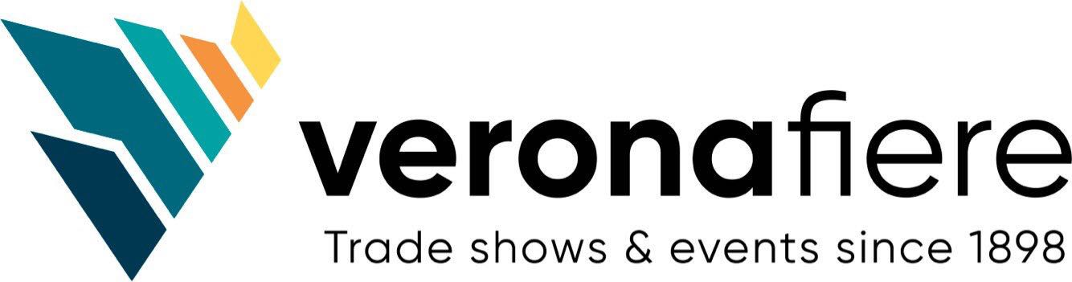
Press Release Contacts: For Immediate Release Vinitaly International
International Media Dept.

+39 045 8101447
media@vinitalytour.com
www.vinitalyinternational.com
Twitter: @VinitalyTour
Join Italian Wine Community on LinkedIn

Vinitaly International Academy marks 10th edition with new faculty: Sarah Heller MW and Henry Davar

Vinitaly International Academy (VIA) announces the new faculty who will lead the reformatted edition of VIA in Hong Kong in November 2018 and in Verona, Italy in April 2019. Sarah Heller, the youngest MW in the world, and Henry Davar, the best scoring Italian Wine Expert in all 9 past editions, will take the lead in VIA’s new educational journey.

Ian D'Agata retires after an exceptional and dedicated service at VIA as its Scientific Director and teacher for four years. With D’Agata and since its inception, VIA has trained 150 IWAs and 11 IWEs (https://www.vinitalyinternational.com/?page_id=663). Today, VIA with its new faculty and program, is seeking to expand its community with an improved learning path comprising of replicable and standardized certification courses from basic to advance level.

After graduating from Yale University, Sarah Heller began her career in the New York and Hong Kong wine trades and wineries in France and Italy. In 2017 she achieved the Master of Wine title. She is also an expert in e-commerce, wine branding, design and communication. Aside from attending to her boutique design agency Radix + Folium, she is also a design collaborator with Lucas Crystal and an accomplished wine journalist for a few local and international publications. On her appointment as part of the VIA Faculty she commented: “VIA has become the industry gold standard for Italian wine education. Being invited to help build VIA into an institution that will secure a robust future for the wines of Italy, the country where I first encountered and fell in love with wine, is both a professional and personal honour.”

Henry Davar is a Wine Educator and boutique fine wine Business Development Manager at Breakthru Beverage Nevada. Henry holds wine certifications from the Court of Master Sommeliers and the Wine & Spirits Education Trust. Most recently, he achieved the Italian Wine Expert certification from VIA becoming one of the eleven VIA-certified Italian Wine Experts in the world and the only one to obtain this title at first try. On the new VIA ecosystem he observed: "I'm very excited to be a part of VIA's growing curriculum and reach. As the Maestro level programs roll-out throughout the world the original Ambassador program will gain added depth and scope allowing for even more focused tasting opportunities and additional incoming programs for its highest level candidates."

Under the guidance of its Founder Stevie Kim, VIA also welcomes the foremost Italian wine scientist, Professor Attilio Scienza as VIA’s Chief Scientist, and major institutional players in the Italian Wine Industry as part of the Institutional Advisory Board. Vinitaly International Academy (VIA) aims to be the gold standard of Italian wine education. VIA offers a complete educational path with standardized courses that will teach professionals and educators to master the diversity of Italian wine in a rigorous, organized manner. VIA’s main objective is to foster a global network of highly qualified professionals who, in turn, will support and promote Italian wine throughout the world. VIA’s ecosystem comprising the main institutional bodies and associations in the Italian wine industry strives to be conduit between the leading players in the Italian wine scene and international professionals.

For additional information: https://www.vinitalyinternational.com/?page_id=1778

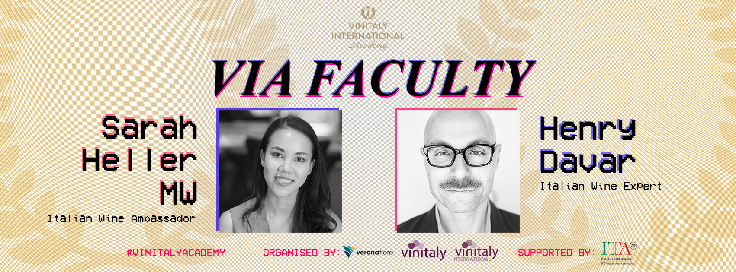
About
The grand Vinitaly 2019 will be held from April 7th to the 10th. Every year, Vinitaly counts more than 4,000 exhibitors on a 100,000+ square meter area and 130,000 visitors from over 140 different countries with more than 30,000 top international buyers. The premier event to Vinitaly, OperaWine (https://www.vinitalyinternational.com/?page_id=646) “Finest Italian Wines: 100 Great Producers,” which will be held on the 6th of April, one day prior to Vinitaly will unite international wine professionals in the heart of Verona, offering them the unique opportunity to discover and taste the wines of the 100 Best Italian Producers, as selected by Wine Spectator. Since 1998 Vinitaly International travels to several countries such as Russia, China, USA and Hong Kong thanks to its strategic arm abroad, Vinitaly International. In February 2014 Vinitaly International launched an educational project, the Vinitaly International Academy (VIA) with the aim of divulging and broadcasting the excellence and diversity of Italian wine around the globe. VIA this year launched the ninth edition of its Certification Course and today counts 151 Italian Wine Ambassadors and 11 Italian Wine Experts.

