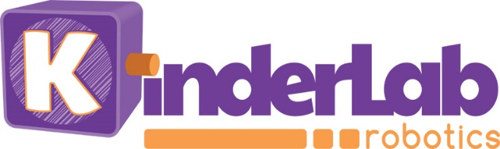 FOR IMMEDIATE RELEASE

KinderLab Robotics Introduces ‘Free Throw’ Extension Set for KIBO Robot
With KIBO’s new throwing arm, kids will have fun exploring math and physics principles while shooting baskets and taking aim at targets
(Waltham, MA) June 12, 2018 — KinderLab Robotics, the creators of the KIBO™ robot kit, today announced Free Throw™, a throwing-arm attachment that lets the KIBO robot toss ping pong-sized balls. This newest Extension Set encourages experiential learning of forces, motion, and energy in a playful and fun way.

KIBO is designed to teach children aged 4–7 to build, program, decorate, and bring their own robot to life without requiring any screentime. It serves as an open platform on which students can imagine and create their own robot. Students plan a coding sequence using the programmable wooden building blocks, scan their sequence with KIBO, press its button—and the robot comes alive.

With the Free Throw attachment, students can now code KIBO to drive to the basket and shoot, hit a target, and play games like basketball, quidditch, lacrosse, and corn-toss. Using rubber bands and ping pong-sized balls, students can throw high or shallow, long or short, while exploring the basics of physics and mathematics, including trajectory, inertia, measurement, and force. Children can experiment with different throwing options, re-load the Free Throw, and launch again. A variety of free activities linked to Next Generation Science Standards are also available for download from the KIBO Resources website.

“I worked with a group of 2nd-graders who experimented with different settings to see if they could throw a ball into a basket. They loved it!” said Barbara Tennyson, an instructional technology specialist at Needham Public Schools in Massachusetts. “I think the Free Throw will be a great way to enhance math lessons on measurement and estimation with hands-on experimentation. I love the fact that students are gaining intuitive experience with forces, trajectories, angles, and other physics concepts. This will provide them a great foundation for STEM work in later grades.”

Mitch Rosenberg, the CEO of KinderLab Robotics, added, “Even if they’re too young to be in a physics class, programming the Free Throw attachment will give students a hands-on introduction to the foundations of algorithms and physics, and a chance to experiment in a playful way.”

With KIBO, young children can become programmers, engineers, designers, artists, dancers, choreographers, and writers. The KIBO robotics kit is based on more than 20 years of research in learning technologies and child development at Tufts University, including testing with thousands of children, teachers, and parents.

To see KIBO’s Free Throw attachment in action, stop by booth 1590 at ISTE 2018.

The Free Throw attachment is now available for purchase on the KinderLab Robotics web store, and is 25% off until July 31, 2018.

About KinderLab Robotics, Inc.
KinderLab Robotics is the creator of KIBO, a robot kit based on more than 20 years of child development research, that enables young children to build, program, decorate, and run their own robot. Developed specifically for teachers by Professor Marina Umaschi Bers at Tufts University, KIBO is used in all 50 states and 54 countries, and has proven efficacy in helping kids learn STEAM—and getting them excited about it! KinderLab offers a complete suite of teaching materials that help integrate STEAM elements into a wide range of curricula, including reading literacy, cultural studies, and art. For more information, please visit KinderLabRobotics.com.

Press Contact
Julia Brolin
PR with Panache!
(612) 669-2456
Julia@PRwithPanache.com

