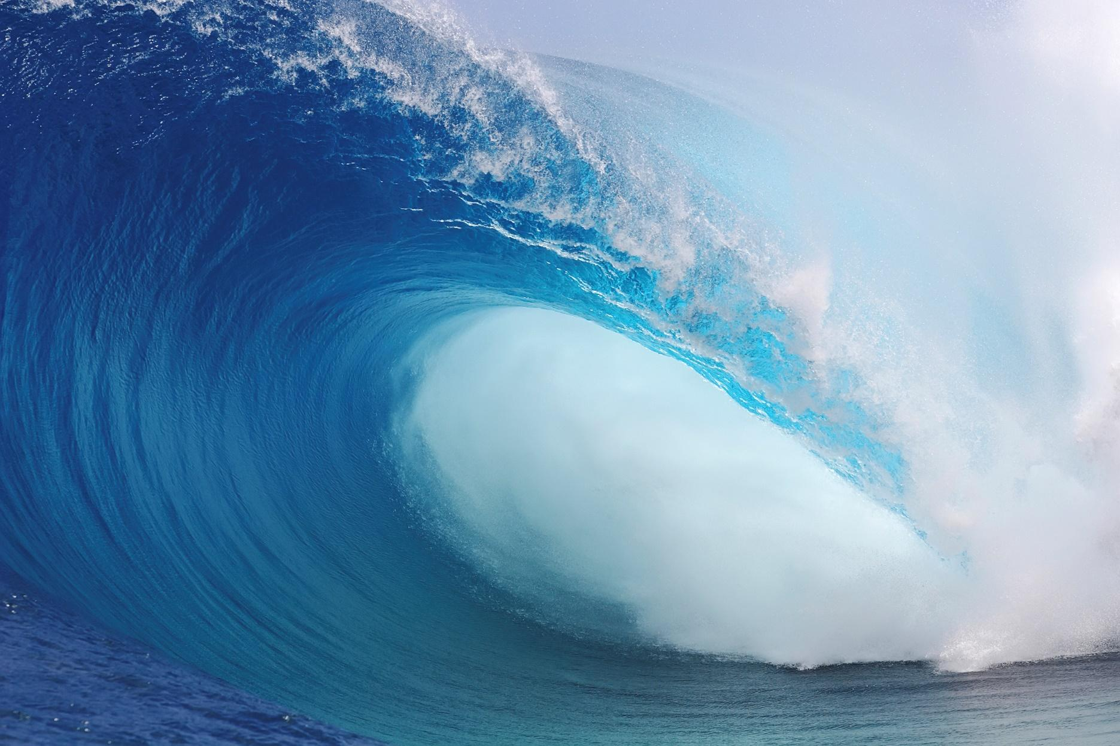
DRTV 101 MEDIA KIT
14375 Myerlake Circle
Clearwater, FL 33760
(813) 944-2926

FOR IMMEDIATE RELEASE
CONTACT: William Korte
Direct: (813) 944-2926 (ext. 163)
Cell: (727) 735 – 3197
Email: william@bluewatermedia.tv

Direct response giants Andy Latimer, Rick Petry to launch new eBook

CLEARWATER, Fla. (June 2018) – Andy Latimer, CEO of Clearwater, Florida based creative groups Bluewater Media and Zahalo partnered with Rick Petry a direct response marketing guru of over 20 years, have written an eBook that serves as a definitive guide to navigating the direct response marketplace.

Latimer is a proven director and producer with over 25 years in direct response marketing, television and film. As an industry leader and innovator Latimer has consistently developed new techniques in marketing direct to consumer. Latimer has lead his Bluewater team to develop industry leading solutions that integrate direct response strategies with online content and product distribution to deliver real measurable results and profits in the integrated world.

Petry has worked with virtually every product category from fitness to housewares to financial services. During his tenure as president of the agency today known as Euro RSCG Edge, Petry was instrumental in building the world’s largest DRTV agency.

Latimer’s agency has produced nationally recognized campaigns and TV spots for big brands like Philips and Soda Stream and has helped early stage and startups like Blackstone Products and Thundershirt become household brands. Along the way Latimer has had the opportunity to work with talent like Kid Rock, Paula Deen, Gordon Ramsey, Jillian Michaels and others. Petry has helped clients such as Bowflex, Char-Broil, Mirro Wearever and Select Comfort realize over a $1 billion in direct sales.

The two now want to share their knowledge and experience in the field of direct response TV marketing with their new eBook, “Direct Response Marketing 101”

ABOUT BLUEWATER MEDIA: We are a brand focused converged creative agency that utilizes branded direct response, brand integration, digital marketing and traditional advertising methods to introduce products to market. Bluewater media was the first end-to-end, fully digital, tapeless studio in the state of Florida.

Andy Latimer: The face of Bluewater Media/ Zahalo

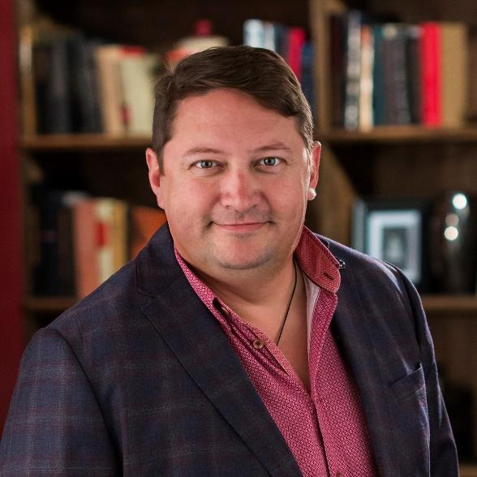
Andy Latimer is the CEO and head of Clearwater, Florida based companies Bluewater Media and Zahalo. He is a visionary, a proven producer/direct and industry leader with over 25 years of experience in the television, film and direct to consumer marketing.

In 2015 as CEO of Bluewater Media, he lead the company to be named the second fastest growing business in Florida. Under his leadership, Bluewater Media lead the way in creative and production, being the first ever end-to-end, fully digital tapeless studio in the state of Florida. As the market shifted, he led Bluewater Media through the evolution in direct to consumer strategies, founding Zahalo and becoming a leader in the digital, social media and influencer marketplace. He has made Bluewater family of companies market leaders in direct to consumer engagement.

With a keen understanding of the effectiveness of content on television and online, Latimer has created a seamless integration that takes consumers from the first exposure to a brand, product or services through the transaction and engagement whether online, in store or on the phone. The strategies he deploys have gained national attention with creative being featured on multiple national news channels and driving sales for brands large and small. An example of this is the evolution of a viral to broadcast campaign model implemented to make products like Kid Rock's American Badass Grill a huge success.

Latimer has worked on multiple news and documentary projects including working for CNN’s TalkBack Live, the CNN Environmental Unit and NBC Nightly News along with working as a producer on multiple nationally distributed public television programs. Latimer has served as executive producer, writer and director on multiple documentaries including “Zero Energy America” and “Ivan Lendl: Return of a Champion” for the Tennis Channel.

In addition to his experience as a producer of content, Latimer has achieved great results as a television commercial director and brand strategist including working with brands like Craftsman, Philips, SodaStream, Blackstone, Big Green Egg, Fleischer and Wolf, Magic Jack, Publix, ThunderShirt, Kid Rock’s American Badass Grill, Bialetti, Corvex, Wolfgang Puck, Inventi and many more.
Backgrounder:
June 2018

Direct Response Marketing 101

- Written by Andy Latimer, CEO of Bluewater Media and Zahalo and Rick Petry, direct response marketing guru and former president of Euro RSCG Edge

- Delivers the five traits of a successful TV and direct to consumer product.

- Gives marketers who are unfamiliar with direct response a better understanding of the discipline and helps to create a common language for those who already do.

- Defines the key components of how to take a direct to consumer product to market in a step by step guide.

- Breaks down numerous parts of direct response marketing ranging from research to scripting, casting and fulfillment.

- Defines key terms and identifies measurable and analytical factors to success

- Offers unique insights about SEO, paid online advertising, marketplace management, SEM and merchant account processing.

- Provides real world examples.

- Uses charts, graphs, illustrations and quotes from movers and shakers of the industry to break down complex conceptualities into real, practical practices for business.

Bluewater Media and Zahalo Fact Sheet

History: Bluewater Media was founded in 2005, with a focus on creative, but quickly expanded to include media and digital services. In 2016 the company merged its digital division with DNA Response, an Amazon marketing company to form Zahalo which has a focus on marketing at the point of transaction. In 2015 Bluewater Media was named the second fastest growing private company in Florida. Bluewater was the first ever end-to-end, fully digital tapeless studio in the state of Florida.

The Team: Bluewater Media is made up of 70 Direct Marketing professionals that provide creative, digital and media buying services, and E-commerce marketplace management. The commitment and closeness of the team provide a boutique shop feel while delivering big agency results in today’s converged world.

Logistics: Bluewater offers a 33,000 sq. ft. studio with two stages, a 4K 60P 6 camera mobile control room, a 6-suite networked avid post production facility, a satellite and fiber broadcast center, a 64-track digital audio recording studio, original music composition, 3 suite 3D animation/graphics studio, brand identity concept and creation, brand messaging concept and creation, script to screen services and a talent booking agency. Bluewater handles the entire campaign, from creative to building a website, payment options, production; everything from the concept of the model to the finished product with a campaign is all done under one roof.

Key Staff:
CEO, Bluewater Media/ Zahalo Andy Latimer
Principle, Bluewater Media: Brian Fasulo
President, Bluewater Media Studios: Rob Fallon
President, Bluewater Media Division: Gina Pomponi
President, Zahalo: Sandy Goldman
Partner, Director of Post Production: Mark Henning

Other: Bluewater’s team has built successful campaigns in every major category; their branded response model allows for increasing ROI effectively and they understand the marketplace and its nuances. Bluewater Media is a brand focused converged agency and creative group that utilizes branded direct response, brand integration and traditional advertising methods to grow businesses.
Rick Petry: Creative Writer LLC
Rick Petry was instrumental in helping grow one of the largest domestic DR marketing agencies, The Tyee Group, to unprecedented growth, resulting in its acquisition and integration into the Havas global agency network.
Today, Petry supports clients as a writer, director and consultant who specializes in direct marketing for both B2C and B2B clients. Brands Petry has worked with over the years include Bosley, Bowflex, CharBroil, Education Connection, FanDuel, GOLO, Joybird.com, OYO Fitness, Philips Consumer Electronics, Revitive and a host of others. He is a past chairman of the board of ERA and has published over 200 articles, columns and blogs on direct marketing best practices.
Petry is the recipient of the ERA Volunteer of the Year and the DRMA Member of the Year. He is a popular industry speaker whose previous appearances have included The Great Ideas Summit, D2C, NATPE, MTC Expo, Response Expo, and Retail Industry Leaders Association. Petry can be reached at 503-740-9065 or through email at rick.petry@icloud.com. For more information on him and his services go to www.rickpetry.com.

