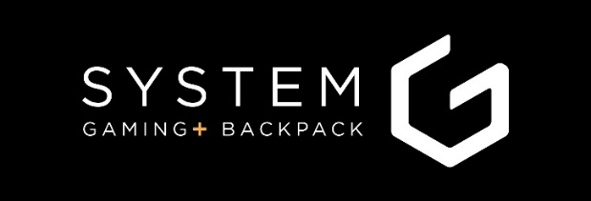

FOR IMMEDIATE RELEASE 12 July 2018 ___________________________________________________________________________________________

SYSTEM G to Launch GAMING+ Backpack on Kickstarter
The Gaming Backpack. For Everyone.
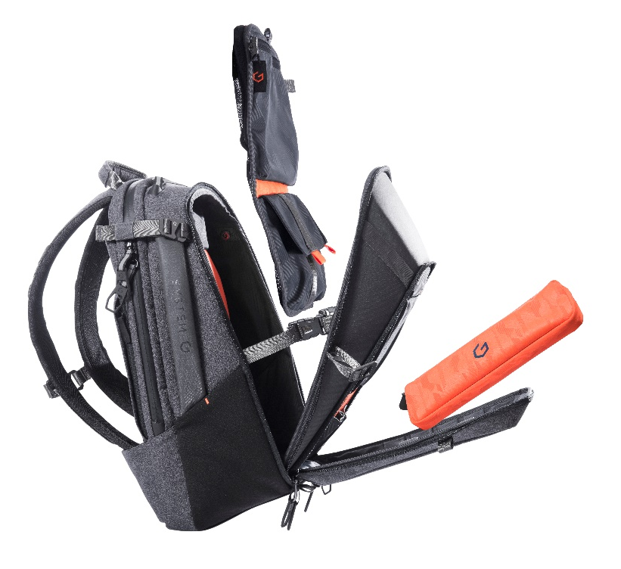
Introducing the SYSTEM G GAMING+ Backpack.
Conceived as a full feature backpack that caters to gamers and everyone that wants to carry the daily gear that the modern world demands, in a meticulously designed and engineered package

SYSTEM G GAMING+ BACKPACK is different.
With so much experience gained from designing bags for a host of international brands in gaming and utility backpacks, the team at SYSTEM G decided to put all this knowledge into what we believe offers the best, most practical and versatile storage in a small form factor.
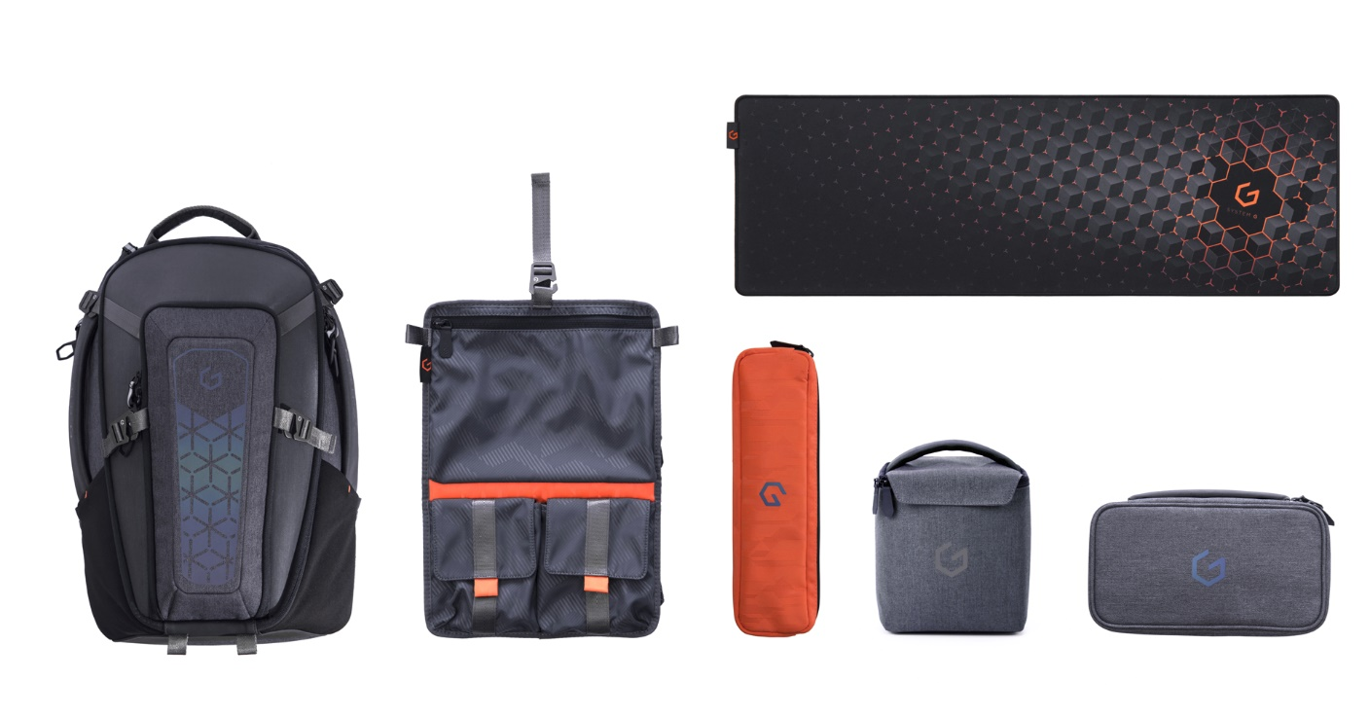
Insane attention to detail, beautiful premium materials, custom hardware and a whole collection of accessories go into the GAMING+ BACKPACK - whether gaming, travelling, photographing or just organising your life, we’ve designed a complementary product for each so you can customise the way you want to carry.
In short, SYSTEM G GAMING+ BACKPACK is one the most versatile & well thought out backpacks on the market.
Gaming+ BACKPACK
- Available in 2 sizes to hold 15 & 17-inch laptops
- Each backpack includes a removable travel organizer for storing clothes and a removable cable management pouch
- Optional extras include – mousepad, camera bag & accessory pack
- Metallic finish formed EVA shell for protection of all your gear
- All weather outer material and zippers
- Reflective chroma print (Front & Back)
- Quick release G hook, Interlocking G zipper puller for double security
- Heavy coated TPU bottom for extra durability
- Documents compartment
- Air flow back channel with breathable mesh cushion to keep cool
- RFID blocking side pockets for data protection with quick access to cards and keys
- Cushioned side carrying handles and shoulder strap storage
- Hidden security side pockets for small accessories
- Built in luggage strap which can be zipped to become document holder
- Security pocket on back panel to hide mobile phone, wallet and other valuable items
- Hidden bottom straps & G hooks for carrying large items such as mouse pad, tripod, travel pillow etc.
- Top Sunglasses Pocket for quick access
- Buckled Headphone Holder strap
- Large bottom pocket for Gaming console
- Keyboard Storage
- Mouse Pocket
- Power Adaptor Pocket
About System G
The Gaming+ backpack comes from a team of award winning designers and manufacturing professionals with decades of experience that have brought hundreds of carrying products to life and delivered in the millions. We know what we’re doing. We know what it takes to design, develop, test and produce at scale – on time and on budget. With a full complement of sourcing, supply chain and quality professionals to support from develop to delivery we’re highly confident that once funded, manufacturing and fulfilment will run on time, the same as any of our other projects.

Available exclusively on Kickstarter, starting 8th August 2018 with heavily-discounted early bird prices.
Register at www.systemG.co for a chance to win one of our SYSTEM G mouse pads.

Contact Us
Simon Masters Simon@systemG.co
Lucia Sohn Lucia@systemG.co

Download Press pack
DOWNLOAD_SYSTEM G PRESS PACK
More images and videos are available upon request

Website
www.systemG.co

Follow Us
@systemgbackpack Facebook Instagram Pinterest

Visiting and mail address
Unit 13, 15-16, 28/F, Paul Y. Centre, 51 HungTo Road, Kwun Tong, Kowloon, Hong Kong

