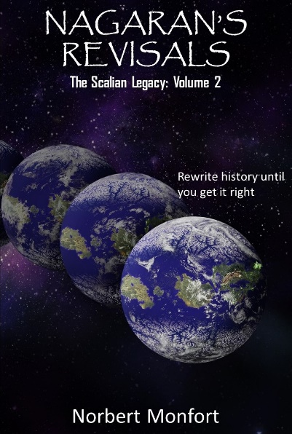
Much Anticipated Science Fiction Sequel Released
Miami, FL [July 19, 2018] – Science fiction fans are in for a treat as Norbert Monfort has created a sequel to his most successful novel – The Scalian Legacy. Set in both the distant future and the present, Nagaran’s Revisals takes the reader on a roller coaster ride through time. Access to a time dilation wormhole has allowed an alien species to wreak havoc on the time continuum. The possibilities of such an event are fully explored with unexpected results as manipulations of time lead to unintended consequences. Sprinkle in some humor, moral dilemmas and plenty of action and science fiction fans will have difficulty putting the book down.
The Scalians are back! In another surprising twist, the end of The Scalian Legacy was not as it seemed, and humanity is still in grave danger. In Nagaran's Revisals, Admiral Tarza matches wits once more with humanity and their allied species for control of the galaxy and time itself. Timelines change rapidly, and the theater of battle spans several millennia in this fast-paced space odyssey. Jack Felder, his brothers, Anterian Rivas, Doctor Simon and other entertaining figures from the original book are joined by new characters as the epic adventure expands and the mysteries of Scalia's past are revealed.
Nagaran’s Revisals is available on Amazon and other select locations.
Amazon links:
The Scalian Legacy Softcover – https://www.amazon.com/Scalian-Legacy-Norbert-Monfort/dp/1534645209
The Scalian Legacy eBook – https://www.amazon.com/Scalian-Legacy-Victory-Before-War-ebook/dp/B01H8XSND2
Nagaran’s Revisals Softcover – https://www.amazon.com/Nagarans-Revisals-Scalian-Legacy-2/dp/1722176547
Nagaran’s Revisals eBook – https://www.amazon.com/dp/B07FP6J96C

About the Author
Norbert Monfort has worked in the IT field at Fortune 500 companies for over 30 years as a senior engineer and in management. He is currently the Vice President of IT Transformation and Innovation at Assurant, Inc. He has spoken at conferences and published articles on the use of Artificial Intelligence and related topics. Norbert holds a B.S. in Computer Science from Florida International University (FIU) and an M.S. in Information Technology from FIU. Norbert is also an Adjunct Professor at FIU teaching IT related subject.
Norbert has authored four books with "Nagaran's Revisals" being the latest - a sequel of his most successful novel (The Scalian Legacy).
Married with three children, Norbert has participated in Scouting for many years enjoying the outdoors with his children. Norbert combines his technical expertise, outdoor experience and joy of Science Fiction to create thrilling and unique reading experiences.
Author site - https://themonforts.wixsite.com/norbertmonfort
Softcover
ISBN: 978-1722176549
Page Count: 329
Release Date: 07/18/2018
Price $15.99 (eBook $2.99)
https://themonforts.wixsite.com/norbertmonfort
NAGARAN’S
REVISALS

A NOVEL

NORBERT MONFORT

