Press Release Contacts: For Immediate Release Vinitaly International
International Media Dept.

+39 045 8101447
media@vinitalytour.com
www.vinitalyinternational.com
Twitter: @VinitalyTour
Join Italian Wine Community on LinkedIn

Federvini, Unione Italiana Vini, FederDOC, and FIVI Vignaioli Indipendenti forge ahead to form the Institutional Advisory Board for Vinitaly International Academy

Vinitaly International Academy (VIA) welcomes the main Italian associations in the wine industry in support of its educational project. Following the appointment of Italian academic Prof. Attilio Scienza as its Chief Scientist, VIA starts a productive dialogue with Federvini, Unione Italiana Vini (UIV), FederDOC, and FIVI Vignaioli Indipendenti on the trajectories of Italian wine education abroad.
On Friday July 13th, 2018, VIA Founder Stevie Kim and VIA Chief Scientist Attilio Scienza met the representatives of the four major institutions in the Italian wine sector, that will form the new VIA’s Institutional Advisory Board. At wine2digital in Verona, Kim and Scienza discussed VIA’s enlarged and reformatted project with FederDOC President Riccardo Ricci Curbastro and Director Cristiana Tirabovi, Federvini Director Ottavio Cagiano, UIV Communications Director Giulio Somma, and FIVI President Matilde Poggi. The associations endorsed VIA’s new directions and commitment to build the international gold standard for Italian wine education as well as the so-called VIA Ecosystem, the educational and administrative infrastructure that will engage not only wineries and professionals from all over the world, but also the Italian wine world at large, with local bodies like consortiums. VIA’s Institutional Advisory Board members will act as the institutional guarantors of the project and will help enhance the connections between the sector in Italy and international trade professionals that come to Italy to learn more about its wines.
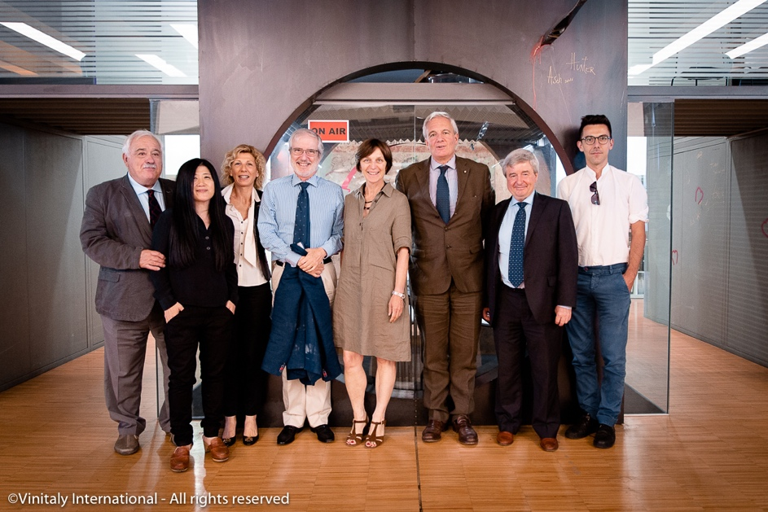
Left to right: Prof. Attilio Scienza (Chief Scientist, Vinitaly International Academy); Stevie Kim (Founder of VIA); Cristiana Tirabovi (Director, FederDOC); Ottavio Cagiano (Director, Federvini); Matilde Poggi (President, FIVI); Riccardo Ricci Curbastro (President, FederDOC); Giulio Somma (Communications Director, UIV); Tommaso Iori (FIVI).

In the Italian wine sector, the four institutions that will collaborate with VIA oversee the interests of wineries and of wine production in Italy. FederDOC (Confederazione Nazionale Consorzi Volontari per la tutela delle denominazioni dei vini italiani) is the national association that groups together wine consortiums and that looks after the certification of territory-specific appellations. Federvini is the industrial association bringing under its tutelage larger producers of wine, spirits, vinegar, and other wine-related products. UIV (Unione Italiana Vini) is a category-specific association of winery owners instituted in 1895 that combines all the various companies pertaining to the sector (individual wine growers, more structured wineries, wine cooperatives and industries). FIVI (Federazione Italiana Vignaioli Indipendenti) is the association that lobbies at national and European level to safeguard independent wine growers.
All representatives of the associations fully supported VIA’s educational objectives and gave their availability and commitment to work together in the name of Italian wine. FIVI President Matilde Poggi comments: “We are very proud, and I am very proud to have been invited here to participate as part of the Institutional Advisory Board. I believe that Vinitaly International Academy is doing exactly what was really needed for Italian wine and no one else has achieved this thus far.” Federvini Director Ottavio Cagiano acknowledges VIA’s efforts in its educational enterprise: “At the forefront, Vinitaly International Academy has done enormous work in this area. We are very interested and in need of this collaboration with VIA as we look to improve on the way we develop future initiatives.” On the collaboration with VIA, FederDOC president Curbastro adds: “We always talk about Italian wine as one of the great masterpieces of the world, but it’s true that we need more and more passionate ambassadors and people that can better develop and interpret the knowledge about what we do, the passion of the producers, the different landscapes and the different territories we represent. For this reason, the cooperation between FederDOC and Vinitaly Academy is something that I see as one of the key points for the future of Italian wine.” UIV’s Communications Director Giulio Somma looks forward to working with VIA, stressing that the collaboration is “the first organized experience of high-level education on Italian wine, an essential tool to promote the diversity of Italian wine and its richness in production. UIV is willing to contribute as a system of wine companies and avail of the benefits of this collaboration and educational activities for their members and, more generally, for the Italian wine companies, thus starting a dialogue that will be very important, surely, for the whole wine sector.”
The next VIA Certification Course will take place in Hong Kong from November 4th to 8th, prior to the Hong Kong International Wine & Spirits Fair. It will be taught by new Faculty members Sarah Heller MW and Henry Davar. The application form and additional information are available here: https://www.vinitalyinternational.com/?page_id=1785.

About
The grand Vinitaly 2019 will be held from April 7th to the 10th. Every year, Vinitaly counts more than 4,000 exhibitors on a 100,000+ square meter area and 130,000 visitors from over 140 different countries with more than 30,000 top international buyers. The premier event to Vinitaly, OperaWine (https://www.vinitalyinternational.com/?page_id=646) “Finest Italian Wines: 100 Great Producers,” which will be held on the 6th of April, one day prior to Vinitaly will unite international wine professionals in the heart of Verona, offering them the unique opportunity to discover and taste the wines of the 100 Best Italian Producers, as selected by Wine Spectator. Since 1998 Vinitaly International travels to several countries such as Russia, China, USA and Hong Kong thanks to its strategic arm abroad, Vinitaly International. In February 2014 Vinitaly International launched an educational project, the Vinitaly International Academy (VIA) with the aim of divulging and broadcasting the excellence and diversity of Italian wine around the globe. VIA this year launched the seventh edition of its Certification Course and today counts 151 Italian Wine Ambassadors and 11 Italian Wine Experts.

