My Plates to auction the 1980’s and 1990’s
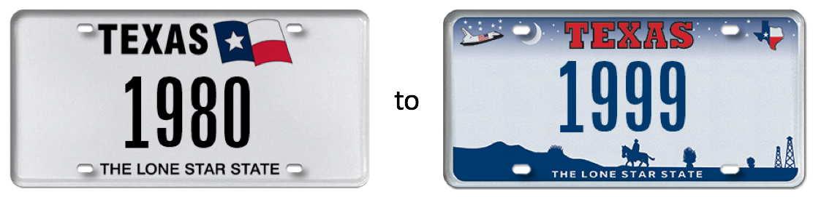
(Austin, TX) July 18, 2017 – If you are ready for some GREAT summer fun, then the “My Plates Decades Auction” has something for you! The State of Texas’ official specialty license plate vendor has released a TOTALLY cool assortment of 25 special auction plate messages, awaiting you at www.myplates.com/auction. Along with these and other GREAT plate messages, My Plates is also releasing rare 4-digit plate messages covering the decades of the 80’s and 90’s. The numeric plate messages on offer begin with 1980, and skip through the decades up to, cue lyrics, party like it’s 1999.
The 1980’s were full of amazing people, things and events. The 80’s saw the end of the Cold War and the rise of synthesized music. Pop culture was more important to people than ever before and when it came to fashion, the 1980’s weren’t subtle. LIKE big hair and bright colors of neon and pastels were the rage. Fashion color combinations were commended for their creativity. Music was over-digitized, and commercialism consumed everyone. 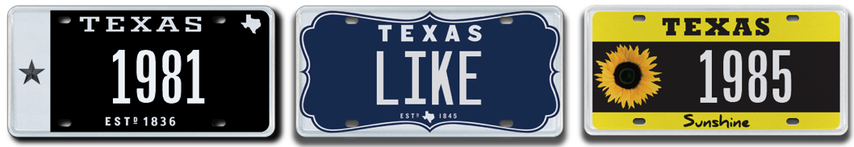
The 1990’s were a really intense decade. First, we start off with a war, the first Iraq War (AKA Desert Storm). Then we get the birth of “grunge” as Seattle takes over the way everyone dresses and listens to music. Hip hop also had a huge impact on the way people dressed, talked and acted. Sports became even more popular than they were before particularly in Texas. The 90’s were good to the Cowboys, winning three Super Bowls, 93, 94 & 96. Then there’s the basketball championships with the Rockets wins in 94 & 95 and the Spurs in 99. Let’s not forget the Stars bringing home the Stanley Cup in 1999.
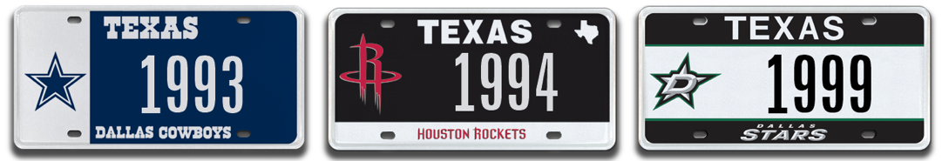
The My Plates Decades Auction is conducted online, where registration and bidding is so quick, secure and EZ PZ that you’ll FOR SURE feel positive the instant you begin bidding.

The auction opens on July 18, 2018 just after midnight and will run through 8pm Central on August 15, 2018. For more details head to www.myplates.com/auction.

My Plates auction plates are unique beyond their messages and rareness. Unlike everyday Texas license plate messages, My Plates auction plate messages are legally transferable. This means the plate owner has the right to pass it on to a family member, or gift to a friend. Transferability also means these plates can be sold, and therefore could make great investments. Any future recipient also gets the same ongoing transfer rights.

All plate messages within this auction come with a 5-year term, first right to renew, and have an opening bid of only $500, with no reserve beyond that. If only the opening bid has been received when the auction closes, that will be the final and winning bid!

Auction Details:
My Plates Decades Auction dates:
- Begin Bid Date: Tuesday, 07-18-18 at 12:01 am
- End Bid Date: Wednesday, 08-15-18 at 8:00 pm

People interested in the auction can visit www.myplates.com/auction for more information and to view the complete list of plates for sale.

Plate messages being offered for auction are:

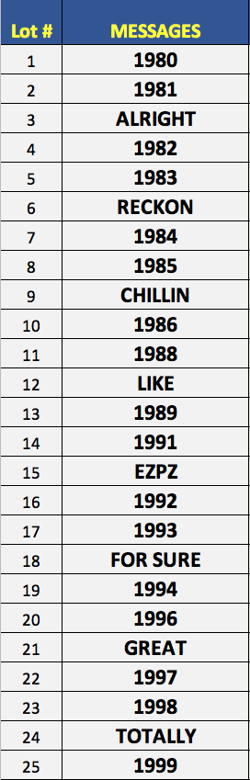

____________________________________________________________
Some Previous Auction Results:
- 12THMAN sold for $115,000, September 2013 making it the most expensive plate in Texas.
- HOUSTON sold for $25,000 in January 2013.
- ROCKETS sold for $16,500 in January 2013.
- FERRARI was sold at the very first My Plates auction in 2011 and sold for $15,000.
- J was sold for $10,500 in February 2018.
- ALAMO was sold for $10,250 in March 2016.
- 99 sold for $9,000 in April 2018.
- DALLAS sold for $7,250 in March 2014.
- 12 sold for $6,250 in November 2016.
- 1969 sold for $5,250 in August 2017.
____________________________________________________________

My Plates designs and markets new specialty license plates as a vendor for the Texas Department of Motor Vehicles. Texans have bought more than 370,000 My Plates since November 2009, putting more than $67M in the state general revenue fund. My Plates’ goal is to create a long-term, mutually beneficial relationship designed to maximize revenues for the state through the sale of My Plates specialty plates. www.myplates.com.

The Texas Department of Motor Vehicles (TxDMV) serves, protects and advances the citizens and industries in the state with quality motor vehicle related services. For every $1 it spends, TxDMV returns $11 to the state. Each year the agency registers more than 24 million vehicles; issues more than 8 million vehicle titles; licenses approximately 34,000 motor vehicle dealers and distributors; credentials more than 60,000 motor carriers; issues more than 650,000 oversize/overweight permits; investigates approximately 13,000 complaints against dealers and motor carriers; and awards grants to law enforcement agencies to reduce vehicle burglaries and thefts. Learn more at www.TxDMV.gov.
____________________________________________________________

For more information, contact Steve Farrar at (512) 633-7978 or steve@myplates.com

