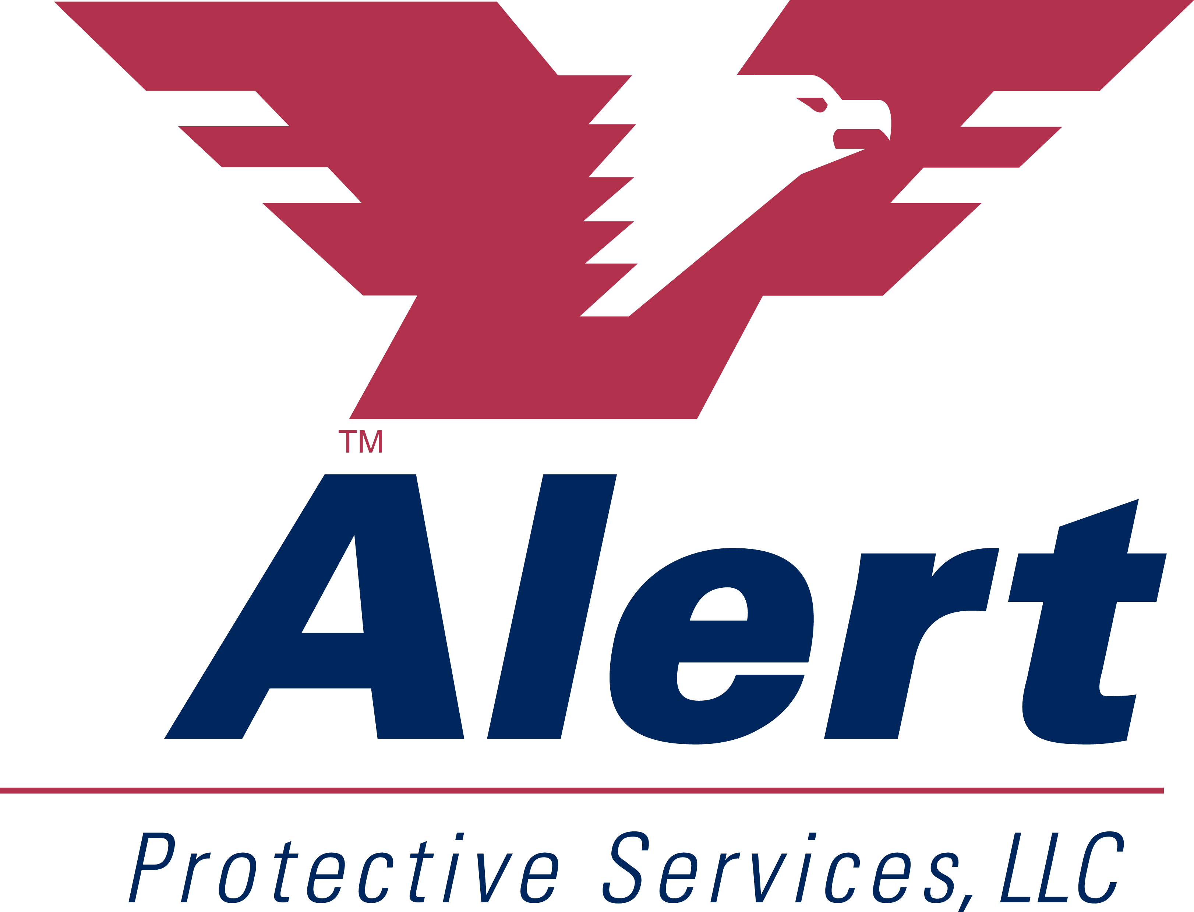Media Contact:
David Silberstein
President & CEO
Alert Protective Services
Office: 773-685-8383
david@alertprotective.com

PRESS RELEASE: August 7, 2018
FOR IMMEDIATE RELEASE
Alert Protective Services Partners with Roscoe Village Neighbors to Install Security Cameras
A recent crime wave prompts Chicago neighborhood to take action and raise $40,000 to fund network of cameras

CHICAGO -- On the heels of a string of robberies in May 2018, the Roscoe Village Neighbors (RVN) has partnered with Alert Protective Services on the launch of the “Neighborhood on Watch” (NOW) video camera program that will install high-definition security cameras in key undisclosed neighborhood locations to enhance security and deter crime.
WGN News reported in May a “mini crime wave” that saw eight armed robberies in one week in the Roscoe Village neighborhood.
“As crime continues to rise throughout Chicago, neighborhoods are forced to come together to create solutions for the safety of their residents,” said David Silberstein, President and CEO of Alert Protective Services. “This integrated security system is the first of its kind to be installed in Roscoe Village and will give the neighborhood’s 10,000 residents peace of mind that steps are being taken to solve this issue in the local community.”
All footage will be uploaded to a uniquely designed and encrypted cloud portal. If a crime occurs within Roscoe Village, the footage can be instantly retrieved and viewed by RVN administrators or Chicago Police detectives.
CWB Chicago reported on August 8th that one of the first cameras installed captured footage at Commonwealth Tavern at 2000 W. Roscoe Street of two suspects that helped police connect the same offenders to that theft and another in the area.
The NOW program will feature cameras and signage installed at strategic locations throughout Roscoe Village. Residents and business owners can enroll to have additional cameras installed on their properties that can be integrated into the cloud network regardless of their location.
Alert Protective Services will handle the installation and maintenance of the network and will also donate the signage that will be posted alongside the cameras at each location. To learn more about the NOW Network or to get a similar program implemented in your neighborhood, please contact nownetwork@alertprotective.com.
About Alert Protective Services
Alert Protective Services, LLC is Chicago’s leading security company. For nearly 40 years, Alert Protective’s mission has been to be “The Shield of True SecurityTM and to provide our residential, commercial and government clients with peace of mind by offering world-class customer service and leading technology across the alarm, camera, access control and life safety/security spectrum. 773-685-8383 www.alertprotective.com
About Roscoe Village Neighbors Association
Roscoe Village Neighbors Association is a 501(c)(3) working to provide enhanced safety and quality of life for the residents and business owners of Roscoe Village, an area bordered by Addison Street on the north, Belmont Avenue on the south, Ravenswood on the east, and the Chicago River on the west.
