Scientific Advances to Treat Scalp Conditions and Hair Loss
Solutions for Women - An Educational Seminar on September 18th

Parkersburg, WV - “Few things are more important to your appearance than your hair. It’s the one accessory that goes with you everywhere!” says Pamela Creel, owner of Aspire Salon in Parkersburg, West Virginia. An expert who has always sought the best for her clients, Pamela is now holding a free seminar on September 18th at 6:30 p.m. to introduce Head First, a combination of analysis and therapy that she believes is the next leap forward in hair and scalp health.

“While we have focused on the hair itself for generations, it’s both hair and scalp health that are vital to the best appearance. That’s why I’m delighted to have certification as a Head First hair renewal specialist,” says Pamela. With Head First, her salon can now help not only those experiencing aging hair and hair loss, but those who have a healthy scalp and hair and want to keep it that way. The science of trichology has advanced significantly in the last decade, and Head First has the most comprehensive line of products to offer.

"Modern Salon magazine recently did a study on hair loss and found that most people don't know what they can do or where to get help!" Pamela said. "That’s why I decided to sponsor a seminar to help educate women on their options. There are programs that can generate hair regrowth. If the hair follicle is void of hair but still alive, it is possible to stimulate new growth. If the hair follicle dies, there is no option other than transplantation. Timing is essential."

Pamela’s studio has been helping men, women and children since 1993, with a full range of services. Pamela herself noticed 15 years ago that her own hair was thinning. As a stylist, she wanted to know what could be done for herself and her customers. She investigated options like laser therapy, which can help certain clients. In 2011 she opened a hair restoration clinic to attract clients with thinning or aging hair, hair loss, and medical conditions. She found that a cancer resource center was seeking someone to help their patients who had lost hair due to chemotherapy.

“Then, in 2013, I went to a Hair Visions, International conference and it opened up a world of possibilities for my clients,” she says. “I learned about Head First, which isn’t just another solution but a whole system for identifying hair and scalp problems and applying the right therapy to each client. I was delighted!” Pamela earned her Head First certification, and now wants to offer what she knows to people who have been looking for answers. “This is a personalized, holistic approach, which is why clients are so pleased with it.”

Head First provides trichology scalp examinations with a camera that microscopically shows the conditions of the scalp and hair follicles. The Head First product line is lab-designed to address these problems with corrective treatments to stimulate blood flow and nutrients to the hair follicles. Bottom line: a healthy scalp leads to healthy hair.

The seminar will be led by Karla Hurtado of Hair Visions, an international company with decades of research and product experience. "Losing your hair can shake your confidence," says Karla. "This seminar provides the most up-to-date information on medically-endorsed and FDA-approved treatments. Every time we hold these events, women laugh, cry and bond over what they’ve experienced and what they see can be done with the proper treatment. The results can be life-changing. We always have so much fun at our seminars sharing stories with each other."

This free educational seminar will be on Tuesday, September 18 from 6:30-8:30pm at 705 Market Street in Parkersburg, WV . Response is typically enthusiastic, and seating is limited, so reservations are requested. Refreshments will be served. All attendees will receive a complementary microscopic hair and scalp analysis to address their individual concerns. To register, or for more information, call Pamela at 304.917.3633 or write to www.aspirewv.com.

###

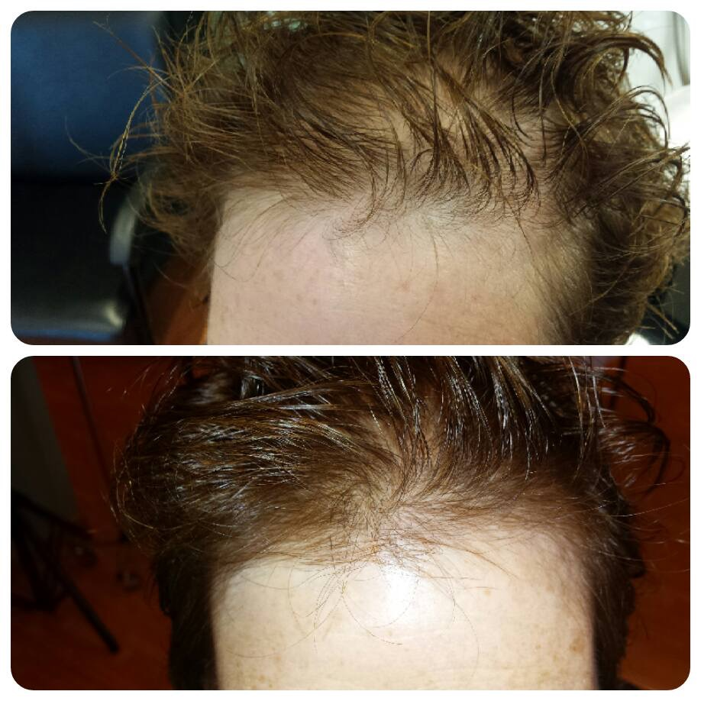

Client's hair regrowth after only 8 weeks on Head First Program.

