Cheap Numbing Creams Cost Too Much: Dr.Numb® Helps to Identify Authentic Product

In the age of online shopping and numerous discount offers, the hunt for a better deal often comes at a price. Following the number of stories shared on Internet about people suffering unexpected medical effects after the usage of non-registered product, Dr.Numb®, the leading topical anesthetic cream brand, warns the potential customers about risks and shares several simple tips how to identify the authentic product from a fake.
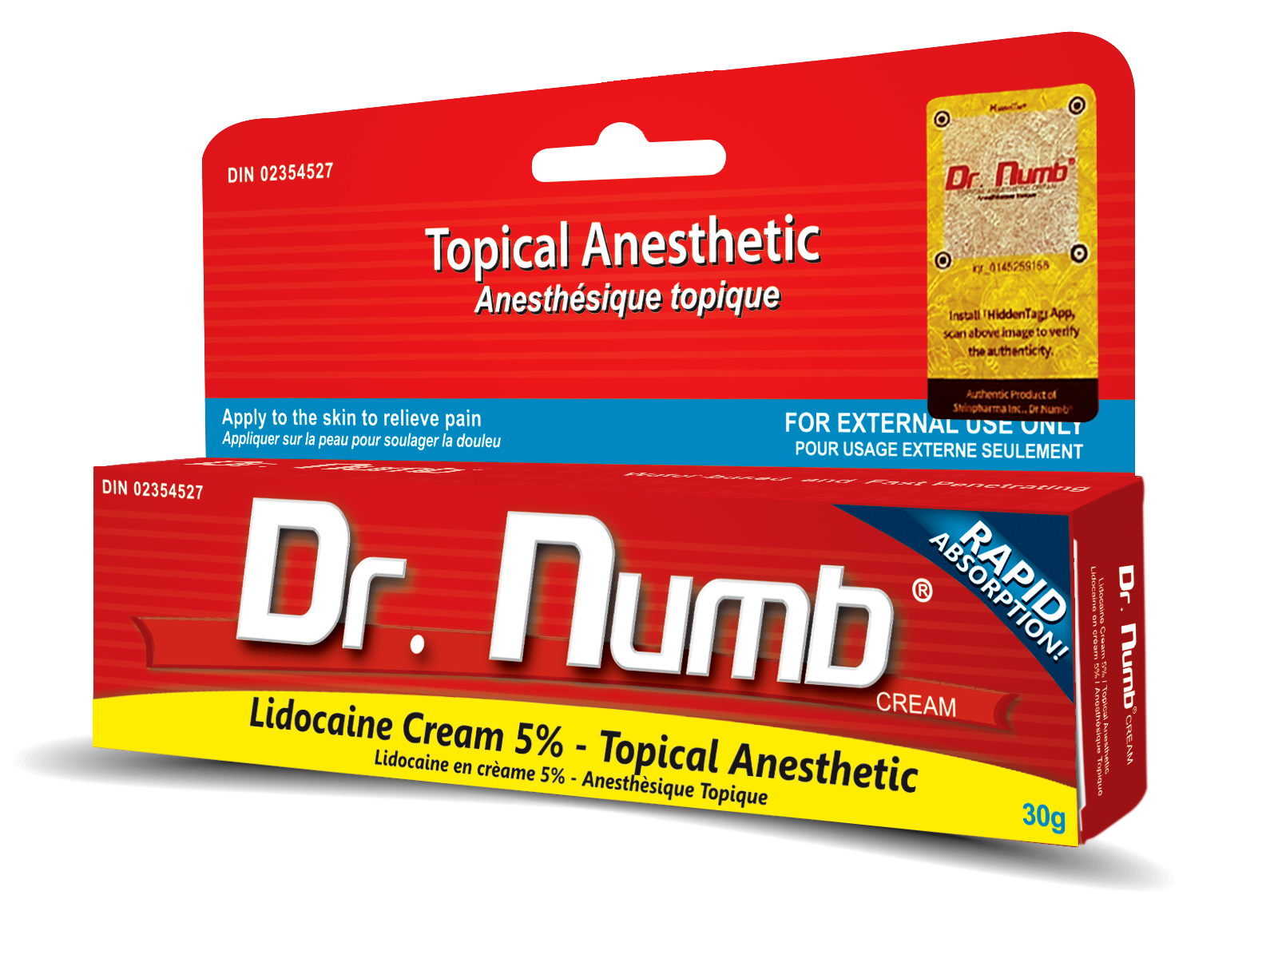
After the series of health accident cases happening all over Britain when people were buying fake anesthetic cream, Dr.Numb® worked closely with BBC program “Fake Britain” to investigate the case. The laboratory tests of the fakes revealed shocking results:
"We were looking for lidocaine which is what it states on the packaging and on the internet has been the active anesthetic ingredients. So lidocaine is a relatively safe product and there is no known real risk to humans. So when we run the tests on the counterfeit, we didn't find any lidocaine at all. IT CONTAINS TETRACAINE. Tetracaine has warnings associated with it. It's been found to cause fetal defects in animal experiments and there are no studies supporting that it is without risk in the use of humans. It's reckless to put this into a product and to label it as lidocaine.” - shares Paul Thomas, Professor of Analytical Science, Loughborough University.
"Lidocaine and Tetracaine are similar in the sense that they both work as local anesthetics. They're different in their chemical structure. Tetracaine has an ester-based structure, Lidocaine has an amide-based structure. What difference that does make, well there's higher instance to allergic reactions to ester-based anesthetics. The allergic reactions to tetracaine vary. It is possible to get a full blown anaphylactic reaction to tetracaine. So the fact that you can buy a cream which is supposed to contain lidocaine but in practice contains tetracaine is worrying, particularly if you then apply very large amount to your skin and cover it. It is that you run the risk of absorbing large amounts of tetracaine which would be very dangerous.” - adds Dr. Tom Clutton-Brock, Consultant Anesthetist at Queen Elizabeth Hospital Birmingham.

Founded over a decade ago by Canadian pharmaceutical company ShinPharma Inc., Dr.Numb® built its reputation as a brand of topical anesthetic products. The bright red packaging of Dr.Numb® today is recognized all over the world and is associated with the quality, efficiency and customer trust.
Although, this popularity turns out to have a downside: the number of counterfeit products is growing daily, confusing the customers and often causing dangerous consequences.
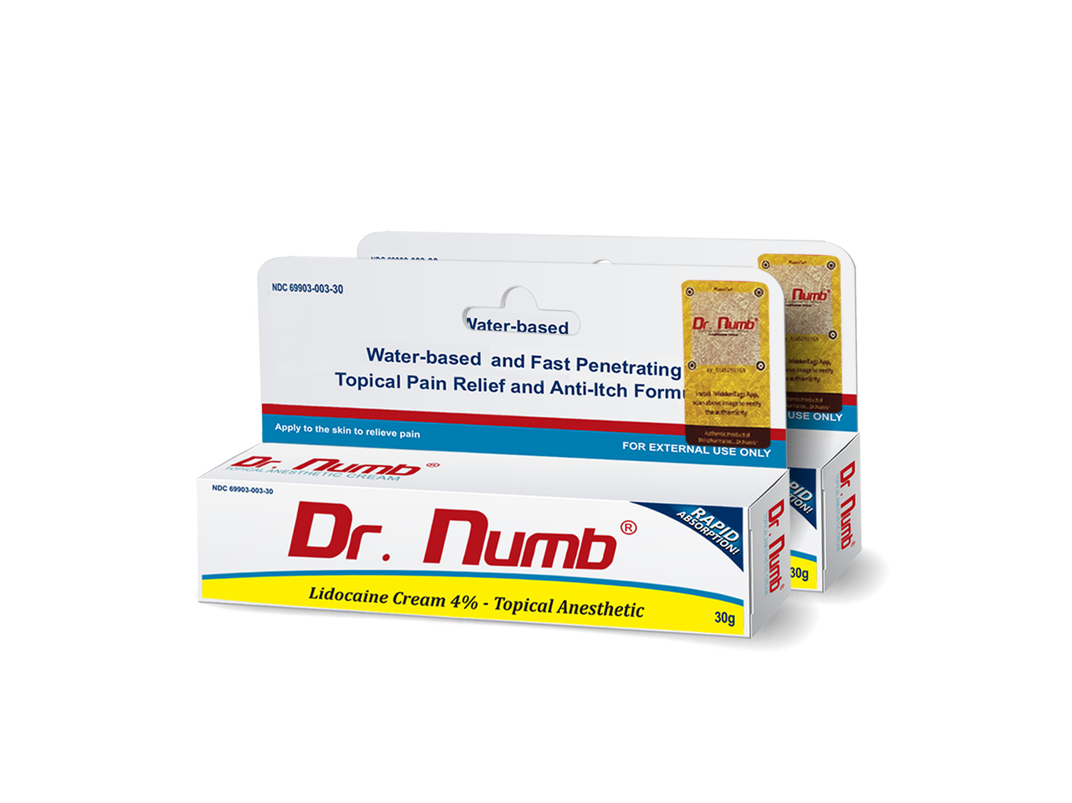“During the last year alone, we identified over 100 outlets which are selling counterfeit products, mostly within the aesthetic industries in Russia, UK, Eastern Europe and Asia. Sometimes, USA outlets also have some fake products even without realising it. Craig Crosby from the Counterfeit Report has taken down almost 10,000 of counterfeit product listings just on eBay each year which is a shame that eBay opens its door for counterfeit sellers to easily list the products for sale without verifying its origin such as by requesting sellers to produce certificate of analysis. Globally, the trafficking of counterfeit goods is growing and expanding its reach in a shocking speed. This growth is fueled by consumer demand and the desire to buy Dr. Numb® products at very cheap prices with little regard to possible dangers of using products with no certifications and have unknown origins.” - says Daniel Shin, the Founder of ShinPharma Inc.
Dr.Numb® creams are used in countless cosmetological procedures (such as tattoos, microblading, permanent and semi-permanent makeup, and waxing) and dermatological treatments (such as microneedling, laser treatments, injection of dermal fillers, etc.) all over the world. To make sure that the Dr. Numb® product on hand is real, Dr.Numb® has prepared some easy steps to distinguish the real from fake:

- Dr. Numb® manufactures both 4% and 5% lidocaine in North American Market.
This is the highest concentration of lidocaine allowed in North America to be sold as over-the-counter product. Numbing creams that contain higher than 5% active substance and claim to be OTCs are illegal products.
- Dr. Numb® has a shelf life of 3 years:
Each tube has batch number and expiration date clearly imprinted on the box and the tube itself. Dr. Numb® distributes fresh batch only. Every production batch goes through stability testing. The purpose of stability testing is to provide evidence on how the quality of a drug substance or drug product varies with time under the influence of a variety of environmental factors, such as temperature, humidity, and light, and to establish a retest period for the drug substance or a shelf life for the drug product and recommended storage conditions. Shinpharma Inc. will never release any product that has not gone through a testing. It is recommended to verify such documents for its authenticity and to ensure safety of the product. Call 1.877.786.2001 to verify batch number, authenticity and expiration.
- Dr. Numb® Packaging:
  - Box: The authentic Dr. Numb® box has vibrant colors of red, yellow and blue with prints both in English and Canadian French languages. The box should also have a hologram sticker label in the upper right corner which confirms the authenticity of the product. Data is embedded in the hologram stickers for scanning and serves as prevention of illegal copy attempts, protection of intellectual property rights, and confirmation of ownership through the embedded unique information into digital contents.
  - Fake Dr. Numb® products are commonly distributed in the market come in boxes with varying colors. with pale red, white and blue colors and claim to have 13% concentration of lidocaine, prilocaine and benzocaine.
  - Tube: The authentic Dr. Numb® tube material is made of High Density Polyethylene (HDPE) material, in which the surface appears smooth, shiny and not dented. The crimping of tube is also neat and clean.
  - The material used in counterfeit products are sometimes made of aluminum, a material that is not approved by Health Canada and Consumer Product Safety Commission (CPSC) as receptacle for substances such as lidocaine cream.
  - Leaflet Insert: All Dr. Numb® products come with a leaflet insert that contains product information and precaution. Fake Dr. Numb® products usually claim inappropriate uses of the product and false ingredient list.
- When buying Dr. Numb® on eBay or amazon, look for Authorized Resellers. Authorized Resellers can be looked up using the official Dr. Numb Retailer Map. For other inquiries pertaining to authorization / registration of Resellers, call 1.877.786.2001.

Choosing the authentic Dr. Numb® product is not only important for fighting counterfeit, but also for ensuring consumer safety. All Dr. Numb productions are Health Canada and FDA-compliant and are all properly documented and certified.

More about product range you can learn at: www.drnumb.com
Distributors and retailers can apply at: https://www.drnumb.com/become-a-drnumb-distributor/

ENDS

Contacts for media:
G&V Public Relations
Olga Glioza
olguitaglioza@yahoo.com
Ronnier Vergara
ronniervergara@yahoo.com

