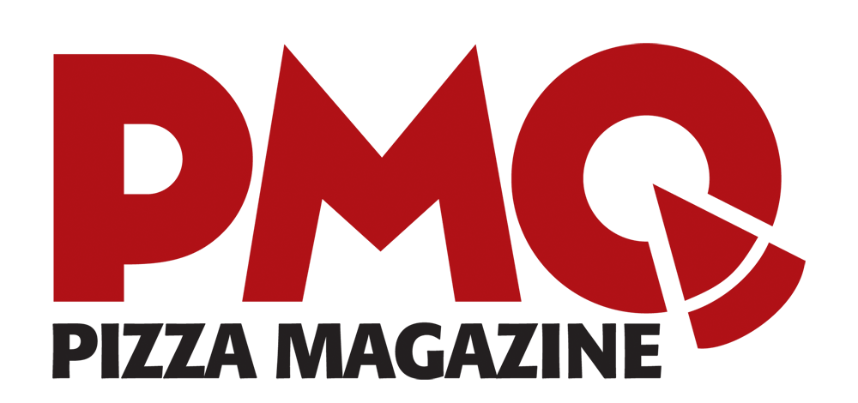
Heather Wilson
PMQ Pizza Magazine 662-234-5481, ext. 137
heather@pmq.com For Immediate Release

United States Pizza Team Announces Newest Sponsor

Promoting pizza through sportsmanship and a new partnership in 2018 as Galbani® becomes the platinum sponsor for the United States Pizza Team.

Oxford, MS, August 22, 2018 — Pizza Magazine Quarterly (PMQ) is proud to announce Galbani as the official platinum sponsor for the United States Pizza Team (USPT).

"We are proud to support the USPT as the platinum sponsor with our Galbani Italian cheeses. Just like the USPT, our goal is to support pizzaioli in all of their creative and competitive endeavors—and to help elevate the pizza industry as a whole,” said Gary Kolling, Marketing Director of Galbani. “We hope our Galbani Professionale cheese is a key factor in the success of the USPT and its members, this year and beyond."

“To have our team use Galbani Professionale cheese is an incredible honor and advantage. We greatly appreciate the support in bringing attention to the people and products that make pizza the world’s most beloved meal. It's a great day for pizza,” said CEO and Publisher of PMQ Steve Green.

First crafted in Italy by Egidio Galbani in 1882—Galbani® Italian cheeses have long been the #1 cheese brand in Italy. Today, Galbani is proud to offer its Professionale line of world-class Italian cheeses made in the Old World tradition for foodservice professionals, including Premio Mozzarella, Fresh Mozzarella, Ricotta, Mascarpone, Bel Paese, Blue, Gorgonzola, Provolone, Romano, Parmesan, and Asiago.

Lactalis American Group is the North American division of Groupe Lactalis and is the parent company of Sorrento Lactalis, Lactalis USA, and Mozzarella Fresca, which collectively include some of North America's most popular cheese brands: Président, Sorrento, Precious, rondelé, and Galbani. Lactalis American Group is a subsidiary of Parmalat S.p.A., an Italian public entity majority-owned by Groupe Lactalis. Headquartered in France, Groupe Lactalis is the world's largest dairy corporation.

PMQ Pizza Magazine, the business trade publication for the pizza restaurant industry, created the U.S. Pizza Team in 2000. Since its formation, the U.S. Pizza Team has participated in an international event every year, most frequently at the World Pizza Championship in Parma, Italy. Ranging from culinary masters to dough tossing phenoms, the Pizza Team renews the passion of those in the industry year after year.

For more information about contact Heather Cray at 662-234-5481 x 137 or email ​heather@pmq.com​. For more info on the Galbani brand, please visit ​www.​lactalisculinary.com/brands/galbani​.

###

###

