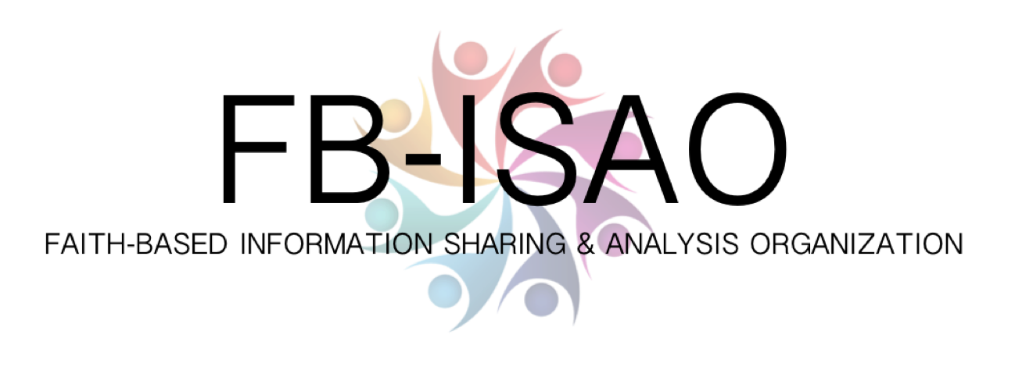

|  |  |
| --- | --- |
| **FOR IMMEDIATE RELEASE** | **Contact:** Mayya Saab, Faith-Based Information Sharing and Analysis Organization |
|  | **Phone: 703.963.3459** |
|  | **Email:** Mayya@faithbased-isao.org |

**Faith-Based Preparedness, Security & Resilience: Mitigation Through Collaboration**

## *Threat-Informed, Risk-Based, All-Hazards Information Sharing and Analysis for the Community of Faith*

**Leesburg, VIRGINIA, July 2018 —** Places of Worship tend to be where large numbers of people gather at open-access facilities on a regular basis and on a predictable schedule. From a threat mitigation perspective, that is a less than ideal. Domestically and internationally, physical security threats from crime and extremism continue on a regular basis. Beyond the physical threats, the community contends with the all-hazards threat environment including: natural hazards; health threats; and increasingly faith-based organizations are exposed to an array of cyber threats – from donor data, to potential website and services disruptions, to the potential of having unsecured endpoints weaponized or held for ransom, among other evolving threats. More than ever, the community of faith needs a platform to come together, share, analyze and understand the threat environment, associated risks, and viable mitigation solutions. [The Faith-Based Information Sharing and Analysis Organization](https://faithbased-isao.org/) (FB-ISAO) was founded in June 2018 to assist the community of faith enhance individual and collective risk management, as well as supporting this vital community in furthering the National Preparedness Goal. Bryan Ware, former CEO, Haystax Technology and a technology and national security expert, serves on the Advisory Board of FB-ISAO. Bryan said “FB-ISAO will help bring together leaders from the community of faith to share information, concerns, best practices, and other information in a trusted environment to help enhance both individual organizational and collective community security and resilience. In today’s environment, from extremists to cyber threats, we can’t operate in silos, neither as places of worship or other faiths. FB-ISAO will continue to help bring together the broad community of faith to work together to the betterment of our staff, our facilities, and all those who come to worship.”

Just as for other sectors, American faith-based organizations have a duty to meet the goal of a secure and resilient Nation with capabilities required across the whole community to prevent, protect against, mitigate, respond to, and recover from the various threats and hazards that pose the greatest risk. William Flynn, President GARDA Risk Management, LLC said “Faith-based organizations provide a sanctuary to those in need, but they often lack the foundational capabilities – information sharing, situational awareness and analysis – needed to make informed risk management decisions in today’s dynamic threat environment. FB-ISAO is a trusted partner and addresses those gaps with resources to ensure the resilience of religious organizations.” Partnering with technology and capability enhancing partners to provide a secure and robust information sharing community for its members, FB-ISAO sets out to meet its mission of providing members with information, analysis, and capabilities to help reduce risk while enhancing preparedness, security and resilience.

Meeting the needs of all faiths to share and exchange information on hazards, threats, mitigation and best practices puts the community of faith on par with other critical lifelines such as the Water and Wastewater Sector, vital services such as Healthcare and Public Health, and other critical infrastructure, such as Commercial Facilities. Effective collaboration allows organizations to be better prepared to deal with those threats and hazards by keeping each other informed in real-time.

FB-ISAO is a membership-driven organization that is open to US citizens of all faiths and their supporting organizations.

*The Faith-Based Information Sharing and Analysis Organization serves as a trusted partner at the center of a national network of faith-based organizations and associations that have been informed and equipped to****prevent****,****protect****against,****mitigate****,****respond****to, and****recover****from incidents arising from all-hazards, ensuring the****resilience****and****continuity****of these important community assets that include Cybersecurity incidents, Physical security incidents, Public health incidents and Natural disasters. Find us at* [*FB-ISAO*](https://faithbased-isao.org/) *and join the conversation on* [*Twitter*](https://twitter.com/faithbasedisao) *and* [*LinkedIn*](https://www.linkedin.com/company/fb-isao/)*.*

###

If you would like more information about this topic, please call Mayya Saab at 703.963.3459, or email mayya@faithbased-isao.org.