Press Release
Taipei, Taiwan – September 7th, 2018
Cincoze Launches P1100 Series Slim Embedded Computer with CDS Technology
Power Efficient, Reliable, and Comprehensive Display Options
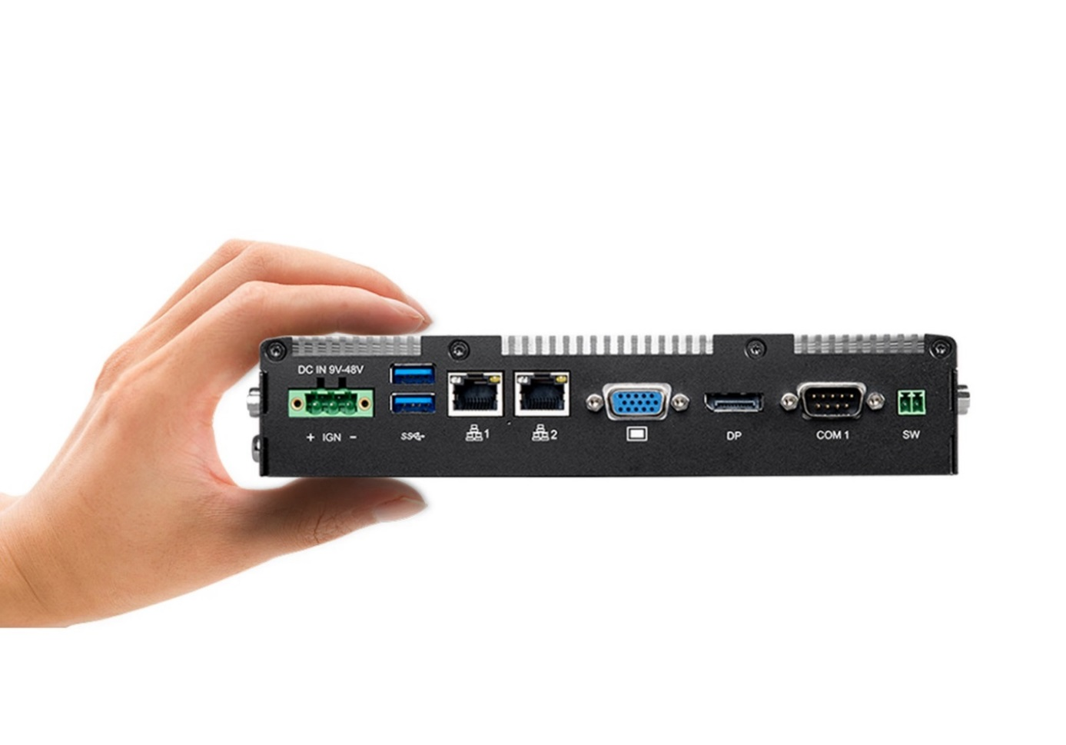
Cincoze, a professional manufacturer of embedded computing platforms, is pleased to introduce its latest fanless slim embedded computer “P1100 series”. The system is designed to be positioned as “One Computer, Two Appliances”, it can be used as both embedded computer or system module for industrial panel PC. PC-1100 series is powered by Intel® Apollo Lake processors including Intel® Atom® x7-E3950 and Intel® Pentium® N4200. Compared to Intel® Bay Trail platform, Intel® Apollo Lake processor increases 1.7 times more computing power and supports faster memory speeds. Integrated with Gen9 Intel® HD Graphics 505, the processor can deliver greatly increased video encode and playback performance for media-rich applications.
With an elegant appearance and a thin profile, P1100 series accommodates rich I/O interfaces, including 2x Intel GbE LAN, 4x USB 3.0, 4x COM, and 8x Isolated DIO. The system also supports three independent displays running simultaneously and enables smooth 4K/2K playback via DisplayPort. In addition, 2x mini PCIe slots and 1x SIM socket are supported to empower the system as a communication hub for wireless data connections. A 2.5” SATA drive bay and a mSATA socket with SATAIII (6 Gb/s) can be installed as a mass storage device. Moreover, users can install the ready-to-use CFM modules to add power ignition sensing and Power over Ethernet (PoE) functions for their specific applications.
The rugged design features include wide range operating temperature and anti-shock/vibration, Its wide range 9V-48V DC power input includes a lockable terminal block connector for industrial automation fields. Supporting with over-voltage, over-current, and power reverse protections, it protects the system against power input faults and ensures long-term stable operation in demanding environments. In addition, the slim embedded computer applies the standard VESA mounting hole pattern, DIN-rail mount, and wall mount for your installation needs.
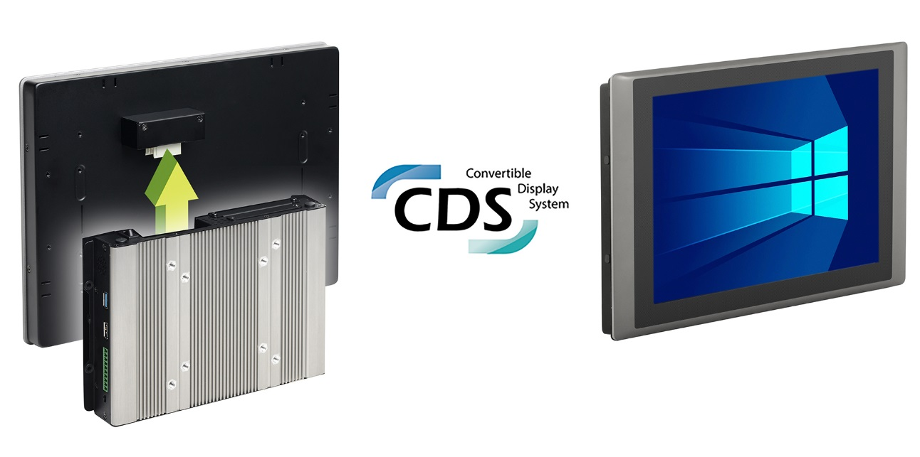
“By taking advantage of Cincoze patent CDS technology and its modular design, P1100 system module is 100% compatible with existing CDS display models. Users can upgrade their existing panel PC to Intel® Apollo Lake platform and take no any design risk.” said Brandon Chien, CEO of Cincoze. “The modular panel PC can easily be assembled by system module and display module, but without having to set BIOS and connect wires. It minimizes the maintenance efforts and offers a massive number of possible panel PC configurations under a low inventory.”
The combinations of P1100 panel PC are available in numerous versions covering a variety of display sizes from 8.4 to 21.5 inches, P-Cap multi-touch or resistive single-touch screen, ultra-high brightness displays, and optical bonding. Customers have a wide range of selection to build their SCADA/HMI system, outdoor KIOSK, and many other industrial applications.

P1100 Slim Embedded Computer (CDS System Module)
CDS System Module | P1101-E50 (Atom® E3950) | P1101-N42 (Pentium® N4200)

P1100 Industrial Panel PC Line Up
Panel Size (Resolution) | Indoor Series (300-500 nits) | Outdoor Series (up to 1,600 nits)
8.4” (SVGA) | CV-108/P1101 | --
10.4” (SVGA)  10.4" (XGA) | CV-110/P1101  CV-110H/P1101 | --  CS-110H/P1101*
12.1” (SVGA)  12.1" (XGA) | CV-112/P1101  CV-112H/P1101 | --  CS-112H/P1101*
15" (XGA) | CV-115/P1101 | CS-115/P1101*
17" (SXGA) | CV-117/P1101 | CS-117/P1101*
19" (SXGA) | CV-119/P1101 | CS-119/P1101*
15.6” (WXGA) | CV-W115/P1101 | --
21.5” (Full HD) | CV-W121/P1101 | --
- with optional Optical Bonding
About Cincoze
Cincoze, a professional manufacturer of embedded computing platforms. We design, manufacture, and market Rugged Fanless Computer, Industrial Panel PC, and Monitor for harsh and demanding environments. With its leading-edge products and application-driven functionalities, Cincoze enables new technologies and solutions for multiple applications, including factory automation, machine automation, machine vision, in-vehicle computing, intelligent transportation, and surveillance.

Cincoze Co., Ltd.
7F., No.4, Aly.1, Ln.235, Baociao Rd, Sindian Dist., New Taipei City 23145, Taiwan
Tel: +886-2-2918-8055
Fax: +886-2-2918-8066
http://www.cincoze.com/

All product names, logos, and brands are the property of their respective owners. All company, product and service names used in this document are for identification purposes only. Use of these names, logos, and brands does not imply endorsement.
Copyright 2018 Cincoze Co., Ltd. All rights reserved

