Rancard Launches R2 on Zendesk Inc. To Drive AI-Powered Customer Engagement

SAN FRANCISCO, CALIFORNIA, USA & ACCRA, GHANA. September 11, 2018 – Rancard, a leader in social recommendations and AI-powered customer engagement technology today announced the launch of R2 on Zendesk, Inc.

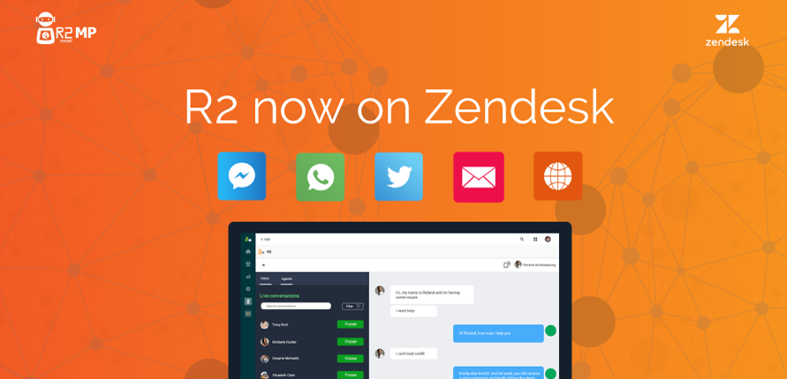

R2 is a virtual agent that makes use of best-in-class Machine Learning and AI to automate interactions between businesses and their customers.
R2 is your customized Artificially Intelligent (AI) personal assistant or customer service agent for both small and large businesses to build and manage an automated response system or bot to efficiently respond to customers’ requests.
The AI virtual agent or bot can handle all requests from customers and notify staff when it encounters any difficulties it can't handle. The virtual agent is subsequently trained to better handle all such difficulties, getting significantly better as it matures.
R2 also makes available the necessary reports and analysis to provide better visibility as to how the virtual agent is performing and what customers are requesting. These tools empower you to make better decisions to optimize and grow your business.

The R2 platform is available now starting free on Zendesk platform and customized packages are also available at https://r2mp.rancard.com/register

About Rancard
Rancard is a social recommendations technology leader for online retail and places, with its Rendezvous AI bot featured by Facebook at F8 2017. Rendezvous connects online retailers and other eCommerce platforms to “conversational recommendations” based on contextual trust among friends.

Rancard historically revolutionized mobile value added services through developing a carrier grade cloud-based mobile service delivery platform in 2007, connecting Google, MTV, BBC, ESPN, VOA and other global enterprises to carriers across 3 continents and 25 countries.
See more at www.rancard.com

