Press Release Contacts:
For Immediate Release Vinitaly International
International Media Dept.

+39 045 8101447
media@vinitalytour.com
www.vinitalyinternational.com
Twitter: @VinitalyTour
Join Italian Wine Community on LinkedIn

CEO of Krug Champagne, youngest Master of Wine, and President of GuildSomm to lead wine2wine 2018 line-up

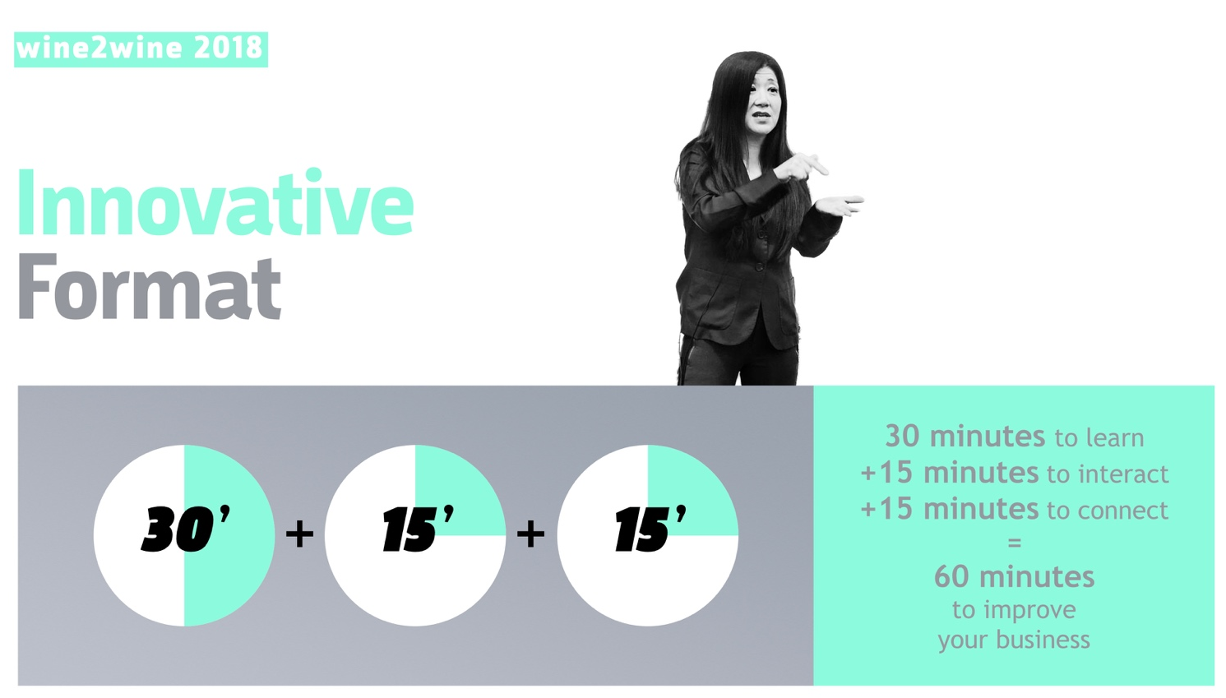

wine2wine is the most important forum on the wine business in Italy, as well as the reference point for wine professionals wishing to develop their business. The 2018 edition, to be held at the Veronafiere Congress Center on November 26th and 27th, showcases a new 45-minute format and a prestigious line-up of international speakers featuring, among others, CEO of Krug Champagne Margareth Henriquez, Master of Wine Sarah Heller, and President of sommelier association GuildSomm Geoff Kruth.
wine2wine offers wine professionals the opportunity to meet, share ideas, and acquire in-depth knowledge on specific themes ranging from digital innovation, communications, and marketing to export, market focuses, sustainability, and more.
At wine2wine 2018, wine producers, export and marketing managers, consultants, journalists, and experts from all spheres of the wine business will gather for a unique chance to participate in educational sessions, labs, and workshops held by an impressive line-up of speakers of national and international standing.
Now at its 5th edition, wine2wine 2018 will open with a keynote address entitled “Luxury brand communication and women’s leadership: Margareth Henriquez shares her story.” In this speech, President and CEO of Krug Champagne and the LVMH Wine Estates will address the way digital tools and storytelling techniques are best integrated into the promotion and brand communication of wines.
In addition to Henriquez, wine2wine will also feature the youngest Master of Wine in the world, Sarah Heller, who lives and work in Hong Kong. Heller will explain how younger Asian female consumers are driving wine consumption growth and changing the tone of the conversation across the Asian continent. She will discuss the way Italian wineries can make their branding campaigns and promotional messages resonate with this new wave of eager wine consumers.
Another international guest of the convention is Geoff Kruth, Master Sommelier and President of the sommelier association GuildSomm. Kruth’s speech is entitled “Sommeliers and Their Influence in the US Market,” and will address the growth and influence of the sommelier figure in the US wine market. Kruth will touch on crucial topics for Italian wineries that are looking to deepen their understanding of the US market: how sommeliers add value to restaurants and their customers; how to extend the reach of the sommelier through social media; and how wineries can work with sommeliers to reach new customers.

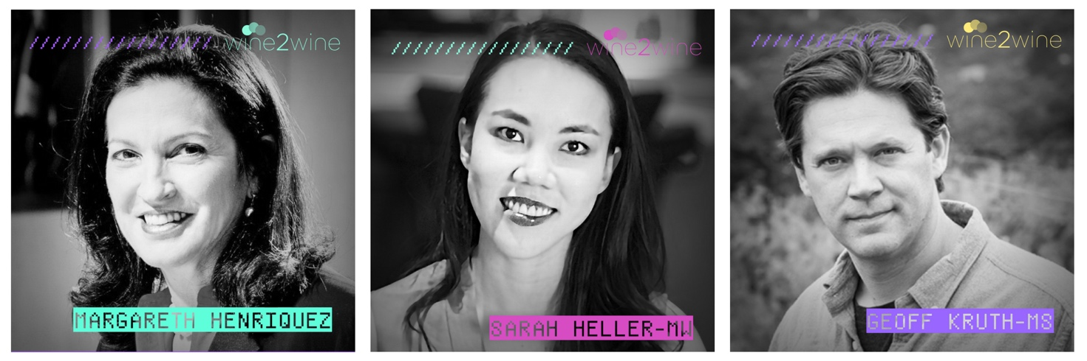

This year wine2wine will also showcase a new 45-minute format, with each session being made up by a 30-minute presentation followed by a 15-minute Q&A. At the end of each presentation, the speakers will highlight practical ‘takeaways’, that is, hands-on suggestions that participants will be able to apply directly to their business. The Q&A part calls for a direct interaction between speakers and attendees. In addition, there will be another 15-minute time window during which participants will have the chance to connect and network with other wine professionals.
Stevie Kim, Managing Director of Vinitaly International, commented on the new format: “Every year we are striving to make slight but significant changes deriving mostly from requests we gathered directly from participants to the previous edition. We are especially mindful of the concept “WIIFM - What’s In It For Me,” since our main purpose is to give attendees solid takeaways to improve their business.”
As part of the revamp of the new edition, #w2wLabs have been included in the program. These sessions are practical demonstrations open to a selected audience, who will have the opportunity to learn about optimizing a website, write a successful PR, or leverage Instagram to grow business.
Participating wineries will also have the chance to enrol for B2B sessions, where they will meet and present their products to buyers from some of the world’s developing wine markets such as South Corea, Poland, Mexico, and Switzerland. Once again, “HireMeVinitaly” will open the second day staging a speed dating between winery owners and professionals seeking to work in the wine industry.
For the third year at wine2wine, Wine Spectator’s Senior Editor and Tasting Director Alison Napjus will reveal the 100 Finest Italian wine producers chosen by the magazine for OperaWine 2019, which will be held on Saturday, April 6th. In a dedicated session during wine2wine Napjus will also explain what wineries need to do in order to be selected for the glamorous gala that traditionally opens Vinitaly.
The 2018 edition of wine2wine will also be remembered for the strong presence of wine producers, who will moderate some of the 60+ sessions included in this year’s program: Valentina Argiolas (Argiolas Winery), Matteo Lunelli (FerrariTrento), Andrea Sartori (Sartori Wines), Ettore Nicoletto (Santa Margherita Group), Jose Rallo (Donnafugata) and Carlo Franchetti (Franchetti Wines) are just a few of the top names in the world of Italian wine that will be present at the event.
Other speakers include:
- Lynne Sherriff MW;
- Lady Penguin, top Chinese wine influencer;
- Lorenzo Montagna, Founder of SecondStarVR;
- Marino Braccu, General Manager at 8 1/2 Bombana;
- Paul Mabray, CEO at Emetry;
- Ayana Misawa. Winemaker at Grace Winery;
- Sue Tolson, wine writer and editor;
- Armando Corsi, senior marketing scientist;
- Xiaohan Zhang, marketing director at Zacky’s China.
Other titles of sessions at a glance:
- How wine brands grow;
- Cannabis, beer and gin, and experiential marketing: the challenges and opportunities the wine industry faces today;
- Brazil, the real deal: opportunities and pitfalls of an alluring country;
- The landscape of wine online in the US market: which companies are relevant for sales, marketing, and awareness;
- Wine tourism: regulations and opportunities;
- How to be listed in a Michelin-starred restaurant.
An Early Bird special tariff is now available until the end of the month. For further information, visit the wine2wine website on www.wine2wine.net or write to info(at)wine2wine.net. Share your experience by using the hashtag #wine2wine.
Special thanks to ICE, the Italian Trade Agency and the Ministry of Economic Development that supported and financed the fifth edition of wine2wine as part of their campaigns aimed at promoting Italian wine and Made in Italy around the world.

About:
The grand Vinitaly 2019 will be held from April 7th to the 10th. Every year, Vinitaly counts more than 4,000 exhibitors on a 100,000+ square meter area and 130,000 visitors from over 140 different countries with more than 30,000 top international buyers. The premier event to Vinitaly, OperaWine “Finest Italian Wines: 100 Great Producers,” which will be held on the 6th of April, one day prior to Vinitaly will unite international wine professionals in the heart of Verona, offering them the unique opportunity to discover and taste the wines of the 100 Best Italian Producers, as selected by Wine Spectator. Since 1998 Vinitaly International travels to several countries such as Russia, China, USA and Hong Kong thanks to its strategic arm abroad, Vinitaly International. In February 2014 Vinitaly International launched an educational project, the Vinitaly International Academy (VIA) with the aim of divulging and broadcasting the excellence and diversity of Italian wine around the globe. VIA this year launched the seventh edition of its Certification Course and today counts 151 Italian Wine Ambassadors and 11 Italian Wine Experts.

