Press Release
For Immediate Release
Italian Wine Podcast
Giulia Bruna
(Producer & Project Coordinator)
Ph. +39 045 8101447
info@italianwinepodcast.com
www.italianwinepodcast.com
Available on SoundCloud, iTunes, and XimalayaFM
Follow us on Facebook, Twitter, Instagram, LinkedIn

Thursday September 27th, 2018

MasterChef of Italian wine: exclusive interview to Joe Bastianich on the Italian Wine Podcast

The Italian Wine Podcast just broadcast an exclusive interview with wine maker, restaurateur, TV celebrity, and musician Joe Bastianich. Podcast host Monty Waldin conversed amicably for half an hour with the eclectic wine and food celebrity about his Italian origins and his relationship with Italian culture more widely.
In an unreserved interview, Bastianich reminisces about his upbringing in New York City and about his deep-rooted Italian connections. Bastianich’s parents came from the Istria region (former North-Eastern Italian territory, albeit Croatian now) and emigrated to New York. There, they worked in restaurants, finally succeeding in opening their own restaurant activity. Bastianich, therefore, grew up in a family environment where good food and good wine were always valued. After starting a career in Wall Street, he eventually went back to the restaurant business, contributing also to innovating the restaurant scene in New York: “When I opened my first restaurant in 1991, it was called Bacco in the Theatre District in Manhattan. We opened up with an all-Italian wine list, which was unheard of in New York in the late eighties-early nineties and every bottle was 15 dollars a bottle (the cost to customers); it was a different time, of course, where you could sell a bottle of wine for 15 bucks in a restaurant, but that is where it all began.” Currently, Bastianich owns several restaurants worldwide with the group Batali & Bastianich.
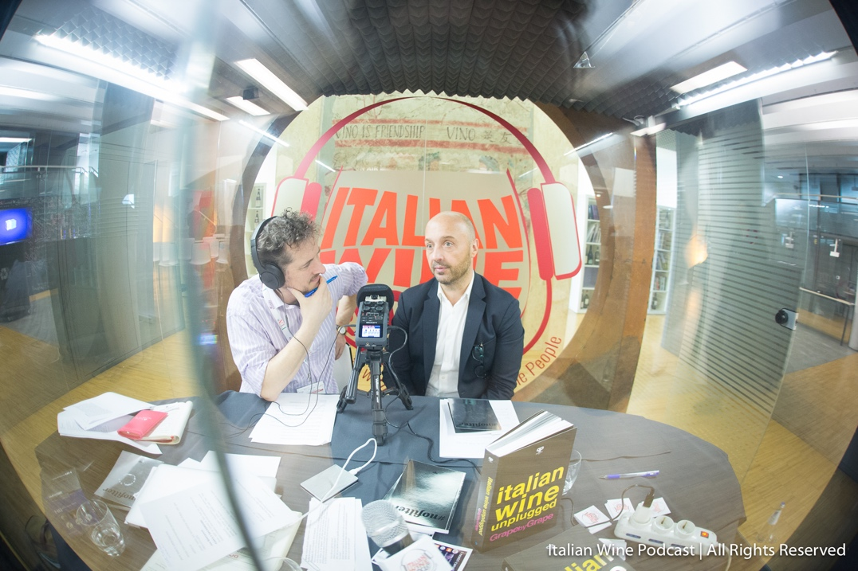
Photograph: Monty Waldin (left) interviews Joe Bastianich (right) during Vinitaly 2018 in Verona, Italy.
Italian wine has always played a key role in both Bastianich’s professional and personal life. Bastianich explains that, in 1997, he opened his own winery in Friuli’s Colli Orientali for his children, as a way for them to reconnect with their Italian heritage: “That was my dream… Aside from loving wine I really had to have my kids be tied to this Italian reality in a real way, like I was fortunate to have my family. And they did! They grew up in the winery, they grew up among people who live there, with a seventy-year-old woman, Gianna, who runs the winery and who taught Italian to all my kids and took care of them like she was her grandmother, and they worked with farmers. They had a whole existence of agriculture, of living in Italy… And although now they are moving away (two of them are in college)… I hope one day they will go back to Italy as a place where they had fond memories and come back to even make it a part of their life.” In the podcast, Bastianich also speaks about his non-interventionist wine making philosophy and marketing wine to the new generations.
Bastianich comments also on his television work as a judge for MasterChef Italy, explaining the close releationship judges develop with contestants during the four-month shooting of the show. He generously shares with Waldin his passion for rock music, which dates back to his teenage years and is linked to the New York City rock scene of the eighties. Bastianich plays guitar and has performed in Italy and the U.S. on various musical projects such as Vino Veritas My Life Unplugged, a concert which combines songs, storytelling, and wine tasting.
Joe Bastianich is one of several internationally-renowned personalities that have turned to wine and wine making out of a heartfelt passion for Italy. The Italian Wine Podcast features a dedicated series exploring “Celebrity Winemakers.” For instance, fashion designer Renzo Rosso (the father of Diesel Jeans) is the owner of a family winery in the hills of Marostica, near Vicenza, in his native Veneto region. In addition, French Bond girl and fashion icon Carole Bouquet settled on Pantelleria island in the Mediterranean and started producing Passito di Pantelleria.
Recently, the Italian Wine Podcast also launched a demographic survey to understand its audience and seek feedback to improve the show. The survey is available here. On the podcast website, it is also possible to donate to the show. Donations will help fund part of the show’s technical equipment, production, and publication costs.

About:
Italian Wine Podcast: Cin Cin with Italian Wine People! is a new podcast project dedicated exclusively to the Italian wine world. Wine writer Monty Waldin uncovers the unique Italian wine-making tradition in conversation with some of its key protagonists. Italian Wine Podcast aims to inform, educate, and entertain listeners about Italian wine. Italian Wine Podcast is available on SoundCloud, iTunes, XimalayaFM (for China) and on the official website.

