FOR IMMEDIATE RELEASE

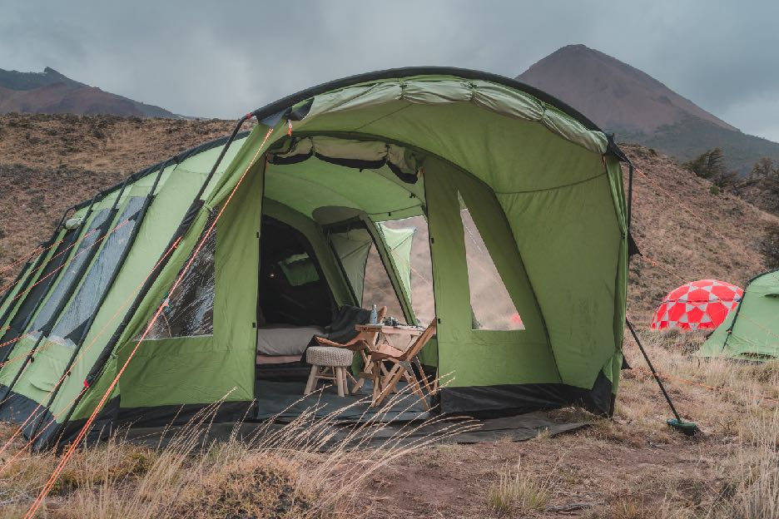
An all-expense paid trip for two to remote Patagonia is up for grabs as Upscape and Crua Outdoors encourage customers to opt outside this Black Friday

View video >>

A Black Friday giveaway for the trip of a lifetime valued at $20,000 USD, with the real, priceless value of complete disconnection. Two brands dedicated to bringing their customers to faraway places in style, experiential travel company Upscape and durable outdoor product maker, Crua Outdoors, are joining the Black Friday movement to “opt outside” this holiday season. The co-branded giveaway, “The Great Crua Outpost Escape,” will include prizes announced weekly and the ultimate prize, an all-expense paid 10-day/9-night trip to Chilean Patagonia, including three nights at Outpost Patagonia and a stay at the Lodge at Chacabuco in Patagonia Park.

Departing March 4, 2019, the trip will start at Outpost Patagonia, which sits on the shores of the Jeinimeni River in the Aysén region of northern Patagonia, and over the course of 10 days head south exploring the rest of Jeinimeni National Park, the Gloria Mountains and Patagonia Park. “This is a really special trip, not only because travelers will experience Outpost Patagonia on its official inaugural season,” says Upscape founder Brian Pearson “but because we will traverse incredible landscapes that are currently undergoing important conservation efforts”. The conservation work spearheaded by Tompkins Conservation and CONAF include connecting the 200,000 acres in the Chacabuco Valley with the Jeinimeni Reserve and the Tamango Reserve further south, coming together to become one large 640,000-acre Patagonia National Park, allowing bi-national access across the border of Chile and Argentina and opening previously blocked wildlife corridors.

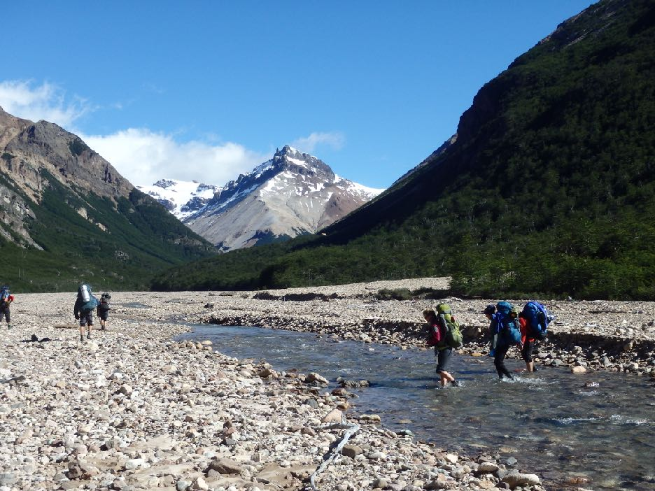
Outpost was launched earlier this year and opened with Outpost Patagonia and Outpost Maule, with Outpost Elqui soon to be announced for the total solar eclipse in 2019. Each site comes fully outfitted with private tents—the Loj by Crua—hotel-quality bedding, shared lounge dome and responsibly-handled tent restrooms, a private chef and guides. “Over the past few years as the Upscape team developed Outpost and tested various products, it was great to see their success with our products in the dramatic and unpredictable weather of places like Patagonia, the type of setting they’re made for” says Crua founder Derek O’Sullivan.

To enter the sweepstakes, participants submit their name and email on the brands’ landing page. Additional engagement will take place across Instagram and Facebook channels over the course of the sweeps, as repeat registrations are accepted daily. Winners will be announced on November 30, 2018.

###

About Upscape
Upscape is an experiential and adventure travel company based in Santiago, Chile with 15 years of know-how in creating unique itineraries in the Southern Cone, including Uruguay, Argentina and Chile. Their extensive knowledge covers iconic cities such as Buenos Aires, Santiago and Montevideo, wine-growing regions, alternate season ski destinations, on and off-the-grid in Patagonia and the Atacama Desert. Upscape itineraries have been recognized by the likes of National Geographic Traveler, Vogue and Food + Wine. In 2018 Upscape was named to the Travel + Leisure A-List for the 5th year in a row and in 2017 Upscape Founder Brian Pearson was recognized as a Condé Nast Traveler Top Travel Specialist for the third year in a row. Upscape’s most recent development, off-grid glamping sites named Outpost, have been opened in Chilean Patagonia, Maule Valley and soon to be announced Elqui Valley, specifically outfitted for the 2019 total solar eclipse. For more visit www.upscapetravel.com

About Crua Outdoors
Crua was founded by an Irishman with years of experience in camping and trekking outdoors. The team has expanded now, and we reckoned that building an all-weather tent worthy of our own adventures was a natural fit for our skills...so yeah, we pushed the limits and over engineered the heck out of it. So much so that the unique Thermo Tent insulation that we developed is now patent protected. Introducing the revolutionary Crua range of high-quality insulated tents. It’s all about getting a better night’s sleep in any weather, which a Crua tent provides by virtue of its superior quality, functionality and design. You won’t find a better thermally and acoustically insulated tent in the world! For more visit www.cruaoutdoors.com

Media Contact
Nancy Harrison
nharrison@adventuremedianews.com
307.421.4473

