Press Release Contacts:
For Immediate Release Vinitaly International
International Media Dept.

+39 045 8101447
media@vinitalytour.com
www.vinitalyinternational.com
Twitter: @VinitalyTour
Join Italian Wine Community on LinkedIn

Vinitaly International Academy to launch reformatted, tasting-intensive Italian Wine Ambassador course in Hong Kong
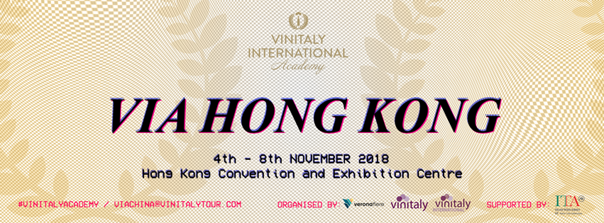

Vinitaly International Academy (VIA) launches its reformatted Italian Wine Ambassador certification course in Hong Kong from November 4th to 8th at the Hong Kong Convention and Exhibition Centre in the lead-up to the region’s famous International Wine and Spirits Fair starting on November 8th. 30 students coming mostly from Hong Kong, China, and Taiwan but also from the Philippines, Brazil, and Australia will sit through the revised Ambassador course, whose lecturing and tasting components have been considerably enhanced.
The Italian Wine Ambassador course 2018 has been redesigned by the recently appointed VIA Faculty members Sarah Heller (Master of Wine and VIA Italian Wine Ambassador) and Henry Davar (VIA Italian Wine Expert), with an input from Prof. Attilio Scienza, the new VIA Chief Scientist, who is also the guarantor for the academic integrity of the whole Vinitaly International Academy educational project. The reformatting of the Ambassador course is part of VIA’s new directions characterized by the creation of the VIA Ecosystem, the educational and organizational infrastructure consisting of new courses and new partners. As such, in addition to the new Chief Scientist and Faculty, VIA also welcomed the new Institutional Advisory Board made of leading Italian wine trade associations Federvini, Federdoc, Unione Italiana Vini, and Vignaioli Indipendenti FIVI.
At its tenth edition, the new features of the VIA Italian Wine Ambassador course debuting in Hong Kong include: revisited theory lectures on grape varieties and the wines’ territories of origin; focussed sessions on specific topics crucial to the understanding of Italian wine at an international level; an enhanced tasting component with guided tastings and additional tasting labs in collaboration with Italian wine consortiums. Stevie Kim, Managing Director of Vinitaly International and VIA Founder, comments on VIA’s work in preparation for the Hong Kong debut: “I would like to thank Sarah and Henry for their amazing work on the Ambassador course. I am looking forward to seeing them teach in Hong Kong and meeting the new VIA candidates. I am confident students will appreciate the enhanced tasting component and the more systematic methodology in the lectures. With the revised Ambassador course and the reformatted VIA Ecosystem, we have made considerable progress in building the gold standard for Italian wine education.”

The revised theory lectures will introduce students to the complexity of Italian wines and will comprise an augmented focus on the wines’ territory, soil, and viticultural techniques, in addition to exploring native grape varieties—the backbone of many Italian wines and an element of distinction for Italian wine in comparison with wines from other national traditions (around 30% of the world’s grape varieties are Italian).
Additional new elements to the course are also the opening “Warm-up” sessions that will precede three out of four morning lectures. These sessions provide a focus on important themes in the wide-ranging landscape of Italian wines, topics which are essential to foreign professionals for a well-rounded understanding of the subject. In Hong Kong, these warm-up classes will cover iconic grapes such as Nebbiolo and Sangiovese as well as Italian sparkling wines. Additional topics will be added to future editions of the Ambassador course and presented in rotation. Henry Davar comments on the revisions and standardization carried out by the VIA Faculty: “It’s a great responsibility to update what was already the most progressive Italian wine curriculum and to maintain the highest standard of the VIA course. Learning about Italian wine means delving into the complexity and diversity of Italian grape varieties and its many appellations. So I find context helps. By connecting to regions’ history, culture, and food we are better able to appreciate and understand its wines.”
The main innovation to the Ambassador course is its enhanced tasting component. The guided tastings following the theory lectures have been further standardized with a focus on recognizing the wines and evaluating their quality. Moreover, after the morning classes students will be able to join the VIA Tasting Labs and taste additional Italian wines to the ones presented in the guided tastings. With this new addition, VIA is committed to expose candidates to as many Italian wines as possible as well as to enhance their wine tasting skills. In Hong Kong, the new VIA Tasting Labs will concentrate on wines from Abruzzo and Trentino-Alto Adige. Sarah Heller MW comments on her approach to wine tasting: “In teaching about Italian wine, I really love to focus on tasting. Because the level of tannins and acidity are often so high and the fruit is often quite subtle, it really forces people to reconsider what they consider quality in wine. For anyone wanting to become an Italian wine specialist, I suggest that they embrace the complexity. Trying to compare the wine to something that it isn’t can be misleading. Instead, it is important to focus on communicating the passion and love that are a critical part of what Italian wine is.”
The exam at the end of the Ambassador course will also reflect this increased tasting component. In addition to the written test, students will blind-taste two wines, one red and one white. An additional blind tasting will also feature if candidates will run for the Italian Wine Expert title, the highest recognition of VIA for top-scorers in the exam. Another innovative component to the exam also includes a group project whereby students will be asked to prepare a video presentation on a topic surrounding native grapes. This collaborative video presentation aims at improving communication and team building skills as well as fostering community development.
VIA is currently accepting applications for the Italian Wine Ambassador Course in Verona prior to Vinitaly. Information can be requested at via@vinitalytour.com.

About:
The grand Vinitaly 2019 will be held from April 7th to the 10th. Every year, Vinitaly counts more than 4,000 exhibitors on a 100,000+ square meter area and 130,000 visitors from over 140 different countries with more than 30,000 top international buyers. The premier event to Vinitaly, OperaWine “Finest Italian Wines: 100 Great Producers,” which will be held on the 6th of April, one day prior to Vinitaly will unite international wine professionals in the heart of Verona, offering them the unique opportunity to discover and taste the wines of the 100 Best Italian Producers, as selected by Wine Spectator. Since 1998 Vinitaly International travels to several countries such as Russia, China, USA and Hong Kong thanks to its strategic arm abroad, Vinitaly International. In February 2014 Vinitaly International launched an educational project, the Vinitaly International Academy (VIA) with the aim of divulging and broadcasting the excellence and diversity of Italian wine around the globe. VIA this year launched the seventh edition of its Certification Course and today counts 151 Italian Wine Ambassadors and 11 Italian Wine Experts.

