Press Release
Taipei, Taiwan – Oct. 29th, 2018
Cincoze announces DS-1200 Rugged Embedded Computer Featuring 8th-Gen Intel® Core™ Processor, Modular Design, and PCI/PCIe Expansions
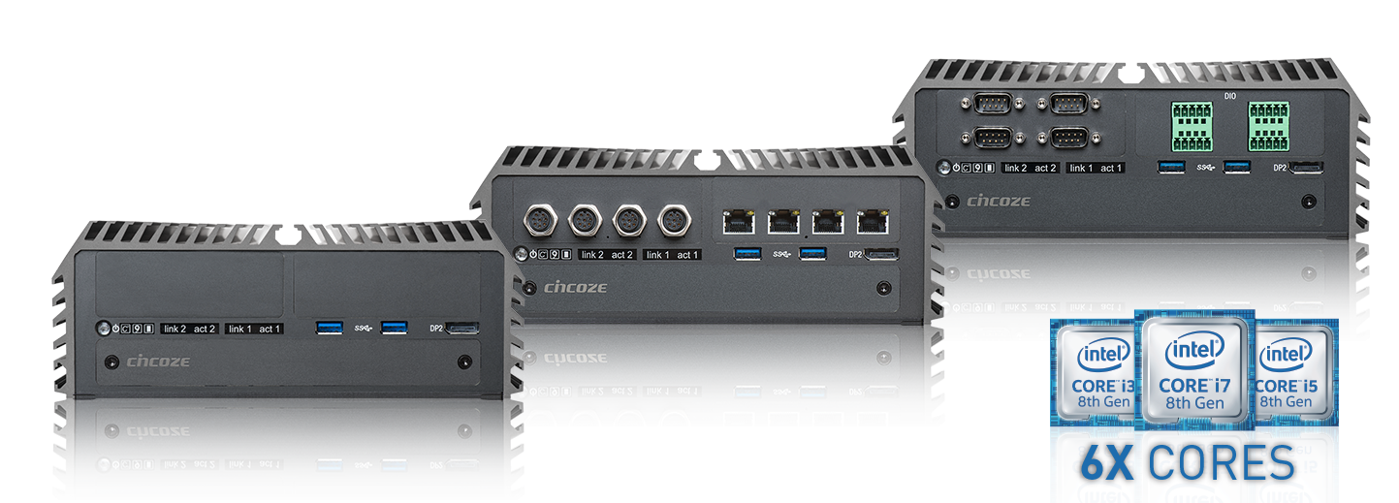
Cincoze, a professional manufacturer of embedded computing platforms, is pleased to introduce its latest rugged embedded computer DS-1200 series. The system is equipped with Intel® Q370 chipset and supports the 8th Gen Intel® Core™ / Pentium® / Celeron® 35W/65W LGA 1151 processors family. The new 8th generation Intel® Core™ processor (Coffee Lake) for the first time offers up to 6 cores, 12 threads and 1.4 times computing performance improvement comparing to the previous generation (Kaby Lake). The integrated Intel® UHD Graphics can drive up to 3 independent display outputs and support 4K UHD resolution. DS-1200 series also supports the most advanced technologies, such as DDR4-2666 SO-DIMM memory, USB 3.1 (Gen2) ports, and ultra-fast PCIex4 NVMe SSD for users to experience the highest performance possible.
DS-1200 series comes with rich I/O connectors, including 2x Intel® GbE ports, 8x USB ports, 1x DVI-I, 2x DisplayPort, 1x PS/2, 1x Line-out, 1x Mic-in, 2x RS-232/422/485 ports, and a remote power/reset connector. The system also has 2x front accessible SIM card slots for redundant 3G/4G connections. In addition, DS-1200 series provides friendly features, including instant reboot, replaceable fuse, and integrated SuperCap for easy maintenance.
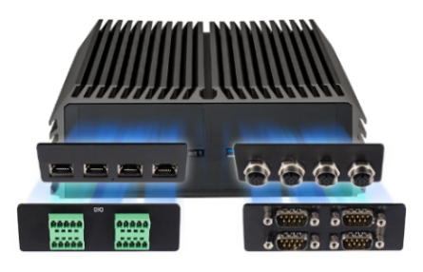
Based on Cincoze’ innovative CMI & CFM technology, it allows users to expand I/O and functionalities through ready-to-use modules, such as GbE/PoE ports, serial ports, optical isolated digital I/O and power ignition function. Additionally, the system provides 3x full-size Mini PCI Express slots and up to 2x PCI/PCIe expansion slots for more I/O expansions.
“To leverage the latest Intel® 8th generation Core™ processor, we have designed-in multiple cutting-edge computer technologies for DS-1200 to provide the best performance.” said Brandon Chien, CEO of Cincoze. “DS-1200 is a truly rugged computer series featuring fanless/cableless design, wide operating temperature (-40°C to 70°C), wide range DC power input (from 9V to 48V), high tolerance of vibration/shock (5G/50G), and industrial-grade protections (OVP, OCP, ESD Surge, ...etc). It passed various rigorous tests, as well as industry compilance EN50155 (EN50121-3-2) and EN60950-1 certifications for operations in harsh environments.”
DS-1200 series is available in three different models: DS-1200 without PCI(e) expansion slot, DS-1201 with one PCI(e) expansion slot, and DS-1202 with two PCI(e) expansion slots. By choosing optional riser cards, users can install versatile add-on cards for their specific applications.
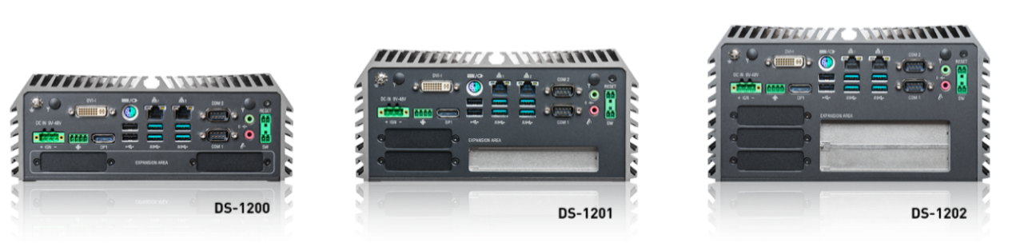

DS-1200 Series Line Up
DS-1200
8th Generation Intel® Core™ Series Processors, High Performance, Expandable and Modular Rugged Embedded Computer
DS-1201
8th Generation Intel® Core™ Series Processors, High Performance, Expandable and Modular Rugged Embedded Computer with 1x PCI/PCIe Expansion Slot
DS-1202
8th Generation Intel® Core™ Series Processors, High Performance, Expandable and Modular Rugged Embedded Computer with 2x PCI/PCIe Expansion Slots

About Cincoze
Cincoze, a professional manufacturer of embedded computing platforms. We design, manufacture, and market rugged fanless computer, industrial panel PCs, and monitors for harsh and demanding environments. With its leading-edge products and application-driven functionalities, Cincoze enables new technologies and solutions for multiple applications, including factory automation, machine automation, machine vision, in-vehicle computing, intelligent transportation, and surveillance.

Cincoze Co., Ltd.
7F., No.4, Aly.1, Ln.235, Baociao Rd, Sindian Dist., New Taipei City 23145, Taiwan
Tel: +886-2-2918-8055
Fax: +886-2-2918-8066
http://www.cincoze.com/

All product names, logos, and brands are the property of their respective owners. All company, product and service names used in this document are for identification purposes only. Use of these names, logos, and brands does not imply endorsement.
Copyright 2018 Cincoze Co., Ltd. All rights reserved

