
FOR IMMEDIATE RELEASE
SKYWAY CR
PR CONTACT: Nancy Harrison
TEL: 307.421.4473
EMAIL: nharrison@adventuremedianews.com
CORPORATE CONTACT: Maria Lourdes Meneses
TEL: 888.524.9396
EMAIL: lmeneses@skywaycr.com
WEB: www.skywaycr.com

ACCESS ALL THE HOT SPOTS WITH SKYWAY COSTA RICA

Costa Rica is the Most Popular Destination for North Americans

San Jose, Costa Rica – SKYWAY Costa Rica is pleased to announce that they are open for business and ready to serve the travel needs of visitors from North America. Costa Rica has much to offer to travelers from the USA and Canada who love the warm weather, sunshine, beaches, mountains, wildlife and adventures available – and at a time when much of North America is in the grips of winter. What a great time to visit this beautiful and diverse country! In order to experience all there is to do, flying from San Jose to various destinations is the best and fastest way to travel.

SKYWAYCR can take visitors to the full array of destinations in Costa Rica. Not only can they deliver guests to their chosen location, they also offer all-inclusive packages to experience them.

Sun and beaches
Flights to Tamarindo and Bocas del Toro
Recommended Package Tamarindo: https://skywaycr.com/costarica-vacation-package/costarica-all-inclusive

National Parks
Flights to Puerto Jimenez and Drake Bay
Recommended Package: https://skywaycr.com/costarica-vacation-package/jungle-journey
Mountains and Rivers
Flights to Puerto Jimenez and Liberia Recommended Package in Liberia: https://skywaycr.com/costarica-vacation-package/romantic-adventure

Wildlife
Flights to Arenal and Manuel Antonio
Flights to Arenal, Manuel Antonio and flights connecting Arenal with Manuel Antonio, Quepos.
Recommended Package Url https://skywaycr.com/costarica-vacation-package/choose-your-family-adventure
Families and Culture
Flights to Arenal
Recommended Package Url : https://skywaycr.com/costarica-vacation-package/luxury-family-resort
Weddings and honeymoons
We have flights to Arenal, Liberia, and flights connecting Arenal with Liberia.
Recommended Package Url : https://skywaycr.com/costarica-vacation-package/deal-romance

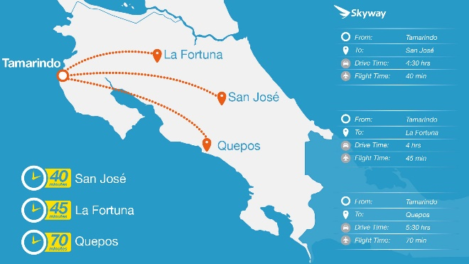
SKYWAY CR provides a complete array of transportation options – from scheduled flights, charter flights, ground transportation, car rental – to helicopter flights. Their Concierge Service stands ready to book hotels, restaurants, tours, spas and every element that makes vacations pure pleasure and relaxation. Fully inclusive vacation packages are also available through the helpful staff at SKYWAY CR.

Costa Rica invites you to visit and while you are there – Fly the Sky Way!

# # #

