Press Release Contacts:
For Immediate Release Vinitaly International
International Media Dept.

+39 045 8101447
media@vinitalytour.com
www.vinitalyinternational.com
Twitter: @VinitalyTour
Join Italian Wine Community on LinkedIn

Hong Kong, 8 November 2018

10th edition of Vinitaly International Academy Italian Wine Ambassador Course celebrates 2 new Experts and 7 new Ambassadors in Hong Kong

On November 8th, 2018, two new Italian Wine Experts and seven new Italian Wine Ambassadors officially joined the Vinitaly International Academy (VIA) community of dedicated wine professionals worldwide. These new Ambassadors and Experts successfully completed the re-formatted, tasting-intensive VIA Italian Wine Ambassador certification course held in Hong Kong at the Hong Kong Convention and Exhibition Center in the lead up to the International Wine and Spirits Fair.

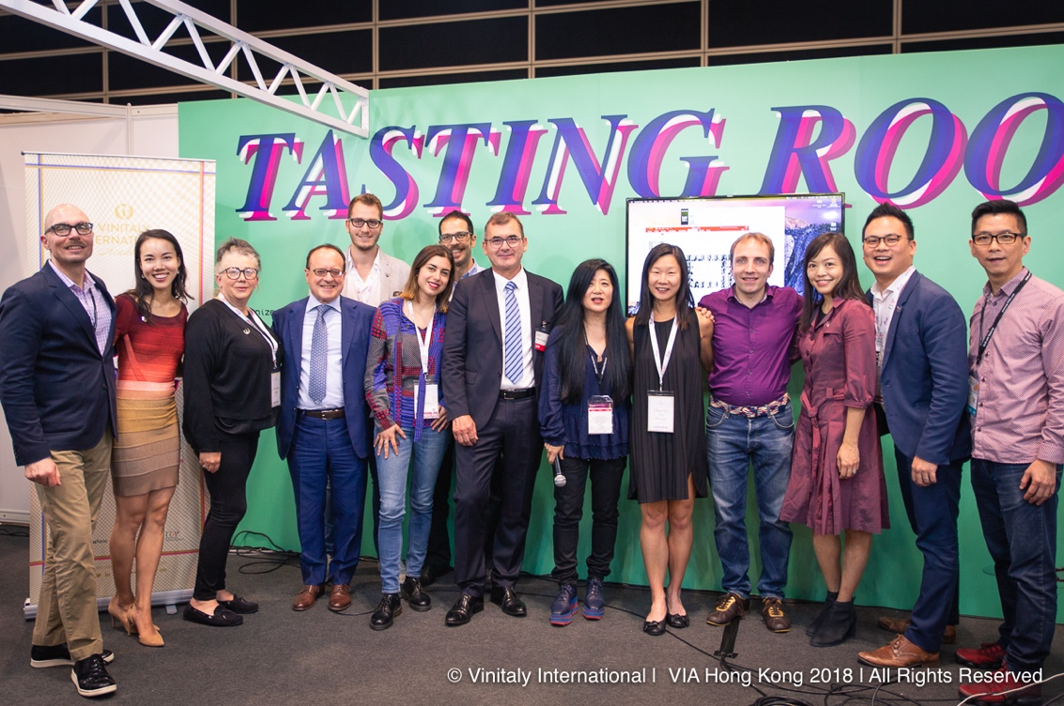
Left to right: VIA Faculty Henry Davar and Sarah Heller MW; Gill Gordon-Smith, new IWE from Australia; Veronafiere General Manager Giovanni Mantovani; Luca D'andrea new IWA from Italy; Giulia Mengoni new IWA from Italy based in Australia; Francesco Marchio, new IWE at the first try from Italy but based in Hong Kong; Veronafiere President Maurizio Danese; Stevie Kim, Vinitaly International Managing Director; Phyllis Wan Yin Chan, new IWA from Hong Kong; Sebastian Wöll new IWA from Germany but based in China; Alice Wong, new IWA from Hong Kong; Anson Wan, new IWA from Hong Kong; Vincent Yuen M.S., new IWA from Hong Kong.

The overall count for VIA-certified Italian Wine Experts and Ambassadors after the Hong Kong course has now reached 171 professionals, of which 13 are Experts and 158 are Ambassadors. The VIA Expert title is the highest certification of proficiency in Italian wine awarded by VIA. In Hong Kong, two new professionals received this prestigious title:
- Francesco Marchio, Managing Director at Vinoveritas Asia in Hong Kong;
- Gill Gordon-Smith, Wine Educator and Owner of Fall From Grace Winery in Aldinga, South Australia.
VIA Italian Wine Ambassadors certified in Hong Kong include:
- Alice Wong, Co-founder and Wine Coach at Vinetude Asia in Hong Kong;
- Anson Wan, Sales Manager at ASC Fine Wines HK Trading Corporation Limited in Hong Kong;
- Phyllis Chan Wai Yin, Senior Executive Officer at the Constitutional & Mainland Affairs Bureau in Hong Kong;
- Vincent Yuen, Freelance Wine Columnist at Winenow in Hong Kong;
- Sebastian Wöll, Main Educator at Wine Family Education & Consulting based in Hangzhou, China;
- Giulia Mengoni, Sommelier at The Crafers Hotel in Crafters, South Australia;
- Luca D’Andrea, Export Manager at the Corvezzo Winery in Italy.

VIA Founder Stevie Kim proclaimed the new Ambassadors and Experts during the traditional pinning ceremony held in the Vinitaly Hong Kong pavillion at the International Wine and Spirits Fair in the presence of Veronafiere’s President Maurizio Danese and CEO Giovanni Mantovani, and VIA Faculty Sarah Heller MW and Henry Davar. Kim comments on the innovative aspects and educational objectives of the revisited Ambassador course: “This was our 10th edition and it was a bit tricky as we were implementing a newly-formatted Ambassador course, which was characterized by key elements of innovation aimed at strengthening the candidates’ knowledge of Italy’s distinctiveness in viticulture and winemaking and enhancing the candidates’ tasting skills. I am pleased with how it went and confident that VIA is on the right track to educate wine professionals abroad to the complexity and quality of Italian wine in an effective and thorough way.”

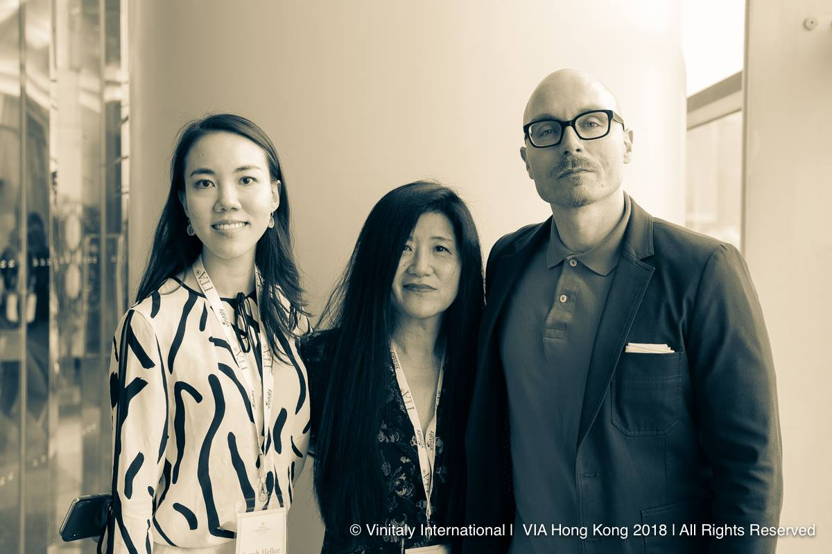
VIA Founder Stevie Kim (center) with VIA Faculty members Sarah Heller MW (left) and Henry Davar (right).

The 29 candidates, who sat the four-day educational program in Hong Kong, immersed themselves in the Italian wine culture through lectures on grape varieties and the wines’ territories as well as close examinations on themes which are central to appreciating the Italian wine-making tradition at an international level (e.g. the Nebbiolo and Sangiovese iconic grapes, Italy’s tradition of sparkling wines). VIA Faculty member Henry Davar, who co-devised and co-taught the course in Hong Kong with Sarah Heller MW, commented on how the Ambassador course fulfils VIA’s core objective: “Over the course of four days, it became clear that the VIA class of Hong Kong 2018, first individually, and eventually collectively as a group, had begun to fully understand and embrace the mission statement of VIA and the true nature of the ambassadorship. Having gained a stronger grasp of the Italian cultural heritage and viticultural landscape, they started to recognize in themselves the potential of championing the diversity and uniqueness of Italian wine.”
The enhanced tasting component of the course included tastings led by the VIA Faculty and additional self-guided Tasting Labs. In total, VIA Ambassador candidates tasted 85 labels of Italian wine coming from the 20 regions of Italy. The addition of the new Tasting Labs was particularly welcomed by these professionals; in Hong Kong, these Labs featured wines coming from Abruzzo and Alto-Adige.
Another key element of innovation was the group video project where candidates presented a video exploring the evolution of the Valpolicella blend. This new component to the course has been designed to strengthen the candidates’ communication skills and facilitate community-building. VIA Faculty member Sarah Heller MW comments on the reaction of the VIA class in Hong Kong to the new format: “I’ve been immensely impressed by the enthusiasm of our students, some of whom have traveled from as far away as the US and Mexico as well as all over Asia to take part in this first new edition. They’re highly engaged and really seem to be embracing the new, more structured format based on the insightful, informed questions we’ve been fielding all week. Also, the group video project seems to have accelerated the community-building that is another key pillar of this project.”
New VIA Italian Wine Ambassador certification courses will run in 2019 in Verona, Italy, in the lead-up to Vinitaly from March 29th to April 2nd (registrations are open) as well as in a number of locations in the United States and Asia soon to be announced.

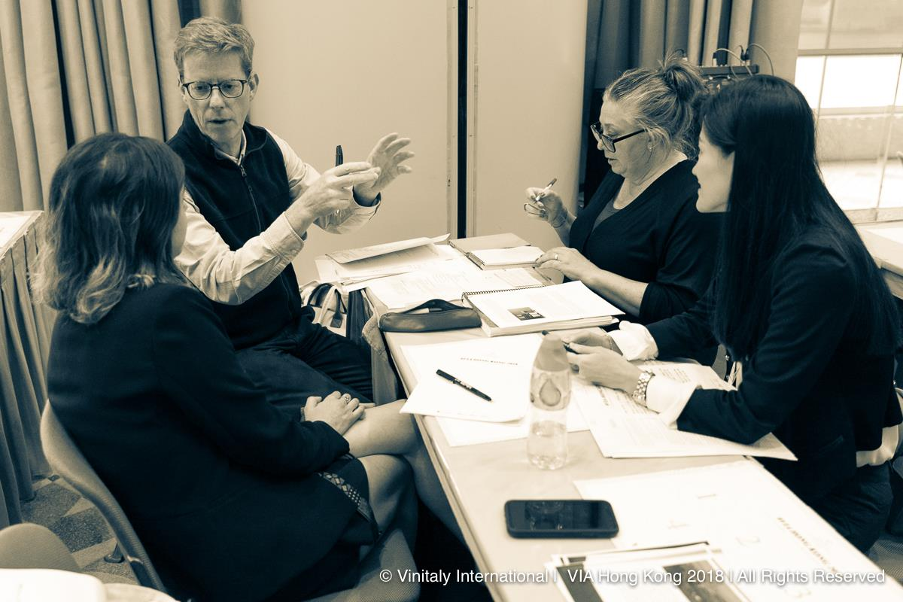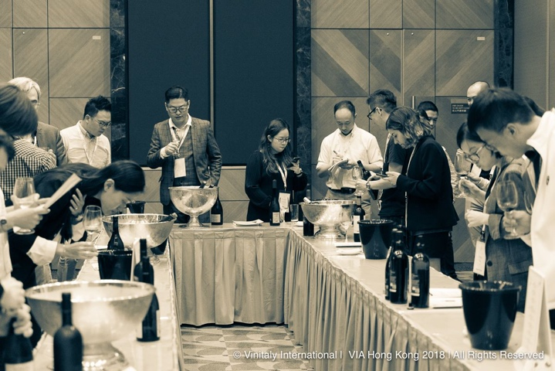
Left: VIA candidates at work on the group video project; Right: VIA candidates practising tasting during one of the Tasting Labs organized in collaboration with Italian wine consortiums.

About:
The grand Vinitaly 2019 will be held from April 7th to the 10th. Every year, Vinitaly counts more than 4,000 exhibitors on a 100,000+ square meter area and 130,000 visitors from over 140 different countries with more than 30,000 top international buyers. The premier event to Vinitaly, OperaWine “Finest Italian Wines: 100 Great Producers,” which will be held on the 6th of April, one day prior to Vinitaly will unite international wine professionals in the heart of Verona, offering them the unique opportunity to discover and taste the wines of the 100 Best Italian Producers, as selected by Wine Spectator. Since 1998 Vinitaly International travels to several countries such as Russia, China, USA and Hong Kong thanks to its strategic arm abroad, Vinitaly International. In February 2014 Vinitaly International launched an educational project, the Vinitaly International Academy (VIA) with the aim of divulging and broadcasting the excellence and diversity of Italian wine around the globe. VIA this year launched the seventh edition of its Certification Course and today counts 158 Italian Wine Ambassadors and 13 Italian Wine Experts.

