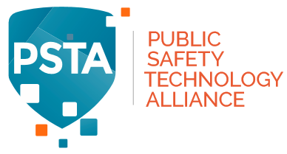

Press Release:

Former FirstNet Vice Chair Appointed to PSTA Board of Directors

FREMONT, CA, November 8, 2018: Former FirstNet Vice Chair and Western Fire Chiefs Association CEO Jeff Johnson was recently appointed to the PSTA Board of Directors.

Chief Johnson (ret) has an extensive public safety background, with broad experience at the local, state, national and international levels. He rose through the ranks to become the Tualatin Valley Fire & Rescue (Oregon) Fire Chief for 15 years, retiring in 2010 after a 32-year career. Most recently, he served as the Vice Chair of the First Responder Network Authority and has also served as President of the International Association of Fire Chiefs (IAFC) and President of the Western and Oregon Fire Chiefs Associations.

Chief Johnson also has an extensive private sector background, serving as an advisor or board member to numerous technology companies, and is the principal at Sisters Meat and Smokehouse in Sisters, Oregon.

“Chief Johnson’s leadership, public safety operational background and business expertise in the public and private sectors are well known, respected and widely recognized,” said Maggie Goodrich, PSTA Board Chair. “We look forward to his insights and contributions to the PSTA Board of Directors,” she added.

Chief Johnson is one of five public safety directors on the PSTA Board, which oversees the activities of the multiple technical subcommittees working to select and recommend relevant open standards and APIs for each respective topic area to ensure true operability among public safety broadband applications and technologies.

About PSTA
The Public Safety Technology Alliance (PSTA), comprised of telecommunications industry, public safety, and technology leaders, is a nonprofit coalition with a mission of adopting open, best-in-class, standards-based technology for the public safety user community. As broadband and narrowband networks evolve to meet the demands of first responders, so too must the standards evolve to ensure interoperability between and among the various networks, applications and databases upon which public safety users rely. For more information visit www.pstalliance.org.

Contact
Victoria Lee
Tel: 541-771-2144
Email: vicki@publicsafety.network

