FOR IMMEDIATE RELEASE:

Files.fm Announces Development of a New Type of Digital File Library

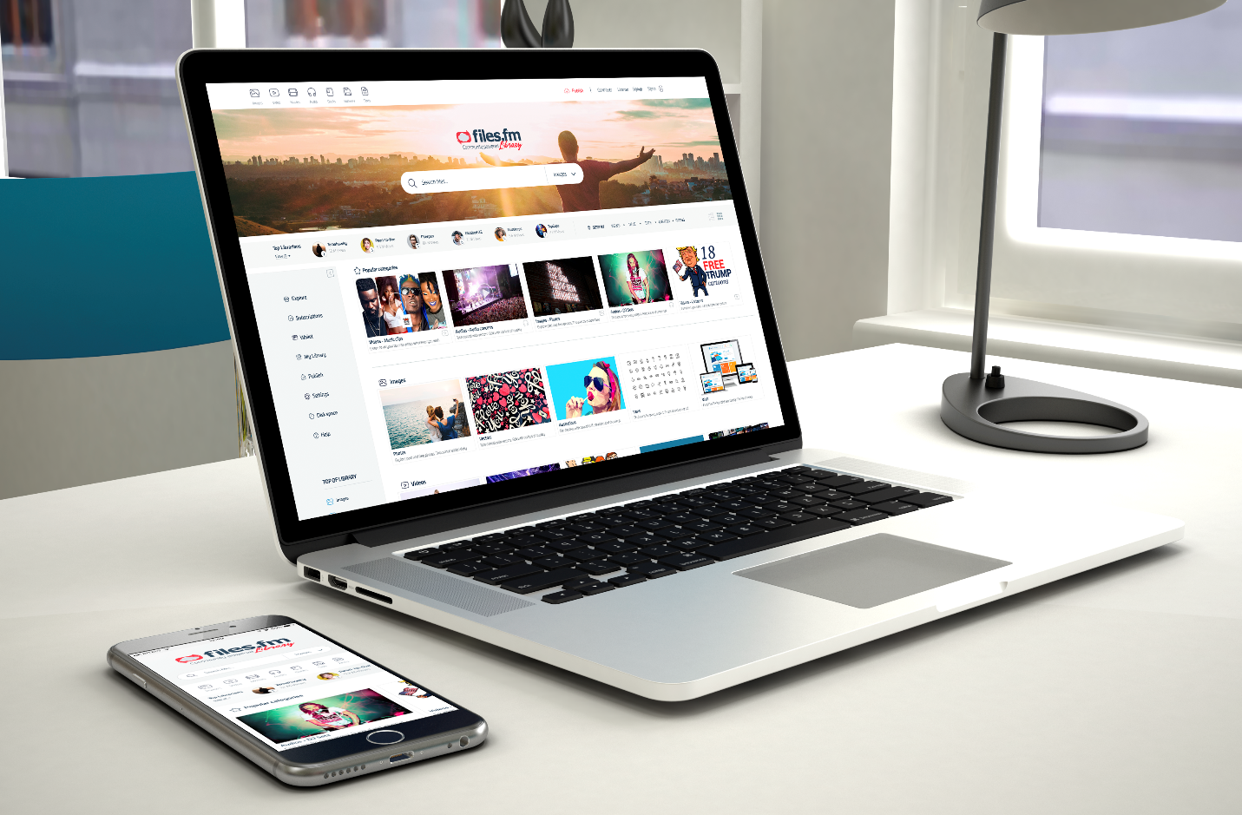
Riga, Latvia – November 22, 2018 – In this digital age people have an astonishing amount of files on their computers, a large portion of which could be useful to others. However, currently there is no unified platform where people could upload these files for others to find and use. They could be uploaded to personal websites or cloud storage, but most people will never find them. On the other hand, existing digital libraries only accept vetted content that fits their quality standards. Files.fm is creating the Files.fm Library (FFL) in order to allow anyone to upload useful files for everyone to find and access, while the users will be rewarded with FFM tokens for their beneficial actions.
FFL will be a free to use hybrid-decentralized data library, built and maintained through the collective efforts of the community. FFL aims to provide space for anyone to upload their files for future preservation, and by adding correct metatags any file in the database can be easily found and accessed. It will store both copyright-free files available for everyone and copyrighted files that users will be able to buy. All IP content will be logged on blockchain and users will decide about file or tag quality by reaching consensus on blockchain.
Files.fm has a distinct advantage for creating a project of such a massive scale – they have operated in the cloud file storage field for more than ten years. The current Files.fm platform has already attracted more than 750,000 registered users and almost 2 million unique monthly visitors. The company has developed the sharing platform, back-up solution, file module transfer for printing companies, ability for users to sell files via their platform and is currently testing large-scale P2P hybrid-decentralized content streaming.
Currently, there are several existing public digital file storages, but they are strictly divided into copyright-free and copyrighted. FFL aims to bridge this gap by creating a single unified platform that will ensure correct copyrights and give the profits directly to the copyright holders. This service hopes to create a more accessible future, where people won’t have to switch between numerous separate websites or apps to find and access the files they need. Instead, all of them will be available in this one unified platform.
FFL will be hybrid-decentralized, which means it will use combined centralized servers and decentralized P2P web user network for file storage and traffic. This is done to solve the biggest individual problems these two networks have: for centralized servers, slower download speed and potential crashes or downtime due to large traffic; for P2P networks, lack of seeders for specific files. FFL uses hybrid-decentralized technology to ensure fast download and upload speeds and the file remaining accessible even if the server goes down or there are no peers. In addition, the use of P2P networks reduces the costs of servers, therefore making the service free for everyone. To make file accessibility more convenient, FFL users will be able to watch videos straight from the website using hybrid-decentralized streaming technology.
However, a single service can only do so much. If FFL moderators were the only ones responsible for uploading and tagging the files, it would take countless man-hours and the process would be long and exhausting. This is why FFL will rely on community submissions and edits. It will reward the editors with tokens that can later be exchanged for copyrighted materials, such as movies, TV shows, books, music. This is done to create a thriving ecosystem where users will upload, tag and seed files in exchange for the opportunity to later watch movies or read books for free.
In a way, files.fm is attempting to solve the free-rider problem that is so prevalent in P2P networks – that users download what they need and close the service without seeding the file for others. It aims to incentivize people to commit their resources by rewarding them with free products in a legal way and more conveniently that most other existing alternatives.
For this plan to succeed, it is necessary to acquire start-up funding to implement all the necessary technologies on a large-scale basis. In the coming weeks, Files.fm is going to launch a crowdfunding campaign where you can support our project and be the first to receive FFM tokens.
If you are interested in the Files.fm Library project, you can find out more on the https://library.files.fm website or follow the most recent developments on Telegram, Facebook, Twitter, Bitcointalk, Medium or Reddit.
Video explainer: https://files.fm/f/fvzb7bsu
About Files.fm
Files.fm is a European information technology company that provides secure, convenient and scalable cloud data storage solutions for business, professional and private users, so that they can quickly store, share, distribute, backup or sell files worldwide. The company has been operating since 2007 and provides tailored solutions for certain B2B and B2C niches, like content sellers, media, printing & design.

Press contact
Agija Rumpe, Files.fm Marketing Manager
+371 26198422
agija@files.fm

