Press Release Contacts:
For Immediate Release Vinitaly International
International Media Dept.

+39 045 8101447
media@vinitalytour.com
www.vinitalyinternational.com
Twitter: @VinitalyTour
Join Italian Wine Community on LinkedIn

Wine business forum wine2wine to help Italian wineries understand emerging wine markets in Poland, South Korea, and Switzerland

The Polish, South Korean, and Swiss wine markets will be the focus of three in-depth talks at wine2wine 2018, the annual wine industry forum organized by Veronafiere, Vinitaly, and Vinitaly International. Taking place on Monday 26 and Tuesday 27 November in Verona, Italy, wine2wine will offer a wide range of lectures and workshops on key topics that are of interest to the wine business community such as consolidated and emerging markets for Italian wine or the latest trends in communications and the digital.
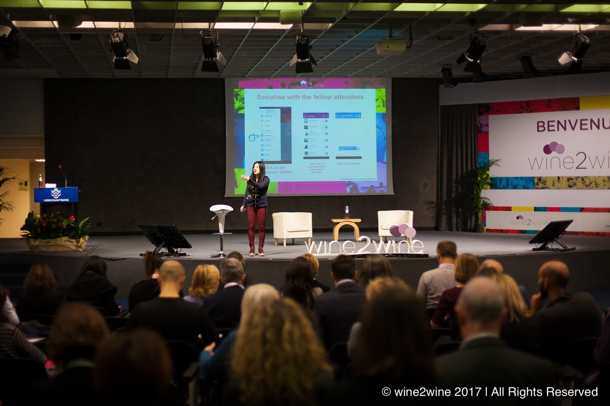

Photograph: On stage Stevie Kim, Managing Director of Vinitaly International, at the opening session of wine2wine 2017 in Veronafiere’s PalaExpo.

The emerging markets for Italian wine in Poland, South Korea, and Switzerland will get dedicated podium-time at wine2wine 2018, as they represent a big chunk of future gains for Italy’s wines. These sessions have been organized in collaboration with the Italian Trade Agency-ICE: each session features a market expert from each country as well as a government commissioner also operating there, in order to provide a comprehensive understanding of the opportunities for Italian wineries in each of those emerging markets. These sessions on emerging markets have been scheduled on Tuesday 27 November during both morning and afternoon.
One of the emerging markets for Italian wine is Poland, described as a transitional market. Poland is starting to rapidly embrace wine and the products being chosen are influenced by personal values, according to a study published in Wine Economics and Policy: “Consumers who were most likely to engage in exploratory behavior valued creativity, fun, and risk taking and were less concerned about behaving properly. They also had more global outlook as they were more likely to purchase wine in other countries and desired more wines from regions outside Poland.” Poland’s xenophile attitudes in wine consumption are certainly to bear in mind for Italian wineries when targeting consumers. Polish market expert Woijciek Gogolinski and Italian Trade Agency commissioner Antonio Mafodda will discuss this and other issues on Tuesday 27 November at 11:00am.
South Korea is another potential success story for the Italian wine market. According to a report released by the USDA Foreign Agricultural Service in 2018, this small country drinks wine for their health, favoring French and Italian wines for import over American produced wines. While South Korean wine market is growing steadily, Chile and Spain have been tough competitors to other markets trying to embed themselves in Korea’s unfolding market. Consumer tastes have been evolving in a similar way to China, in that the globalized younger generations seek new wine experiences and demand choice. Unfortunately, the current high distribution costs and tight government regulations has resulted in wine being recognized as a premium product among the general public, and so it is still only consumed by a limited section of the population. A bonus for the Italian market is that Korea produces very little domestic wine and it imports a large amount of it in bulk. Another hurdle in Korea, as the report notes, is the complicated labelling and food safety standards that are constantly changing with very little notice. At wine2wine 2018, local market expert Hyunjin Kim and Italian commissioner Vincenzo Calì will dig deeper into ways of harnessing the potential of the South Korean market for Italian wineries on Tuesday 27th at 12 o’clock.
Switzerland is another interesting market for Italian wine. Its close vicinity to Italy and France make it a prime candidate for imports. Wine sales in Switzerland has been on a steady upswing over the last few years. According to an article in Swiss newspaper Le News, in 2017 the Swiss consumed 249 million litres of wine, with 87 million litres of the total (35%) being produced in Switzerland. 163 million litres of it was imported mainly from Italy (41%), France (21%), and Spain (17%)—overall, 79% of imports come from these three nations. wine2wine will be addressing the Swiss market with Swiss market expert Bruno Bonfanti and Italian Trade Agency commissioner Simona Bernardini on Tuesday at 3.15 pm.
The wine2wine 2018 sessions dedicated to other international markets will analyze the U. S. and Chinese wine market and the Canadian markets. wine2wine tickets can be purchased directly on the website. With the ticket, attendees will gain access to the event app which provides information on all the speakers, talks, and sponsors.
Special thanks go to wine2wine Premium Sponsors Antares Vision, Apra, Acatena, and Signorvino as well as to Partners, Bottlebook, Italian Wine Podcast, Meininger's Business International, Philp Kotler Marketing forum, Vinepair, Regione Sicilia, Wine Meridian, WineTV, the UK Wine Show. Technical Sponsors Asiago, Nespresso, Monte Veronese, Surgiva, Parmigiano Reggiano have also contributed to the successful organization of the fifth edition of wine2wine.

About:
The grand Vinitaly 2019 will be held from April 7th to the 10th. Every year, Vinitaly counts more than 4,000 exhibitors on a 100,000+ square meter area and 130,000 visitors from over 140 different countries with more than 30,000 top international buyers. The premier event to Vinitaly, OperaWine “Finest Italian Wines: 100 Great Producers,” which will be held on the 6th of April, one day prior to Vinitaly will unite international wine professionals in the heart of Verona, offering them the unique opportunity to discover and taste the wines of the 100 Best Italian Producers, as selected by Wine Spectator. Since 1998 Vinitaly International travels to several countries such as Russia, China, USA and Hong Kong thanks to its strategic arm abroad, Vinitaly International. In February 2014 Vinitaly International launched an educational project, the Vinitaly International Academy (VIA) with the aim of divulging and broadcasting the excellence and diversity of Italian wine around the globe. VIA this year launched the seventh edition of its Certification Course and today counts 157 Italian Wine Ambassadors and 13 Italian Wine Experts.

