Press Release Contacts:
For Immediate Release Vinitaly International
International Media Dept.

+39 045 8101447
media@vinitalytour.com
www.vinitalyinternational.com
Twitter: @VinitalyTour
Join Italian Wine Community on LinkedIn

Wine Spectator reveals selection of OperaWine 2019 Italian producers at wine2wine
The names of the Italian wine producers selected by leading American magazine Wine Spectator to take part in the 2019 edition of OperaWine have been announced during wine business forum wine2wine on Monday 26 November. For the 2019 line-up, significant changes include the listing of 15 wineries selected for the very first time and the introduction of 6 completely different Brunello di Montalcino producers compared to last year’s.
Wine Spectator’s senior editor and tasting director Alison Napjus announced the 103 wineries that will pour their signature wines during OperaWine 2019, Vinitaly’s opening gala to be held in collaboration with the prestigious wine magazine in Verona, Italy, on Saturday 6 April next year. As is been customary for the past three years, the announcement has been made in Verona during the wine business convention wine2wine organized by Veronafiere, Vinitaly, and Vinitaly International. Napjus proclaimed the 103 finest Italian producers for 2019 on Monday 26 November at wine2wine in the presence of Maurizio Danese (President of Veronafiere), Giovanni Mantovani (CEO of Veronafiere), Gianni Bruno (Area Manager of Vinitaly), and Stevie Kim (Managing Director of Vinitaly International), and called the wineries’ representatives on stage for the traditional group photograph.
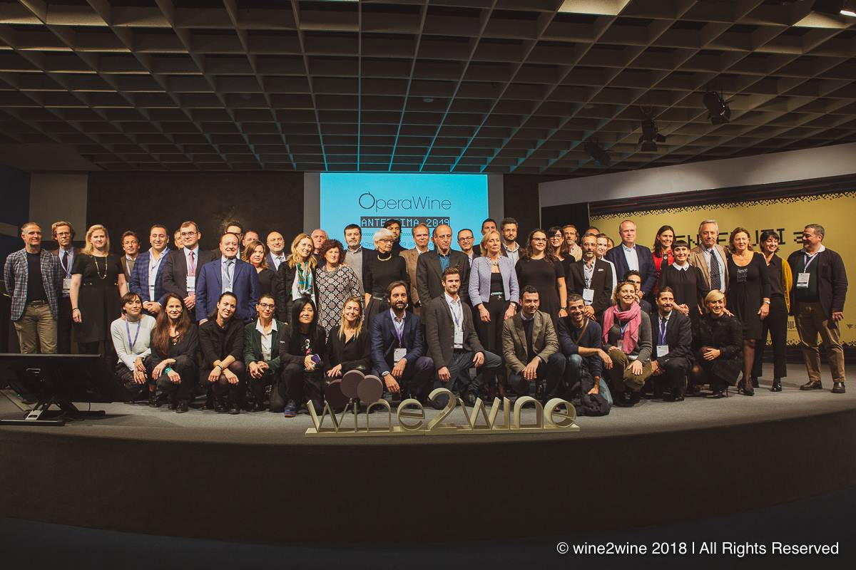

Every year, Wine Spectator’s selection of Italian wineries strives to showcase both the high quality and regional diversity of Italian wines. For the 2019 selection Wine Spectator chose 15 producers that had never participated before. Moreover, as Napjus pointed out in her announcement speech, the Montalcino area and its Brunello producers have undergone the most significant change in the magazine’s selection process: “To keep the tasting interesting and fresh we change part of that roster of producers every year. Over the course of 7 OperaWine, we highlighted more than 200 different producers and this year 15 producers will be pouring at OperaWine for the very first time. The biggest change in this line up is seen from Brunello. All 6 of the Brunello producers who poured at last year’s OperaWine will not be there in 2019, instead we will see 6 faces who are making equally outstanding examples from Montalcino. We also have 7 wineries returning to OperaWine after a hiatus of a year or two and all together it’s a beautiful group of wines with representation from every region of Italy, encompassing more than 70 red wines, 15 whites, and 10 sparkling and dessert wines, and including bottlings all the way back to the 1998 vintage.”
The 100 top Italian wines have been selected among 2600 samples from Italy that Napjus along with Wine Spectator Senior Editor Bruce Sanderson received in 2018. Criteria for the selection are the quality of the wines as showcased during the rigorous blind tasting process the magazine is famous for as well as, in Napjus’s words, “leadership, historical significance, diversity for the tasting itself.” The wines will be poured to a select cohort of press and trade professionals during the 8th edition of OperaWine Grand Tasting that will take place in the heart of Verona city center in the historic Palazzo Gran della Guardia on Saturday 6 April 2019.
Wine Spectator’s list of the 2019 100 best Italian wine producers is available below and additional information on OperaWine can be accessed on its website.

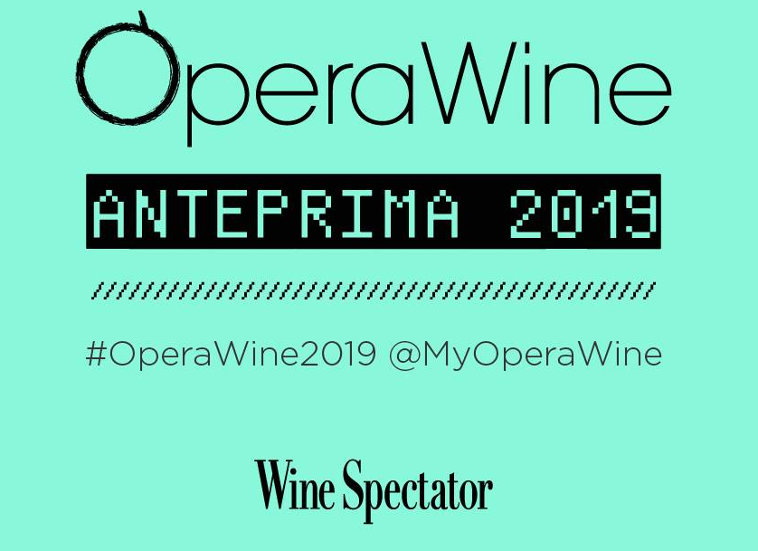

OperaWine: 100 Great Producers
- Aldo Conterno | Barolo Romirasco 2010
- Allegrini | Amarone della Valpolicella Classico 2013
- Antoniolo | Gattinara San Francesco 2012
- Argiolas | Isola dei Nuraghi Turriga 2013
- Arnaldo Caprai | Montefalco Sagrantino 25 Anni 2012
- Avignonesi | Merlot Toscana Desiderio 2013
- Baricci | Brunello di Montalcino 2010
- Bastianich | Venezia Gulia Plus 2009
- Bellavista | Brut Franciacorta La Scala 2013
- Benanti | Etna Rovitello 2004
- Binomio | Montepulciano d’Abruzzo Riserva 2008
- Bisci | Verdicchio di Matelica Riserva Senex 2010
- Bortolotti | Dry Valdobbiadene Superiore di Cartizze U. Bortolotti NV
- Boscarelli | Vino Nobile di Montepulciano 2012
- Braida di Giacomo Bologna | Barbera d’Asti Bricco dell’Uccellone 2016
- Ca’ del Bosco | Franciacorta Cuvée Annamaria Clementi Riserva 2008
- Canalicchio di Sopra | Brunello di Montalcino Riserva 2006
- Cantina Sociale di Santadi | Carignano del Sulcis Superiore Terre Brune 2012
- Cantina Terlano | Sauvignon Alto Adige Terlano Quarz 2013
- Cantine Lunae Bosoni | Vermentino Colli di Luni-Liguria Black Label 2015
- Carpineto | Vino Nobile di Montepulciano Riserva 2013
- Castellare di Castellina | Toscana I Sodi di San Niccolò 2014
- Castello d’Albola | Chianti Classico Gran Selezione 2013
- Castello di Ama | Chianti Classico Vigneto Bellavista Gran Selezione 2015
- Castello di Volpaia | Chianti Classico Coltassala Riserva 2015
- Cavallotto | Barolo Bricco Boschis Vigna San Giuseppe Riserva 2011
- Cesari | Corvina Veronese Jèma 2010
- Cleto Chiarli e Figli | Secco Lambrusco di Sorbara Vecchia Modena Premium 2017
- Di Majo Norante | Molise Don Luigi Riserva 2015
- Donnafugata | Passito di Pantelleria Ben Ryé 2015
- Elena Fucci | Aglianico del Vulture Titolo 2003
- Elena Walch | Alto Adige Beyond the Clouds 2016
- Elvio Cogno | to be confirmed
- Eredi Fuligni | Brunello di Montalcino Riserva 2007
- Falesco | Lazio Montiano 2005
- Falletto di Bruno Giacosa | Barolo Falletto Vigna Le Rocche Riserva 2012
- Fattoria di Fèlsina | Chianti Classico Berardenga Rancia Riserva 2009
- Ferrari | Extra Brut Trento Perlè Nero 2008
- Feudi di San Gregorio | to be confirmed
- Feudo Maccari | Sicilia Saia 2015
- Fontodi | Chianti Classico Vigna del Sorbo Riserva 2010
- G.B. Burlotto | Barolo Acclivi 2013
- Gaja | Barolo Sperss 2014
- Garofoli | Verdicchio dei Castelli di Jesi Classico Podium 2016
- Gianfranco Fino | Primitivo di Manduria Es Riserva 2014
- Gini | Soave Classico Contrada Salvarenza Vecchie Vigne 2010
- Giuseppe Mascarello & Figlio | Barolo Monprivato 2013
- Grosjean Freres | Pinot Noir Valle d’Aosta Vigne Tzeriat 2016
- Hofstätter | Pino Bianco Alto Adige Barthenau 2016
- Jermann | Venezia-Giulia Vintage Tunina 2014
- La Stoppa | Emilia Macchiona 2007
- Le Colture | Brut Valdobbiadene Prosecco Rive di Santo Stefano Gerardo 2016
- Le Macchiole | Bolgheri Paleo 2004
- Leone de Castris | Salice Salentino Per Lui Riserva 2014
- Leonildo Pieropan | Soave Classico La Rocca 2015
- Lisini | Brunello di Montalcino Riserva 2011
- Livio Felluga | to be confirmed
- Livio Sassetti | Brunello di Montalcino Pertimali Riserva 2004
- Lungarotti | Torgiano Rubesco Vigna Monticchio Riserva 2011
- Maculan | Veneto Acininobili 2011
- Mamete Prevostini | Sforzato di Valtellina Albareda 2015
- Marchesi Antinori | Chianti Classico Badia a Passignano Gran Selezione 2013
- Marchesi de’ Frescobaldi | Toscana Montesodi del Castello di Nipozzano 2015
- Marchesi di Barolo | Barolo Sarmassa 1999
- Marco Felluga | Collio Russiz Superiore Col Disôre 2013
- Masciarelli | Montepulciano d’Abruzzo Villa Gemma Riserva 2012
- Masi | Amarone della Valpolicella Classico Campolongo di Torbe 2009
- Massolino | Barolo Vigna Rionda Riserva 2008
- Mastroberardino | Taurasi Naturalis Historia 2011
- Mazzei (Castello di Fonterutoli) | Chianti Classico Castello Fonterutoli Gran Selezione 2013
- Montevetrano | Colli di Salerno 2009
- Morgante | Nero d’Avola Sicilia Don Antonio 2014
- Nino Franco | Brut Vino Spumante Grave di Stecca 2012
- Nino Negri | Sforzato di Valtellina 5 Stelle Sfursat 2013
- Odoardi | Calabria GB 2014
- Ornellaia | Bolgheri Superiore 2011
- Paolo Scavino | Barolo Monvigliero 2011
- Paternoster | Aglianico del Vulture Don Anselmo 2013
- Pietradolce | Etna Vigna Barbagalli 2015
- Planeta | Etna White 2017
- Prà | Soave Classico Monte Grande 2016
- Produttori del Barbaresco | Barbaresco 2009
- Quintodecimo | Aglianico Irpinia Terra d’Eclano 2013
- Renato Ratti | Barolo Marcenasco 2010
- Roagna | to be confirmed
- Roberto Anselmi | Veneto White Capitel Foscarino 2017
- Rocca delle Macìe | Chianti Classico Sergio Zingarelli Gran Selezione 2014
- Salvatore Molettieri | Taurasi Vigna Cinque Querce Riserva 2009
- San Felice | Chianti Classico Poggio Rosso Gran Selezione 2015
- San Filippo | Brunello di Montalcino Le Lucére Riserva 2012
- San Martino | Aglianico del Vulture Arberesko 2013
- Tabarrini | Montefalco Sagrantino Colle Grimaldesco 2010
- Tasca d’Almerita | Contea di Sclafani Rosso del Conte 2008
- Tenuta delle Terre Nere | Etna Calderara Sottana 2015
- Tenuta di Trinoro | Toscana 1998
- Tenuta Pederzana | Lambrusco Grasparossa di Castelvetro Cantolibero 2016
- Tenuta San Guido | Bolgheri-Sassicaia Sassicaia 2006
- Tenuta San Leonardo | Vigneti delle Dolomiti Red San Leonardo 2013
- Tormaresca | Aglianico Castel del Monte Bocca di Lupo 2013
- Umani Ronchi | Verdicchio dei Castelli di Jesi Classico Superiore Casal di Serra Vecchie Vigne 2016
- Vietti | Barolo Lazzarito 2013
- Vincenzo Ippolito | Calabria 160 Anni 2013
- Zenato | Amarone della Valpolicella Classico Sergio Zenato Riserva 2006

About: The grand Vinitaly 2019 will be held from April 7th to the 10th. Every year, Vinitaly counts more than 4,000 exhibitors on a 100,000+ square meter area and 130,000 visitors from over 140 different countries with more than 30,000 top international buyers. The premier event to Vinitaly, OperaWine “Finest Italian Wines: 100 Great Producers,” which will be held on the 6th of April, one day prior to Vinitaly will unite international wine professionals in the heart of Verona, offering them the unique opportunity to discover and taste the wines of the 100 Best Italian Producers, as selected by Wine Spectator. Since 1998 Vinitaly International travels to several countries such as Russia, China, USA and Hong Kong thanks to its strategic arm abroad, Vinitaly International. In February 2014 Vinitaly International launched an educational project, the Vinitaly International Academy (VIA) with the aim of divulging and broadcasting the excellence and diversity of Italian wine around the globe. VIA this year launched the seventh edition of its Certification Course and today counts 157 Italian Wine Ambassadors and 13 Italian Wine Experts.

