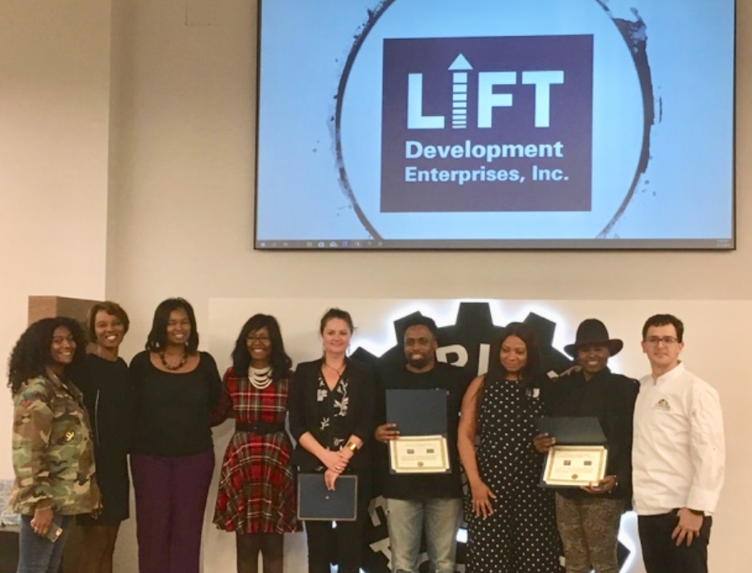

LIFT Development Enterprises Accepting Owners To Participate In 60-Day
Austin, Texas Small Business Accelerator Program

The LIFT Development Enterprises program educates underserved companies by catapulting them to the next stage of growth by giving them the tools and mentorship to scale their businesses.

January 9, 2019: Austin, TX — LIFT Development Enterprises, Inc. (LIFT), a not-for-profit, is currently accepting a select number of enrollees for their 60-day small business growth program, called the “Elevate My Business Challenge,” by targeting Austin, TX service-based small businesses to help them become livable-wage job creators.

Businesses participate in an accelerated expansion focused educational curriculum and are coached by a group of seasoned experts committed to the growth of these service-based, revenue generating companies. After completion of the program, businesses will have the chance to compete for up to $5000 in cash and prizes through a Shark Tank-like event where they will pitch their company’s story to a group of investors.

LIFT’s mission is to assist underserved women, minority, and veteran-led service-based small businesses with revenues between $50,000 and $250,000 with the tools, resources, access to growth capital and coaching through the “Elevate My Business Challenge Program.”

“I would say that most folks truly underestimate these small business owners. All of them leverage personal savings to start their business,” said Kim Folsom, Author, co-founder of Founders First Capital Partners and LIFT. “Businesses join this program to learn how to improve their operations, product offerings, hire key team members and grow their businesses.”

Small businesses are the nations lifeblood and largest employers. However, most resources are targeted to start-up, tech or established businesses above $1 million in annual revenues. LIFT is focused on helping those owners between $50,000 and $250,000 get to the next level and become leaders in their communities by creating quality jobs.

“Empowering business owners results in benefits to both the business owner, and the area in which they operate, as teaching them how to apply these new business development concepts will help grow our regions overall economic development framework,” “Small businesses are always looking for a way to get to that next level,” said Dr. Steven Edmonds, Dean of the School of Business and Technology at Huston-Tillotson University in Austin, Texas. “The Elevate My Business Challenge is about keeping your personal and professional edge as you achieve that next level.”

LIFT partners with National University Extended Learning program and Founders First Capital to leverage their online curriculum platform. Participating members must complete an online application where it is reviewed to confirm participants meet revenue requirements.

“Bank OZK is committed to providing small businesses with the tools and capital to grow their businesses, which often leads to retaining and creating new jobs. We understand that many startup companies with vision, the appropriate tools and support become giants in their respective industries. Here at Bank OZK we support such growth and success in our economy” said Penny King, Community Development Officer at Bank OZK.

“Small businesses are always looking for a way to get to that next level,” said Chris Gillan, Senior Vice President of Corporate Innovation for The Capital Factory. “The Elevate My Business Challenge is about keeping your personal and professional edge as you achieve that next level.”

Enrollment closes on January 26 , 2019. Workshops will begin on January 29, 2019 and will be held at Huston-Tillotson Center for Entrepreneurship and Innovation. The Pitch Competition will be held on March 26th at The Capital Factory.

Participants who wish to enroll can visit: http://EMBChallengeSignUp.liftde.org.

Partners: Huston-Tillotson University, Capital Factory, BCL, Accion, The City of Austin Economic Development Center, Div, Inc, Austin Young Chamber of Commerce

Sponsors: Bank OZK, Wells Fargo

About LIFT
LIFT is a not-for-profit social responsibility and community impact organization whose mission is to provide community organizations tools to deliver economic development programming and resources to introduce, encourage, motivate and guide under served, under presented micro small business owners about the latest entrepreneurial and innovative growth strategies, techniques and tools to support small business growth with an impact to grow employment base.whose goal is to encourage, motivate and guide underserved and underrepresented micro small business owners while giving them the tools to succeed in business.

Contact Info:
Mike Jacobson
mjacobson@f1stcp.com
415- 271-4562
website: www.liftde.org

