PRESS RELEASE 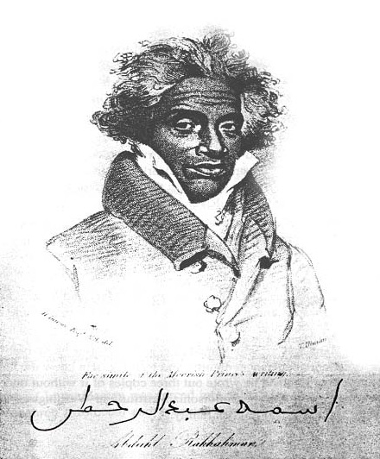

CONTACT INFORMATION :
Office of Princess Karen Chatman
Fatima Al Khouri
404-947-5131
H.R.H.princesskaren@gmail.com

FOR IMMEDIATE RELEASE

The office of the Royal House of His Royal Highness Abdul-Rahman ibn Ibrahima Sori introduces; Her Royal Highness Karen Brengettsy Chatman

New York – The Abdul-Rahman Ibn Ibrahima Sori foundation acknowledges and announces Her Royal Highness, Karen Brengettsy Chatman (Princess Karen) for her continual work and dedication to educate the world on the need for clean water and air, shelter, and technology development for the advancement in food generation to feed the hungry.

Princess Karen, a direct decedent of Prince Abdulrahman Ibrahim Ibn Sori (Prince Sori),a Moor Prince from Morocco and Futa now known as present day Guinea Africa.

Princess Karen promotes and wears her Royal Title in non-governmental capacity, to lead humanitarian efforts world-wide, speaking to audience on the need for unity in providing resources to countries which lack the ability to provide clean water, food, and sheltered to their citizens.

Princess Karen, in addition, is an advocate for Breast Cancer Awareness and seek to assist in efforts that involve research that is designed at finding alternative therapy and a cure for Breast Cancer. Princess Karen, started Think Pink Qatar in 2006 and Think Pink International in 2014. The two organizations are known globally and are fast becoming the most recognized Breast Cancer Awareness Campaigns within the Middle East and South East Asia.

Princess Karen’s, lineage leads back to Prince Abdulrahman Ibrahim Ibn Sori, whom was a Prince that was sold into slavery in 1788 to Thomas Foster of Natchez Mississippi. Prince Sori, lived 38 years as a slave before his Royal Lineage was verified and he return to Africa.

Princess Karen born and raised in Natchez Mississippi, lineage and her humanitarian efforts are well documented and acknowledge by the United States Government, the Royal House of Morocco, and the Africa Governments of North, South, East, and West Africa.

In the Book “A Prince Among Slaves”’ by Terry Alford documents and tells the journey of Prince Sori as does the movie of the same name directed by Andrea Kalin and Bill Duke 2009.
In addition Dr. Artemus Gaye, the son of famous Football player Borbor Gaye of Liberia; Monrovia a direct descendant of Prince Sori and cousin of Princess Karen, has written “Rooted Beyond Boundaries” a book detailing the life of Prince Sori and his journey from Africa to the his final days.

In February, Black History Month, both Princess Karen and Dr. Gaye will be speaking at Alcorn University to an audience that yearn to hear of the journey of the Prince that lived as a Slave.

###

