FOR IMMEDIATE RELEASE

The New Trax G+ LTE Tracker Leads the Way in Safety Innovations
Trax G+ is one of the first consumer-grade GPS devices with 4G LTE-M connectivity.
ISPO ‘Gold winner’ 2019 with POCito VPD Air Vest + TRAX POC Edition.

Stockholm, Sweden - February 4, 2019 - WTS Positioning Solutions, leading innovators in GPS tracking services from Sweden, released the next generation of smart GPS trackers: Trax G+. Top of the range is Trax G+ 4G LTE-M, one of the first LTE trackers commercially available on the market.

The new model supports 4G LTE-M and NB-IoT standards, with both European and US models available.

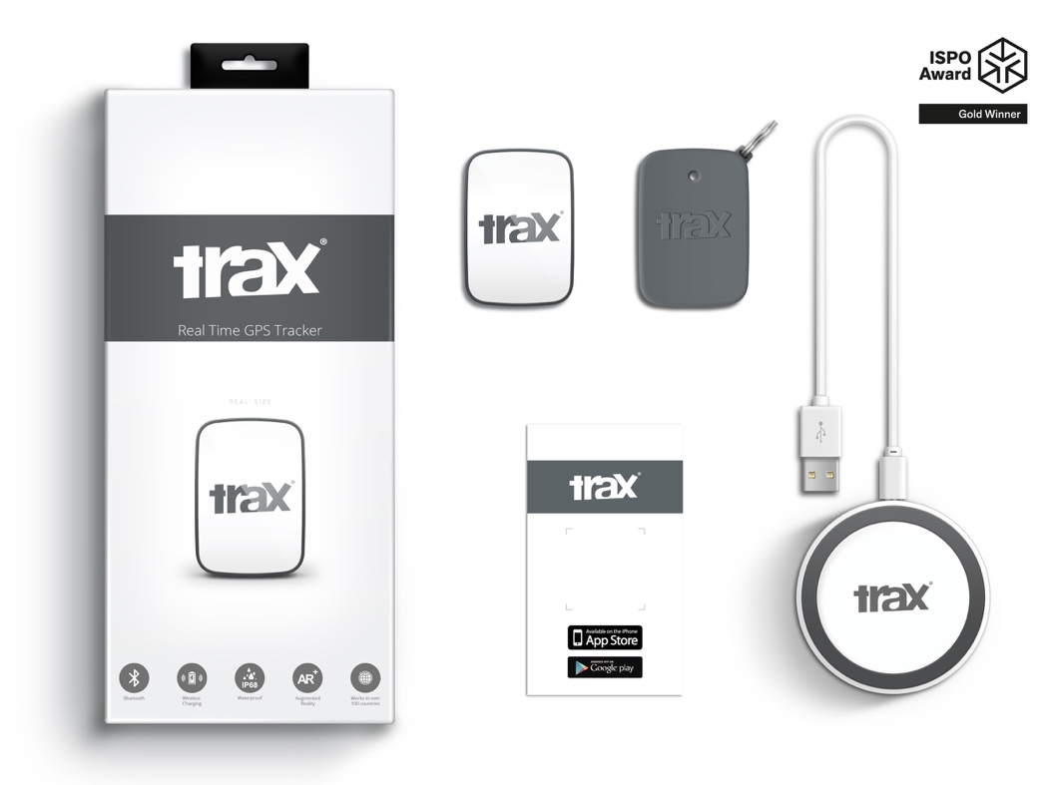

Trax G+ is one of the smallest and smartest GPS trackers for personal use. It has real-time tracking capability with update rates of up to every 10 seconds. For customised industrial applications, the new Trax G+ can support up to 2 updates per second. It also comes with Wireless Charging and IP68 Water Resistance.

The Trax G+ App, available in the App Store and Google Play, has a wide range of features including Unlimited Geofences, Augmented Reality Tracking, Speed Alerts, Location History, the possibility to track multiple devices and device sharing.

All these features have made it possible for WTS to lead the way in safety innovations beyond the enterprise scope, working closely with brands across several consumer markets - from sports gear to event management, security, search & rescue, homecare and telecommunications.

A special collaboration with POC sports brand, leading manufacturer of helmets, body armour and sports apparel, just resulted in an ISPO ‘Gold winner’ award for the POCito VPD Air Vest + TRAX POC edition. The vest is a child-specific back protection for winter sports and is designed to store a TRAX POC Edition device. It is an integrated protection, alert and tracking system, that will allow parents to monitor and keep children safe on the slopes.
The new item will be presented this week by POC at ISPO Munich (Feb 3 - 6, 2019) Hall B6 Booth 414.
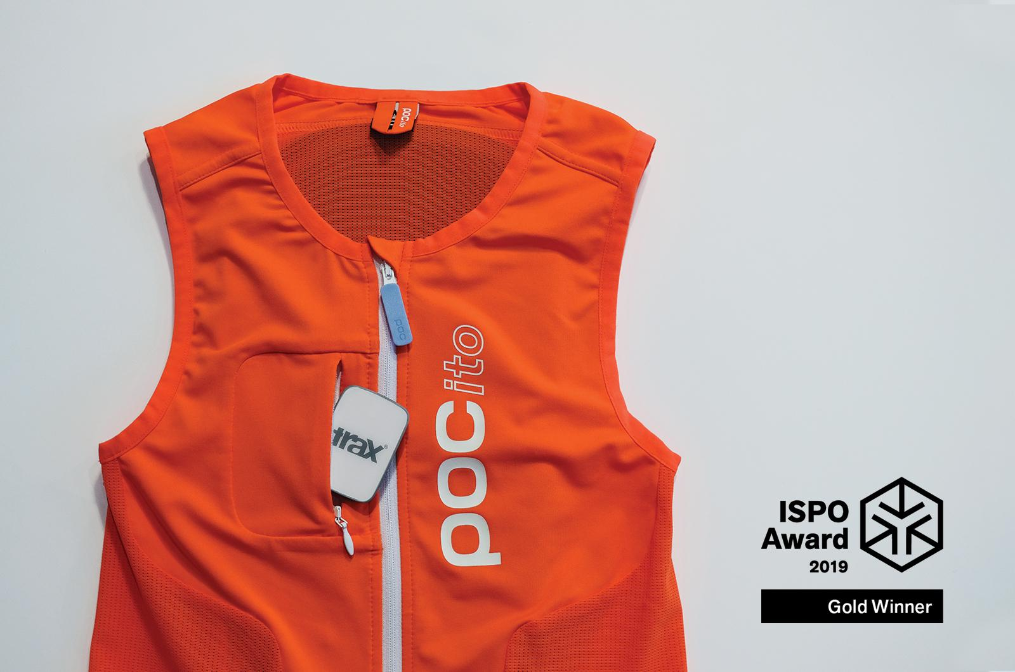

“While 4G NB-IoT and LTE-M networks have an accelerated worldwide deployment, it is exciting to see the opportunities and real-life applications, putting us at the forefront of the developments taking place.” commented Michel Bracké, CEO WTS.
“We are among the first to be able to support the technology with cutting edge, real-time GPS trackers and innovative solutions. Our partnership with POC is just the beginning of what can really be done with location services in sports, events, home care and home automation.”

WTS Positioning Solutions have also released two new and improved GPS models using 3G and 2G standards, to complete the new Trax G+ range and offer a worldwide service.
The new GPS devices can be pre-ordered online at a price of 139 USD for the 4G LTE version, and 149 USD for the 3G version, via traxfamily.com. Pre-orders started shipping in December and will continue until March 2019, when the company plans a full product release, at international level.

An additional data plan purchase is required for the device to work. Trax G+ Data Plans come in 6, 12 and 24 months pre-paid packages and offer international coverage and free roaming in all supported countries.

Company Information
WTS Positioning Solutions are specialists within the Global Navigation Satellite System (GNSS) industry, supplying personal GPS trackers, plus customised hardware, software, server and data solutions for high precision real-time location and tracking information.
Media Resource
Further downloadable assets available here - Media Kit & Images.
Press Inquiries
Mihaela Novac – Marketing & Growth, Stockholm
ela.novac@traxfamily.com
Mobile: +46 739 84 04 50 | Traxfamily.com

