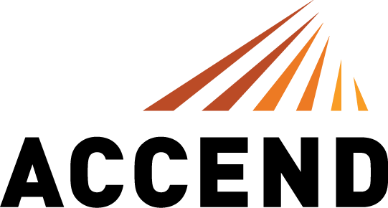

For more information:
Caroline Wellford
Caroline@cstrategiesllc.com
901-216-7657

FOR IMMEDIATE RELEASE
February 11, 2019

ACCEND CONSTRUCTION LAUNCHES IN CHICAGO
Led by industry veteran Andy MacGregor, 100% employee-owned
general contracting firm to operate out of the West Loop

Chicago (February 11, 2019) – Today ACCEND Construction LLC opens its doors in Chicago for business. ACCEND is a general contracting firm with a fresh philosophy and approach to commercial construction led by Andy MacGregor, an industry veteran who has headed some of Chicago’s largest projects in this space. By utilizing an Employee Stock Ownership Plan (ESOP), ACCEND is the one of the very few general contractors to offer every single employee the opportunity to be an owner.

President Andy MacGregor brings 20 years of experience in the Chicago construction market to ACCEND. He led teams to build some of the region’s largest, most complex and creative tech spaces including 1871, Facebook, Google and Motorola Mobility’s world headquarters at the Merchandise Mart, which is one of the largest interior spaces ever built in the city. In addition, he led teams to build notable projects for JP Morgan Chase, Dentons and Fletcher Jones, among others. MacGregor was motivated to branch out on his own to build the company he always envisioned and shake-up the industry’s status quo, which has typically rewarded firm partners, not the entire organization.

“I love this industry and this city, and I’m thrilled to bring a new way of doing business to Chicago by launching ACCEND,” said MacGregor. “My philosophy is that you invest in your employees, nurture talent, take care of your clients and work your tail off. You plan carefully upfront to make the construction process easier and you strive to make everyone you interact with better in some way. Our ESOP model is foundational to that philosophy because it inspires and motivates employees to go above and beyond – to innovate and act as true client partners and advocates.”

With expertise in commercial interiors, hospitality, new construction, heavy renovation and consulting, ACCEND is catapulting the industry forward. It brings energy and vigor for full project optimization, streamlined processes, thoughtful ideas and a sincere desire to make the construction experience fun.

As a subsidiary of Skyline Construction, based in the San Francisco Bay Area, ACCEND offers the highest quality construction services under an umbrella that is well established, financially sound and committed to the Chicago marketplace, with the added benefit of serving clients in both regions. Skyline Construction brings deep experience in tech, an added benefit to Chicago given the city is among the top three U.S. cities (outside Silicon Valley/San Francisco) poised to be a leading tech hub for years to come, according to KPMG’s 2018 Global Technology Innovation study.

“Strategically this is a great move for our ESOP shareholders. There’s no better market for Skyline to invest in right now than Chicago and no better person to lead the team than Andy MacGregor,” said David Hayes, Skyline Construction’s CEO. “We have big goals for ACCEND, a robust balance sheet to support the expansion and the full support of our board of directors and executive leadership. We can’t wait to see the impact Andy and his team will have on the Chicago market. Many of our existing Bay Area based clients are excited about this office and offering us the opportunity to partner in Chicago.”

Skyline, one of the few major construction companies in the business that offers an ESOP to every employee (including collective bargaining employees), continues to expand this model through subsidiaries like ACCEND, pioneering a new employee-centric way of doing business.

For more information, visit http://www.accendconstruction.com or http://www.skylineconstruction.build/.

About ACCEND LLC
ACCEND Construction LLC is a general contractor with a fresh philosophy and approach to commercial construction. Led by industry veteran Andy MacGregor, ACCEND is catapulting the industry forward. It brings energy and vigor for full project optimization, streamlined processes, thoughtful ideas and a sincere desire to make the construction experience fun. ACCEND is the one of the very few general contractors in Chicago that is 100% employee owned through an Employee Stock Ownership Plan (ESOP). For more information, visit http://www.accendconstruction.com.

About Skyline Construction
An award-winning, general contractor in the Bay area, Skyline Construction specializes in building corporate interiors and is known for delivering the highest level of client service. Skyline is the one of the very few general contractors to be 100% employee owned through an Employee Stock Ownership Plan (ESOP). In 2019, Skyline expanded into both new markets and sectors of the industry with the opening of two subsidiaries: ACCEND LLC in Chicago and Skyline Capital Builders in the Bay Area. Skyline’s 2018 sales were over $500 million. The Skyline family of companies is just getting started and plans for future expansion into many major US cities over the next 10 years. For more information, visit http://www.skylineconstruction.build/.

