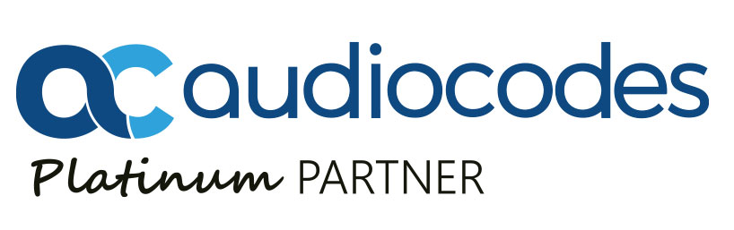

For Immediate Release

Novus Earns AudioCodes Platinum Partner Certification

Longtime AudioCodes Gold Partner Earns Elite Platinum Status in Recognition of Technical Expertise and Proven Market Leadership Driving Adoption for AudioCodes UC and VOIP solutions in North America

Fairfield, CT (March XX, 2019) Novus LLC, a leading value added reseller of telecommunications and IP equipment, today announced it has been awarded Platinum Partner status by AudioCodes in recognition of Novus’ leadership and success helping AudioCodes drive growth for its VoIP and UC solutions in North America. A longtime AudioCodes Gold level partner, Novus earned Platinum level distinction for the second straight year due to its deep technical expertise in Microsoft unified communications and AudioCodes’ solutions for Skype for Business and Microsoft Teams.

AudioCodes Platinum level Partners are the company’s highest tier of channel partners and comprise of a select number of the most accomplished strategic partners who have demonstrated the highest level of expertise and consistent growth and revenue performance for AudioCodes solutions in the North American channel. As a Platinum Partner, Novus meets the highest commercial demands of AudioCodes.

“As a longtime partner of AudioCodes, Novus is honored to earn certification as a Platinum Partner in North America,” said Chris Meehan, Managing Director at Novus LLC. “AudioCodes suite of VoIP and UC solutions represent ‘best of breed’ technology and we are excited to work with AudioCodes in the coming years to help deliver more of their solutions to the market.”

Having achieved Platinum status, Novus is now able to deliver additional benefits to clients to further develop their VoIP portfolios, increase satisfaction and maximize efficiency. AudioCodes Platinum Partners represent a strategic group of partners that have continually demonstrated exceptional AudioCodes revenue performance, making them eligible to extend their benefits to customers.

“Since 2014, Novus has proved itself to be a strong and strategic partner for AudioCodes in North America,” said Eric Bauer, Vice President of Marketing and Business Development, North America at AudioCodes. “As a leading partner for Skype for Business and Microsoft Teams, AudioCodes looks forward to continuing to grow and expand this area of our business by working with strategic partners like Novus.”

For more information about Novus and AudioCodes portfolio of UC and VoIP solutions, visit www.novusllc.com or call (866) 331-1112. Visit Novus’ blog at www.ip-hive.com, follow us on Twitter and LinkedIn.

About Novus
Novus is a leading distributor of IP voice and data communications technology with over three decades of experience advising and supporting both value-added resellers (VARs) and large end users throughout North America. Novus provides a comprehensive portfolio of industry leading telecommunication solutions from best-of-breed software and hardware technology partners. Over the last decade, Novus has established itself as one of Microsoft’s leading unified communication partners and has acquired the elite Microsoft Partner Network Gold Communications competency. The company supports legacy products from Nortel, NEC, Avaya and acts as a liaison for manufacturer-supported programs for remanufactured, new, manufacturer-discontinued, and end-of-life products. Novus also provides unified communications consulting, call center management and asset management services. Learn more at www.novusllc.com.

Media Contacts
John Gates
Elevate Communications
617-861-3651
jgates@elevatecom.com

###

