**For Immediate Release:**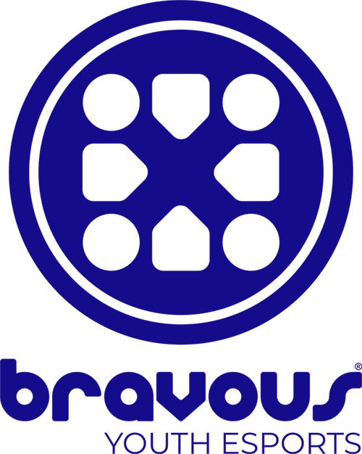

**New Arizona Company Expands Opportunities for New Generation of**

**Well-Rounded Young Athletes Beyond Traditional Sports**

**April 1, 2019: Tempe, AZ** - Scott Novis, Founder and CEO of Bravous Youth Esports, is an engineer by trade but a sports lover by heart, which lead him to combining his passions and create Bravous. Bravous is America’s leading youth esports organization, running competitive video game leagues for elementary, middle school, and high school students.

After seeing the explosion of esports, but no on ramp for kids, Scott saw the opportunity to create a youth oriented esports company. As Founder and CEO of GameTruck, Scott knows the positive impact video games can have on the young community if delivered correctly.

The name Bravous comes from combining bravely-courageous, attributes Scott feels kids develop through competition. The courage to compete, and the bravery to face challenges can be learned through esports. Of the 64 million children in the United States, less than half participate in traditional athletics but 97% play video games. In Scott’s experience many of these children play alone, or online. Most never play in person with their peers which means they miss out on important life lessons sports teach.

Bravous aims to bring players together, face to face, by offering youth esports leagues that focus on the Nintendo Switch. “From our players, to our parents, to our coaches, our focus is on the person,” Scott said. “We are people helping people. We want you to feel the energy that comes from seeing players build self-confidence, show team work, and a competitive spirit.”

Bravous was born from a desire to make a difference for the millions of kids who have fallen out of traditional sports. “We can teach them to be great competitors,” Scott said. “We have a mental economy now, not a muscle economy.” Esports can prepare children for the skills that companies and organizations around the world need today. Bravous started local with a dream to change the world of youth sports.

Bravous prides themselves on education, not only for their athletes but for the parents as well; understanding that esports can lead to opportunities in adult life, including college. Now, over 64 universities offer scholarships for esports while 22 universities recognize esports as Varsity Athletic Programs.

Bravous runs leagues at Boys & Girls Clubs of the East Valley as well as at Dave and Buster’s in Desert Ridge Marketplace. While Bravous is expanding as fast as the esport world, they will be looking to hire new coaches. For more information on starting a leagues, tournaments or showcases in your area, as well as job opportunities, please visit [www.bravous.com](http://www.bravous.com) or call [(888) 290-8415](tel:+18882908415).

For media inquires, please contact:

Colltey Sheldon

623-680-6683

**About Bravous Youth esports:**

Since 2018, Bravous has been America’s leading youth esports academy. We offer unique competitive video game leagues for players in the 3rd through 12th grades. Players train, play, and compete in person. Guided by professional coaches, players join teams, develop skills, and learn the values it takes to compete with courage. Bravous esports leagues create the kind of development opportunities players take for granted in traditional sports such as, belonging, competence, usefulness and contribution. Become Bravely Courageous. Bravous.