FOR IMMEDIATE RELEASE

For More Information,
Contact: Ryan Fogelman
614-327-3744, rfogelman@firerover.com

FIRE ROVER IS NAMED A 2019 GOLD EDISON AWARD WINNER
Fire Rover Wins at New York Ceremony; Awards Celebrate 32 Years of Honoring Innovators and Innovation

New York, NY – April 4, 2019 – The Edison Awards, celebrating 32 years of honoring the best in innovation and excellence in the development of new products and services, announced today that Fire Rover was voted the top prize at the April 4th event at The Capitale in New York City. The Fire Rover fire elimination solution was awarded the gold medal in the Industrial Safety category. Rounding out the category was IBM and The Raymond Company winning the silver and bronze award respectively.

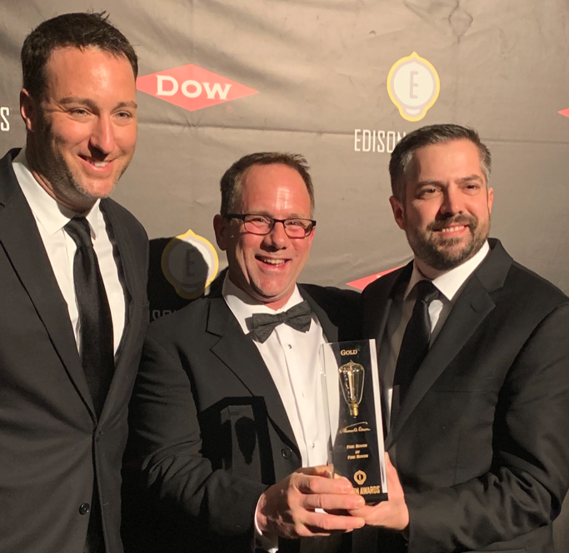

Being recognized with an Edison Award has become one of the highest accolades a company can receive in the name of innovation and business. The awards are named after Thomas Alva Edison (1847-1931) whose inventions, new product development methods and innovative achievements literally changed the world, garnered him 1,093 U.S. patents, and made him a household name around the world.

“Once again, the winners created innovations that are revolutionizing industries and becoming indispensable. One of the game-changing winners Fire Rover was recognized as a true innovator in Industrial Safety,” said Frank Bonafilia, Executive Director of the Edison Awards.

The ballot of nominees for the Edison Awards™ was judged by a panel of more than 3,000 leading business executives including past award winners, academics and leaders in the fields of product development, design, engineering, science and medical.

About Fire Rover, LLC
Established in 2015, Fire Rover was developed to focus on the initial minutes before and after a fire incident can occur ensuring that an incident can be dealt with safely as possible protecting employees, businesses and fire professionals. For more information about Fire Rover, visit http://www.firerover.com.
About the Edison Awards™
The Edison Awards is a program conducted by Edison Universe, a non-profit, 501(c)(3) organization dedicated to fostering future innovators. The Awards have been recognizing and honoring the best in innovations and innovators since 1987. They honor game-changing innovations that are at the forefront of new product and service development, marketing and human-centered design, and are one of the highest accolades a company can receive in the name of successful innovation. For more information about the Edison Awards complete program and a list of past winners, visit www.edisonawards.com.

