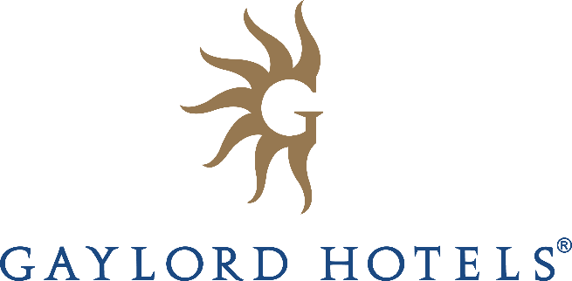

FOR IMMEDIATE RELEASE:

RISE AND SHINE FOR SUMMERTIME FUN AT GAYLORD HOTELS
Gaylord Hotels’ five award-winning resorts host SummerFest events and activities for families nationwide

NASHVILLE, TN (April 17, 2019) – From the east to the west coast, and several other locations in between, families can enjoy cooling off in expansive waterparks or pools, be awe-inspired by extraordinary indoor atriums, partake in a host of entertaining activities, and make summertime memories to last a lifetime during Gaylord Hotels’ SummerFest celebrations presented by Aquafina®. Overnight resort guests can experience unique summertime festivities from Memorial Day through Labor Day.

SUMMER CELEBRATIONS AT GAYLORD NATIONAL RESORT (National Harbor, MD)
Gaylord National Resort located in the breathtaking waterfront destination of National Harbor, Maryland, has added a plethora of complimentary, resort-only activities designed for the whole family to enjoy. Visitors can experience nightly laser light shows, a nature-loving scavenger hunt, and kid-friendly activities by the resort’s junior Olympic-size pool. Additional activities include movies in its 19-story garden atrium, a “Campfire and S’mores” experience, Silent Disco Parties, live music and more.

THE SMURFS AT GAYLORD OPRYLAND RESORT (Nashville, TN)
Visitors will have a “Smurfingly” good time at Gaylord Opryland Resort located in Nashville, TN, with live entertainment, poolside play, and an array of themed activities. Kids and adults will enjoy Breakfast with The Smurfs, Brainy Smurf’s Learning Log, The Smurfs’ Way Home Scavenger Hunt, and a Blues Cruise on the resort’s riverboat. In addition to free nightly fountain shows, garden tours, and multiple restaurant offerings, be among the first to experience SoundWaves – the resort’s brand-new upscale indoor/outdoor resort water attraction featuring 111,000 square feet of water attractions, dining, and amenities.

FLORIDA FUN AT GAYLORD PALMS RESORT (Kissimmee, FL)
Welcoming guests seeking the best of Florida fun, Gaylord Palms Resort located in Kissimmee, Florida, will host water play at their Cypress Springs Water Park featuring a zero-entry family pool; treehouse water structure with four water slides; the Bog Cypress tower with an AquaDrop slide and two racing slides; and The Wake Zone, a Double FlowRider with a surfable simulated wave. Visitors also can experience the Florida Explorer Scavenger Hunt, Pirate’s Treasure Escape Room, Exotic Animal Encounters, and the Illuminate Florida Light Show.

(more)

SummerFest at Gaylord Hotels – pg. 2

WONDERLAND AT GAYLORD ROCKIES RESORT (Aurora, CO)
At the newly-opened Gaylord Rockies Resort located in Aurora, Colorado, resort visitors will experience Lewis Carroll’s storybook classic, “Alice’s Adventures in Wonderland”, with a twist including whimsical costumed characters, rock n’ roll music, pool parties and more. From the Cheshire Cat’s Colorado Adventure Scavenger Hunt and Hatter’s Escape Room to Queen of Hearts Mini-Golf and Breakfast in Wonderland, there is something for all ages to enjoy.

ADVENTURES OF PETER PAN AT GAYLORD TEXAN RESORT (Grapevine, TX)
Gaylord Texan Resort located in Grapevine, Texas, will transform into Neverland, entertaining visitors with a full itinerary of themed activities including Pan’s Painting and Treasures, Pirate’s Revenge Escape Room, a Light Up the Night Pajama Party, and Dream On: A Video Mapping Show. Additionally, adults and kids can splash into summer at the resort’s 10-acre outdoor waterpark, Paradise Springs, featuring a 600-foot long lazy river, four giant water slides, a giant water treehouse water play structure, and more.

All five of Gaylord Hotels’ impressive resorts will feature special summer rates and room packages, so visitors can stay to enjoy all of the family-friendly events and activities. For more information or to book a summer getaway, visit www.GaylordHotels.com/SummerFest.
ABOUT GAYLORD HOTELS
Gaylord Hotels, part of the Marriott portfolio of brands, offers extraordinary environments with everything in one place—diverse dining options, full-service spas, pools, top-notch entertainment, shopping and more. Locations include Gaylord Opryland in Nashville, Tennessee; Gaylord Palms in Kissimmee, Florida; Gaylord Texan on Lake Grapevine, Texas; Gaylord National on the Potomac in National Harbor, Maryland; and Gaylord Rockies in Aurora, CO.

###

MEDIA CONTACT: Martha Neibling, Director of Public Relations, at mneibling@gaylordhotels.com.
AQUAFINA is a registered trademark of PepsiCo, Inc.© 2018 BUBLY and the Bubly Designs are trademarks. Used with permission. All rights reserved.

