The ‘Oscars of Politics’: Latin America's Biggest Political Campaigns sweep the Napolitan Victory Awards

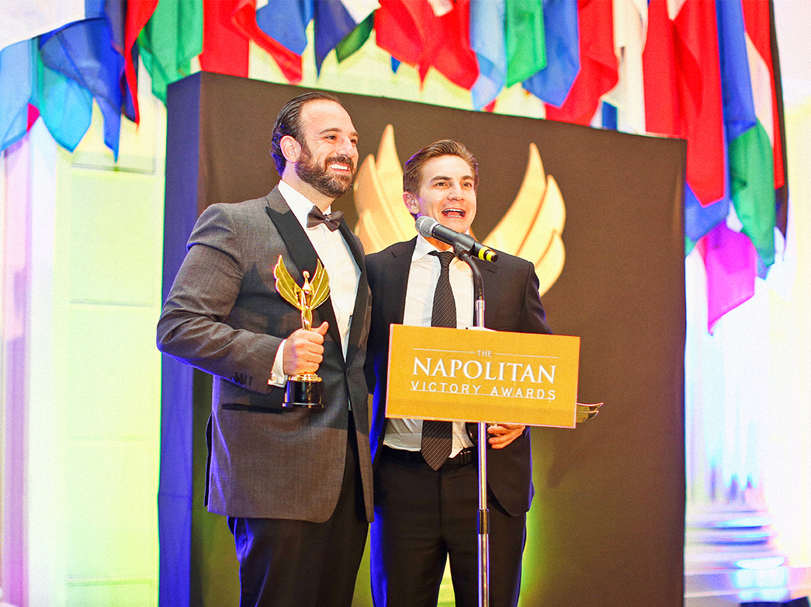
This April, the Washington Academy of Political Arts & Sciences™ celebrated the 8th annual Napolitan Victory Awards. These highly prestigious awards honored over 100 political leaders and campaigns across 47 categories, recognizing some of the best political campaigns and professionals in the world.

One of the big winners of the night was the 2018 presidential campaign for Andres Manuel López Obrador from Mexico. The campaign took home seven awards, one of which was “Campaign of the Year.” Argentinian advertising executive, Carlos Souto, won the esteemed and highly coveted “Consultant of the Year” award.

The highest honors of the night were awarded to former president of Uruguay, José Mujica, and Ralph Murphine. Mujica graciously accepted the Napolitan Honorary Award and Murphine, Latin America’s best known political communications expert, was inducted into the Washington Academy Hall of Fame after working on more than 500 campaigns throughout his career.

In addition to awarding the best political campaigns, The Washington Academy honored thirty political “rising stars” under the age of 30, twelve influential women in political communication and twenty political activists fighting for liberty and global democracy.

Other notable winners included:

- Tren Maya awarded “Political Spot of the Year” for a piece describing the benefits of Mexico’s largest infrastructure projects under Mexico’s current presidential team.
- Guelaguetza Festival from Oaxaca, Mexico awarded for several audio-visual projects.
- Juan Manuel Moreno, President of Andalusian People’s Party, took home the “Electoral Campaign of the Year” and two other awards for his recent work in Spain.
- Media firm 76 Words was one of two American winners, receiving an award for the spot ‘Somos Más.’
A full list of nominees and award recipients can be viewed here.

About the Napolitan Victory Awards

The most highly coveted awards in political communication, The Napolitan Victory Awards are unique in their field, receiving nominees from approximately 30 countries. The awards are named after Joseph Napolitan, widely regarded as the father of modern political consulting. Since 2012, the Napolitans have been held and hailed by the international media as the ‘Oscars of Politics’ and are presented annually by The Washington Academy of Political Arts & Sciences ™.

Honoring talent and success in political communications, election campaigns, and governments, these awards also recognize exceptional contributions in digital and technological media, the press corps, academic institutions, leaders in freedom, democracy, and political excellence.

Napolitan Victory Awards Online:
Website: Napolitans.org
Facebook: Facebook.com/theWAPAS
Instagram: instagram.com/TheWAPAS
Twitter: Twitter.com/TheWAPAS

###

Photo: http://napolitans.org/wp-content/uploads/2019/04/napolitan-victory-awards-NAPOLITANS.jpg

Contact:
Daniel Rios
info@napolitans.org

